|  |
| --- |
| AD Project Report |
| GDipSA47 Team 1 |
|  |
|  |
|  |

|  |
| --- |

**Contents**

1. Project Report 2

1.1 Introduction 3

1.2 Product Deliverables 3

1.3 Recommendations 3

1.4 Lessons Learned 4

1.5 Problems and Solutions 4

1.6 Looking back 4

2. Contribution report 5

2.1 Roles and responsibilities of each member 5

2.2 Deliverables and interaction within the team 6

2.3 Major Challenges and Resolution 10

2.4 Amount of time spent on the project by each member 13

2.5 Reflection on the experience gained from the project by each member 15

3. Non Functional Requirements 17

3.1 User Volume 17

3.2 Data Volume 18

3.3 Business transaction 20

3.4 Security Requirements 22

3.5 Reliability Requirements 23

4. Architecture Platform Specification 25

5. Use Case Diagram 28

6. Entity Relationship Diagram 30

7. Class Diagram 31

8. Sequence Diagram 39

8.1 Web Application for Department Sequence Diagram 39

8.2 Mobile Application for Department Sequence Diagram 48

8.3 Web Application for Store Sequence Diagram 51

8.4 Mobile Application for Store Sequence Diagram 70

9. Test Scripts 75

10. Wire Frames and UI Specifications 78

10.1 Department web User interface 78

10.2 Store web User interface 91

10.3 Department Mobile User Interface 114

10.4 Store Mobile User Interface 120

**1. Project Report**

## 1.1 Introduction

The aim of the project is to develop a fully functional software system which would automate several work processes or main activities for the stationery inventory store as well as the internal customers who order with the said store. User Requirements gathering were conducted in the early phase of the project and from there, our team is able to break down the tasks into various phase with completion date for UAT signoff on the 11th of February.

## 1.2 Product Deliverables

| **Phase/Workflow** | **Deliverables** | **Elements in the Deliverables** |
| --- | --- | --- |
| **Requirement Capture Workflow** | Requirement Specification (Functional) | * Department Use Case Diagram for mobile application * Department Use Case Diagram for web application * Store Use Case Diagram for mobile application * Store Use Case Diagram for web application |
| Requirement Specification (Non Functional) | * User Volume * Entity Volume * Business (use case) Transaction Volume * Security Requirement and Access Matrix |
| UI Specification | Wireframe for each use case |
| **Design Workflow** | Architectural Platform |  |
| Final Design Sequence Diagram | Sequence diagram for each use case for both web and mobile application |
| Consolidated Class Diagram | Class diagram |
| Relational DB Design | Entity Relations Diagram |
| **Implementation Workflow** | Source Code |  |
| **Test Workflow** | Functional testing for each Use Case | Test Scripts |

## 1.3 Recommendations

We would like to recommend installation of electronic display tags for inventory and scanners, leading to increased efficiency and accuracy of the stock check and goods received process. We would also recommend the use of tablets for Store Clerks so they have a better interface when performing their tasks.

**Future phases of development**

Currently, only certain features are accessible in the mobile application. In the future we will continue to incrementally implement more features in the mobile application using AGILE approach to be as comprehensive as the web, as well as making the web application more compatible to be viewed on a mobile web browser; should the user chooses.

In the future, the application would also be able to have a fair allocation system across departments for disbursement, should the request quantity exceed the current stock level in the inventory.

The application will use Google Map API to allow the Department Representatives to track where the Store Clerk is and be alerted when they are nearby the collection point.

We propose the implementation of EDI (electronic data interchange) with suppliers so that purchases can be sent electronically instead of faxing or emailing as attachment. There is also potential for return of purchase confirmation date and quantity so that the clerks do not need to update purchases in the system should there be any changes from suppliers.

## 1.4 Lessons Learned

After breaking down a task, we learned that it was important for the entire team to go through all the completed subtasks to gain a better understanding of the whole project and to vet each other’s work. This brings the whole team to a common understanding of the project and reduces the effort needed to address repeated questions or changes to codes that conflicts with the overall goal of the project.

We also learned that a change control is needed to properly process any alteration in the business requirements and design models. Before we implement the change control, a huge amount of errors occurred during programming, due to changes in the database which was not properly communicated to the rest of the team. After this incident, we start to establish change control to ensure that any changes should be made known to the team, followed by assessing the changes’ impact, and implemented only with everyone’s approval.

Finally we learnt that pair programming can increase the efficiency of programming. When two people are coding and or debugging, it is much faster to spot the mistakes and understand the logic of the code better, cutting down time used to program.

## 1.5 Problems and Solutions

Understanding the user requirements was quite challenging for the team since the perception and level of understanding for each team member was different. This situation was handled by conducting brainstorming sessions to arrive at a common consensus.

During the implementation of the actual mobile and web application, we could not adhere to the initial design model due to complexity and technological limitations of the development software. To overcome, this problem, the team did a lot of research and try out new codes to implement certain complex functionalities of the applications. We also modify the design model to simplify the implementation, while ensuring that the required functionalities of the system were met.

We also face problems during the integration of the source code from each member. As different members were using different versions of the development software to produce the codes, there were some incompatibility issues. To overcome this problem, we created a standardise library of codes of common functionalities and UI proven to work across different platforms that the team used to implement their respective use case. This greatly reduces the errors faced during integration.

## 1.6 Looking back

Currently, we have implemented a basic user-friendly UI for the application due to time constraint and lack of experience. Given time, we would explore and implement advanced front-end technologies for a better user-friendly interface and also come up with creative ideas of implementing other features apart from the user requirements which would benefit them.

**2. Contribution report**

## 2.1 Roles and responsibilities of each member

| **Name** | **Roles and Responsibilities** |
| --- | --- |
| Adam Png Yee Soon | Programmer and Business Analyst |
| Aisha Ashiq | Programmer and Business Analyst |
| Bessa Nicoletta | Programmer and Business Analyst |
| Cen Xudong | Programmer and Business Analyst |
| Chen Wu-Chi | Technical Lead, System Integrator, Programmer and Business Analyst |
| Dicky Lie | Database Administrator, System Integrator, Programmer and Business Analyst |
| Kip Hoe Poon | Project Manager, Documentation Lead, Programmer and Business Analyst |
| Lily Ho Mei Lee | Programmer and Business Analyst |
| Madhumitha Murali | Database Administrator, Programmer and Business Analyst |

## 2.2 Deliverables and interaction within the team

| **Name** | **Deliverables and interaction** |
| --- | --- |
| Adam Png Yee Soon | * Research and development on ASP.NET MVC * Explained MVC concepts to other team members * MVC starter project configuration and set up * Web Purchase Order use case * Web Adjustment Voucher use case * Android Disbursement use case * Android Authentication and Login * Android Store Landing Pages * Android Store Routing of Landing Pages to User Roles * Integration of Store Android * Creation of parts of Project Work Plan * Creation of Platform-specific Architecture * Debugging of Web and Android * Editing of non-technical work * Populating database * Wireframe for initial UI design and annotation for store and web * Checking, updating and submission of the user manual * Rational database table discussion * User Requirement gathering * Crystal Reports testing * Popularized use of Postman for debugging |
| Aisha Ashiq | * Android View Adjustment Voucher for Store Clerk * Android View and Issue Adjustment Voucher for Store Supervisor and Manager * Android Change DR/Collection Point for Department Head and Department Representative * Android Approve/Reject Request for Department Head * Testing of Web API with the above Android Use cases * Performing System, Functional and Regression Testing for whole project (both web and android) * Creating error report to be sent to team for fixing errors * Generation of final Test Scripts * UI Prototype designing * Sequence Diagram for Store and Department * Annotated Wireframes for Store and Department * Created, checked and updated User manual for Store and Department * Project Report * Rational database table discussion * User Requirement gathering * Use case discussion with the whole team |
| Bessa Nicoletta | * Populating database * Created Power BI dashboard (Store and Department Trend Analysis) * Android View Stock Card * Android Purchase Order * User Requirement gathering/ interview * Rational database table discussion * Use case diagrams * Sequence diagrams * Class diagrams * Wireframe for initial UI design and annotation for store and web * Perform Testing of Android and Web * Inform Team for troubleshooting and bug fixing * Checking and updating the user manual * User Requirement gathering * Researched data reporting methods |
| Cen Xudong | * MVC project Configuration and set up * Adjustment Voucher for Web * Stock Card for Web * View history request for DH in Web * Inventory use case for Web * Create Adjustment Voucher for Android * Integration of Store Android * Class Diagram for store and department * Sequence Diagram for store and department * Wireframe for initial UI design and annotation for store and web * Project Work Plan * Progress report week 1 * Populating Database * Email notifications for store * Checking and updating the user manual * Rational database table discussion * User Requirement gathering |
| Chen Wu-Chi | * Database and transaction method design * Integration of asp.net MVC * Discuss the business transaction with team and troubleshoot the problems * Wireframe design * Structure the code of business logic * Raise and edit request use case (web) * Raise and edit purchase order use case (web) * Retrieve goods use case (both web and android) * Disbursement use case (both web and android) * Manage adjustment voucher use case (web) * Manage stock card use case (web) * Role delegation and change DR use case (web) * Restful Web API * Generate the roles in startup.cs for Asp.net identity * Email notifications for store * Bug fix for both android and web * User Requirement gathering |
| Dicky Lie | * Integration as well as code checks in android * Debugging of android * Role delegation for department head * Change collection point and department representative for department head * Change collection point for department representative * Explained MVC concepts to other team members * Help on adding validations for web and androids for many use cases * Responsible on routing the url based on the user roles * Populating database * Wireframe for initial UI design and annotation for store and web * Use case discussion with the whole team * Bug fix and testing for both android and web * Checking and updating the user manual * Email notifications for store * User Requirement gathering |
| Kip Hoe Poon | * Research the creation of spinner and how to set onclicklistener for the spinner to populate the listview * Create a way to pass an intent across 3 activities back to the first activity in the Android studio * Implement proper UI design for Android to be shared with the team. * I familiarise myself in applying the WEB API to the Android, allowing me to mentor others in the team who were still unfamiliar in this area. * Proactive in consulting and seek clarification on who to draw the sequence diagrams which allowed me to shape up the structure for others to follow. * Store and dep wireframe and Use case discussion with the whole team * Help in debugging codes * Class Diagrams for store and department * Write up the progress report, project report, project work plan, Non Functional requirement. * Design the Entity Relational Diagram * Project scheduling (GANTT) * Checking and updating the user manual * Rational database table discussion * User Requirement gathering/Interview |
| Lily Ho Mei Lee | * Created Power BI dashboard (purchasing and chargeback) and Web reports * Android View Stock Card * Android Purchase Order * Crystal Reports form creation and MVC codes for adjustment vouchers and purchase orders * User Requirement gathering/Interview * Rational database table discussion * Use cases for store and department * Sequence Diagram for store and department * Class Diagrams for store and department * UI design * Project scheduling (GANTT) * Project work plan * Project charter * Project report * Populating database for purchasing and adjustment * Wireframe for initial UI design and annotation for store and web * Perform Testing of Android and Web * Inform Team for troubleshooting and bug fixing * Checking and updating the user manual * Researched data reporting methods |
| Madhumitha Murali | * Android View Adjustment Voucher for Store Clerk * Android View and Issue Adjustment Voucher for Store Supervisor and Manager * Android - Search Catalogue for Department * Android Department Landing Pages * Database administrator * Help and also taught teammates how to debug error codes * Testing and Integration of Web API with the above Android Use cases * Performing System and Regression Testing * Creating error report to be sent to team for fixing existing errors * Generation of final Test Scripts * UI Prototype designing * Sequence Diagram for Store and Department * Annotated Wireframes for Store and Department * Created, check and updated User manual for Store and Department * Project Report * Relational database table discussion * User Requirement gathering |

## 2.3 Major Challenges and Resolution

| **Name** | **Major Challenges and Resolution** |
| --- | --- |
| Adam Png Yee Soon | Limited user interactions led to a heavier reliance on case study notes instead of actual interview insights, but this situation was mitigated by having team consensus on product development. The resultant product was able to meet user requirements.  There was a need to apply and integrate novel technologies (JavaScript, jQuery and Power BI) in the web app development and while they were not difficult to learn, integration was not straight-forward so a lot of experimentation and testing were needed to get things working.  User authentication was an off-syllabus topic and although Derek provided an Android workshop, it was abstruse to follow through. Wuchi and I researched and experimented on the user authentication concept in Visual Studio and then got it to work in Android Studio too.  Integrating Store-Android components and general debugging were difficult as there were a lot of areas to analyse and quite often, a problem might even be caused by server-side code. |
| Aisha Ashiq | Limited interaction with users, hence difficult to understand requirements completely. Finalizing the UI design was challenging because the team had different understandings on the user requirements. Somehow, through team discussions we came to a decision and worked on the project. |
| Bessa Nicoletta | Use of an unfamiliar business analytics service to generate reports i.e. Power BI took time to learn  Limited interaction with the users made it difficult to ascertain the requirements which impacted every component (use case, sequence, class diagrams on top of coding) but was resolved by having the team agreed upon the design, and ultimately to achieve a workable solution |
| Cen Xudong | Limited time to interact with user and sometimes may confused with some unfamiliar use case and cause some problem in my code. Luckily ,my teammates found it and help me.Also it took some time to learn how to use the mvc, however finally we made it and learn a lot from this project. |
| Chen Wu-Chi | Not enough time to interact with user and gather requirements |
| Dicky Lie | Limited time with a little interaction with the user. Learning how to use and familiarize with MVC took some time, however after getting used to MVC the project went more smoothly.  Integration and debugging were hard since the code tend to have some problems when it was merged. All the team members were kind enough to help me understand their codes and help me found the problem to fix. |
| Kip Hoe Poon | The use of WEB API is very specific on how it is used to interact with the mobile application using JSON. I found a problem where the WEB API requires an object so we had to convert a JSON array into a JSON object before we get it to interact with the WEB API.  The use of StartActivityforResult is limited to passing intent across 2 activities. So in order for me to pass intent across 3 activities, I used an innovative way to use setresult and StartActivityforResult across 3 activities.  The other technical difficulties would be using spinner and its onclick listener to populate listview. As this was a new functionality I was exposed to, I resolve it by using spinner with Asynctask to populate it, and use activity intent to pass the spinner selection to populate the listview with another Asynctask |
| Lily Ho Mei Lee | Limited time to do the project so we divided the group up with CNY in the last week. It helps to do pair programming(Bessa) I wasn’t good at debugging especially that of the API communicating between android and web luckily Dicky taught me so I can understand and learn. Somethings you cannot learn on the internet and which you can learn from your teammates and share with others! |
| Madhumitha Murali | Implementation of sending model as JSON from web to android. We create a view model and convert the model from database to view model before sending the data to android. It makes things easier as we can collect all the information that we need in the view model before we send it to the android.  Limited interaction with users, hence difficult to understand requirements completely. Team discussion and brainstorming sessions helped to overcome the above issue. |

## 2.4 Amount of time spent on the project by each member

| **Name** | **Amount of time spent** |
| --- | --- |
| Adam Png Yee Soon | 213.5 hours total  Research & Development – 10 hours  User Requirement – 5 hours  Group Discussions – 45 hours  Wireframes – 40 hours  Use case Diagrams – 8 hours  Sequence Diagrams – 3 hours  Coding & Testing – 95.5 hours  User Manual Editing and Compilation – 3 hours  Other Documentation – 4 hours |
| Aisha Ashiq | 193.5 hours total  User Requirement- 5 hours  Group Discussions -15 hours  Use case Diagrams- 5 hours  Sequence Diagrams- 10 hours  Android Coding & Testing- 60 hours  Wireframes- 33 hours  User Manual - 30 hours  Testing & Test Scripts- 20 hours  Documentation – 15.5 hours |
| Bessa Nicoletta | 198 hours total  User Requirement – 5 hours  Wireframe – 40 hours  Group Discussions – 45 hours  Use Case Diagram – 7 hours  Sequence Diagram – 30 hours  Class Diagram – 21 hours  Populating Database – 15 hours  Power BI Reports – 20 hours  Android Coding – 7 hours (pair programming with Lily Lee)  Testing android and web for all processes– 7 hours  Documentation – 16 hours |
| Cen Xudong | 199.5 hours total  User Requirement – 5 hours  Wireframe –40 hours  Group Discussions – 45 hours  Sequence and Class Diagram – 18 hours  Coding and testing– 91.5 hours |
| Chen Wu-Chi | 240 hours total  User Requirement – 5 hours  Group Discussions – 45 hours  Wireframe – 30 hours  Database Design – 20 hours  Coding and testing – 100 hours  Integrating and Debugging – 40 hours |
| Dicky Lie | 233.5 hours total  User Requirement – 5 hours  Wireframe – 37.5 hours  Group Discussions – 45 hours  Database – 10 hours  Coding and testing – 96 hours  Integrating and Debugging – 40 hours |
| Kip Hoe Poon | 243.5 hours total  User Requirement – 5 hours  Wireframe – 37.5 hours  Group Discussions – 45 hours  Database – 2 hours  Coding and testing – 114 hours  Sequence Diagram – 20 hours  Creating Classes and Class Diagram – 20 hours |
| Lily Ho Mei Lee | 227 hours total  User Requirement – 5 hours  Wireframe –41 hours  Group Discussions – 45 hours  Use Case Diagram – 7 hours  Sequence Diagram – 20 hours  Creating Classes and Class Diagram – 30 hours  Populating Database – 6 hours  Power BI Reports – 15 hours  Android Coding – 7 hours (pair programming with Lily Lee)  Test run of the android codes to make sure it works– 5  Crystal reports creation - 21  Testing android and web for all processes – 10 hour  Documentation – 15 hours |
| Madhumitha Murali | 203.5 hours total  User Requirement- 5 hours  Group Discussions -15 hours  Use case Diagrams- 5 hours  Sequence Diagrams- 10 hours  Database – 10 hours  Android Coding & Testing- 60 hours  Wireframes- 33 hours  User Manual - 30 hours  Testing & Test Scripts- 20 hours  Documentation – 15.5 hours |

## 2.5 Reflection on the experience gained from the project by each member

| **Name** | **Reflection** |
| --- | --- |
| Adam Png Yee Soon | Learning and applying new technologies is not as difficult as imagined and should always be considered when taking on a new project, because sometimes an unfamiliar technology might be even more suitable in implementation.  The user gathering process must be thorough to ensure the final product can fulfil requirements. If there were a chance to do an interim check with the users, the resultant product will be even closer to their ideal.  Work breakdown that is aligned to both project deadlines and each member’s forte is essential for achieving project success. Active and committed participation by all team members is integral to high-performing teamwork. |
| Aisha Ashiq | Clear understanding of the user requirements is a must as we are going to build a system for them, hence it is very important to understand their needs and expectations and try to deliver them to the fullest  Team discussion and considering other’s opinions and ideas gives a lot more perception in a different way and hence can avoid last minute changes and problems |
| Bessa Nicoletta | User experience design is very important; however, at our level of competency it might be better to work on the coding first then do it in reverse  Interaction with user cannot be on a one-time basis, there needs to be an on-going timely communication  Deliverables and deadlines need to be clearly stated to make sure no impediments push back the final delivery date  Teamwork is key, agree upon a workable solution first, a satisfying design, then build from there. Most importantly, trust each other. |
| Cen Xudong | The aim of design is to meet the required need and unmet need for user, the interaction with user is most important for a project, it decide the final result and evaluation to the whole project.  Good Team distribution and communication are essential to finish the project, the former will influence the efficiency, the latter will influence the quality and effectiveness. |
| Chen Wu-Chi | Focus on not only UI but UX. Planning is important, and we need to spend more time to know the current business transaction approach because we can design the system to solve the user’s pain points. Working with big group is not easy, we need to keep sharing the progress and the problem we faced, so we can release the stress when we are integrating the system. |
| Dicky Lie | Understand the user needs better to design a better application. Should focus on more user experience rather than focusing only the functionality of the application  Good teamwork and communication are essential on finishing the project. Team members have their own skill set and by helping each other will help increase the project pace |
| Kip Hoe Poon | Clear understanding on how the Design pattern of MVC can promote much more usability and cleaner codes.  It is also important to explore how user interact with their phones and their environment to come up with better user experience.  The importance to tie down design with the implementation of the system. Previously, it was purely design without seeing how the design can impact the system implementation. |
| Lily Ho Mei Lee | Challenging to meet the expectations of all user requirements within the short frame of a month. Would like to implement all in the web and android but it was tough. However, I guess I have learnt that it is not possible even in real life and it is practical to implement the important use cases leaving the “nice to have” as the last to implement if there is enough time. |
| Madhumitha Murali | Team work, proper communication and understanding the strengths of each team member is vital for a successful project. Most importantly listening to all team members opinions and suggestions and arriving at a consensus is a must in every team.  Learnt the importance of team discussions as it arrives at a clear understanding of the requirements and concepts. |

**3. Non Functional Requirements**

## 3.1 User Volume

**User Volume table**

| User Group (Actor) | Country/ Location/ Count | Remark |
| --- | --- | --- |
| Department Head | Singapore/various Logic University departments/10 | Department Head is stationed most of the time in the department, however he is often on the go to other locations for his work commitments. He needs to use the system to grant approval to pending stationery requisition form and maybe delegate an acting department head when is out of the office. |
| Department Employee | Singapore/various Logic University departments/476 | Department Employee are stationed in the department. They need to access the system when they want to raise or edit stationery requisition form. |
| Department representative | Singapore/various Logic University departments/9 | Department Employee are stationed in the department. They need to access the system to raise or edit stationery requisition form and be notified when the stationery can be collected at his selected collection point. Department representatives are given the flexibility to change collection point. |
| Store Clerk | Singapore/Logic University Store/3 | Store Clerk are stationed in the warehouse and will be more reliant on a mobile device than a desktop to access the system to carry out his duties. For example when he gets a notification on low stock level, stock retrieval or stock check. |
| Store Supervisor | Singapore/Logic University Store/1 | Store Supervisor are stationed at the store and mainly use the system to check on the adjustment vouchers and issue adjustment vouchers to the Store Manager for adjustment voucher with greater amount than $250. |
| Store Manager | Singapore/Logic University Store/1 | Store Manager are stationed at the store and mainly use the system to check on the adjustment vouchers with values above $250. |

## 3.2 Data Volume

**Data Volume table**

| Business Entity Class | Source Document | Retention Period | Target Volume |
| --- | --- | --- | --- |
| Request | Stationery Requisition Form | 3 years | 50 raise per week: 7800 request for 3 years |
| Staff | Staff profile in the system | 5 year | 500 records |
| Department | Department list | 5 years | 10 records |
| Inventory | Stationery catalogue | 3 years | 90 records |
| Collection point | Stationery Requisition Procedure for Employees | 5 years | 6 records |
| Supplier | Supplier List | 3 years | 10 records |
| Pricing | Stationery Supply Tender Quotation | 2 year | 180 records |
| AdjustmentVoucher | Inventory Adjustment Voucher | 3 years | 1 adjustment voucher per month; 36 adjustment voucher for 3 years. |
| PurchaseOrder | Stationery Purchase Order Form | 3 years | 10 purchase orders (1 per supplier) raised bi-weekly: 780 purchase orders |
| PurchaseOrderDetails | Stationery Purchase Order Form | 3 years | 10 items per purchase order (for max 10 suppliers) raised bi-weekly: 7800 purchase order details |
| Stockcard | Stock card | 3 years | 90 records |

**Documented Calculation for Data Volume table**   
   
User   
   
User entity list out the username and password for each staff in the department. The record is kept relatively fixed unless there is new hire and exit of work personnel from the department which is difficult to predict the frequency.

Request

The request entity stores the list of stationery requisition form details. On average, 10% of the employees will request for stationery every week which makes up to 50 stationery requisition request per week. If the record is kept for 3 years, the total volume of record is 7800.

Staff 

Staff entity list out the role and details for each staff in the department. The record is kept relatively fixed unless there is a promotion, new hire, exit of work personnel from the department which is difficult to predict the frequency.

Department

Department entity list out the details of the department. The record is fixed.

Inventory

The Inventory entity contains the details of the stationery including category, reorder level, reorder quantity and unit of measure for example. Currently Logic University Stationery Store has 90 different stationery. If the data of each product is retained for 3 years, the target volume to store the data of all products in the Inventory is remains relatively constant at 90 assuming that the record continuously deleted and replaced with a new stationery that is more price competitive.

Collection point

Collection point entity list out the details of the collection point. The record is fixed.

Supplier

The Supplier entity contains the details of the supplier including phone number, address, fax number, contact name for example. Currently Logic University Stationery Store has 10 suppliers. If the data of each supplier is retained for 3 years, the target volume to store the data of the suppliers remains relatively constant at 10 assuming that the record continuously deleted and replaced with a new supplier that offers a wider range of stationery with better pricing.

Pricing

The pricing entity records the price of each stationery offered by the respective supplier. Assuming each supplier provide tender price for 18 stationery, since there are 10 suppliers, there would be 180 record from the 10 suppliers.

Retrieval

The retrieval entity stores the total amount of stationery requested from the consolidated stationery requisition forms. 1 stationery retrieval form is produced every week. If the record is kept for 3 years, the total volume of record is 156.

Adjustment Voucher

The adjustment voucher entity stores the details of each adjustment details. 1 adjustment voucher is produced every month. If the record is kept for 3 years, the total volume of record is 36.

Purchase Order

The purchase order entity stores the details of each purchase order. The purchase order is raised bi-weekly on average so assuming one purchase order is raised for each supplier (there are 10 suppliers) and each purchase order is kept for 3 years, there would be 780 records.

Purchase Order Details

The purchase order details record the items in the purchase order. On average there are about 10 items per purchase order. Since, the purchase order is raised bi-weekly on average so assuming one purchase order is raised for each supplier (there are 10 suppliers) and each purchase order is kept for 3 years, there would be 7800 records.

Stockcard

The Stockcard entity contains the details for each change to the balance of the inventory. One stockcard is tied to one stationery. And since there are 90 different stationery, there will be a need for 90 records.

## 3.3 Business transaction

**Business transaction table**

| Business Transaction (use case) | Persona | Business Criticality | No. of users | Transaction information | Concurrent important activity |
| --- | --- | --- | --- | --- | --- |
| Manage user account | All | Critical | 500 | 500 login data per day    130500 per year (year 2019) | 50 employees in each department can login on the system concurrently |
| Modify supplier information | Store manager/ Store supervisor | Moderate | 2 | Once a month    12 per year | Store manager and store supervisor modify supplier information |
| Issue adjustment voucher report | Store manager / Store supervisor | Moderate | 2 | Once a month    12 per year | Store manager and store supervisor can view and issue adjustment voucher concurrently |
| Process purchase order | Store clerk | Moderate | 3 | Non-peak period:  10 per 2 weeks    Peak period (January and June):  20 per 2 weeks    2360 per year | 3 store clerks can process purchase order concurrently |
| View stock card | Store clerk | Critical | 3 | 90 per day    23490 per year | 3 store clerks can view stock card concurrently |
| Modify stationery catalogue | Store clerk | Moderate | 3 | Once a year | 3 store clerks can modify stationery catalogue concurrently |
| Process adjustment voucher | Store clerk | Moderate | 3 | Once a month    12 per year | 3 store clerks can process adjustment voucher concurrently |
| View Report | Store clerk | Moderate | 3 | Once a month    12 per year | 3 store clerks can generate trend analysis report concurrently |
| Generate charge back report | Store clerk | Moderate | 3 | 10 per year | 3 store clerks can generate charge back report concurrently |
| Process retrieval list | Store clerk | Moderate | 3 | 3 per week    156 per year | 3 store clerks can modify retrieval list concurrently |
| Process disbursement list | Store clerk | Moderate | 3 | 10 per week    520 per year | 3 store clerks can generate disbursement list concurrently |
| Delegate department head duties | Department head | Low | 10 | 10 per year | 10 department head can delegate their duties concurrently |
| Approve / reject request | Department head | Critical | 10 | 500 per week    26000 per year | 10 department head can approve / reject a request concurrently |
| Change department representative/ collection point | Department head | Low | 10 | 20 per year | 10 department head can change their representative / collection point concurrently |
| Modify department Information | Department head | Low | 10 | 20 per year | 10 department head can change their department information |
| View department trend analysis | Department head | Low | 10 | 20 per year | 10 department head can view trend analysis |
| View stationery catalogue | Department head / Department representative / Staff department/ store clerk | Critical | 500 | Non-peak period:  50 per week    Peak period (January and June):  100 per week    3000 per year | 500 users can view the catalogue concurrently |
| Raise requests | Department representative / Staff department/ store clerk | Critical | 495 | Non-peak period:  50 per week    Peak period (January and June):  100 per week    3000 per year | 495 users can create request concurrently |
| Modify pending requests | Department representative/ Staff department | Critical | 495 | Non-peak period:  50 per week    Peak period (January and June):  100 per week    3000 per year | 495 users can view request concurrently |
| Manage cart | Department representative/ Staff department | Critical | 495 | Non-peak period:  50 per week    Peak period (January and June):  100 per week    3000 per year | 495 users can view request concurrently |
| Change collection point | Department representative | Low | 10 | 20 per year | 10 department representatives can change their collection point concurrently |

**Documented Calculation for Business Transaction Table**

Documenting the calculation for transaction information

*In 2019 there will be 261 working days, assuming all the employees will be present for the whole year, there will be 500 logins per day (500 * 261 = 130500 logins per year)

**Assuming 10% of the employee will request for stationery every week, there will be 50 request per week for 10 months (non-peak period) and 100 request per week for 2 months (peak period).   
Total requests = 100 * 2 months * 4 weeks + 50 * 44 weeks = 3000 requests per year

***The department head will receive notification for each request. Whenever the department head approve / reject a request, the respective requester will receive a notification. By using this assumption, the total notification will be (3000 * 2 = 6000 notifications per year). Assuming the total of the rest of notifications (change of collection details, receive reorder notification, delegation of department head duties, etc) are 150 notifications per year, the total notifications per year will be 6000 + 150 = 6150 notifications per year.

****Assuming that per 2 weeks all the supplier will have a purchase order for non-peak period and per 2 weeks all the supplier will have 2 purchase order for peak period (January and June),   
Since there are 10 suppliers, each bi-weekly will have 10 purchase order (non-peak period) and 20 purchase order (peak period).   
The total purchase order in one year is = 20 * 2 months * 4 weeks / 2 + 10 * 10 months * 44 weeks / 2 = 2360 purchase orders

## 3.4 Security Requirements

**Security requirement (Data access)**

| Data (Entity class)\ User Role (actor) | Department Head | Department representative | Employees | Store Clerk | Store Supervisor | Store Manager |
| --- | --- | --- | --- | --- | --- | --- |
| Request | r | c,r,u,d |  |  |  |  |
| Staff | c,r,u,d | r,u | r,u | r,u | r,u | r,u |
| Department | c,r,u,d |  |  |  |  |  |
| Inventory | r | r | r | c,r,u,d | c,r,u,d | c,r,u,d |
| Collection point | u | u |  | u | u | u |
| Supplier |  |  |  | c,r,u,d | c,r,u,d | c,r,u,d |
| Pricing |  |  |  | c,r,u,d | c,r,u,d | c,r,u,d |
| AdjustmentVoucher |  |  |  | c,r,u,d | r | r |
| PurchaseOrder |  |  |  | c,r,u,d | c,r,u,d | c,r,u,d |
| PurchaseOrderDetails |  |  |  | c,r,u,d | c,r,u,d | c,r,u,d |
| Stockcard |  |  |  | c,r,u,d | c,r,u,d | c,r,u,d |

**Security requirement (use case access)**

| Business Transaction (use case)\ User Role (actor) | Department Head | Department representative | Employees | Store Clerk | Store Supervisor | Store Manager |
| --- | --- | --- | --- | --- | --- | --- |
| Manage user account | x |  |  |  |  |  |
| Modify adjustment voucher |  |  |  |  | x | x |
| Issue adjustment voucher |  |  |  |  | x | x |
| Process purchase order |  |  |  | x |  |  |
| View stock card |  |  |  | x |  |  |
| Modify stationery catalogue |  |  |  | x |  |  |
| Process adjustment voucher |  |  |  | x |  |  |
| View report |  |  |  | x |  |  |
| Generate charge back report |  |  |  | x |  |  |
| Process retrieval list |  |  |  | x |  |  |
| Process disbursement list |  |  |  | x |  |  |
| Delegate department head duties | x |  |  |  |  |  |
| Approve / reject request | x |  |  |  |  |  |
| Change department representative/ collection point | x |  |  |  |  |  |
| View stationery catalogue | x | x | x |  |  |  |
| Raise requests |  | x | x |  |  |  |
| Modify pending requests |  | x | x |  |  |  |
| Manage cart |  | x | x |  |  |  |
| Change collection point |  | x |  |  |  |  |

## 3.5 Reliability Requirements

**Reliability**

Operation time

The operation time for the system will be the office hours of Logic University campus (9am - 5pm Mon to Fri; 9am - 12pm Sat).  The down time for maintenance can occur from 2 am to 5 am in the morning, when the system is not being used or it can occur on Sunday. The downtime should not occur more than 1 times a month.

Hardware failure (server, network)

If there is a hardware failure in the server and the network, the recovery duration should not take more than an hour a day. As the system server connects to all the important functions to run the business (e.g. create requests, approve / reject requests, modify stock cards, etc), it is vital that the system recovers in not more than an hour to ensure insignificant disruptions to the business.

After the recovery has been made, the data concurrency cannot be more than an hour old. Users should be able to access data that are not more than half an hour old to ensure a smooth continuation of the business transaction.

*DRJ (https://www.drj.com/articles/online-exclusive/5-disaster-recovery-options-balancing-the-pros-and-cons-objectives-and-cost.html)

Disaster recovery

The maximum down time to do a disaster recovery is not more than one hour. This is a reasonable time needed to do recovery of the system and given that there is a robust system to pre-empt the disaster (refer to the Techniques to improve reliability).

After the recovery has been made, the data concurrency cannot be more than a day old. Users should be able to access data that are not more than half an hour old to ensure a smooth continuation of the business transaction.

Techniques to improve reliability

Data duplication:

Having a mirroring server to back up existing server, so that data backup is possible during disaster.  Setting up a mirroring server can be useful especially when there is planned maintenance such as upgrading to new server or software updates which would require the system to be stopped or rebooted. With this mirroring strategy, the company can do a role switch in which the main server can be swapped at any time when planned maintenance is done.

Backup:

Also implementing an automatic backup system (e.g. Hewlett-Packard backup and recovery manager has a 7 days auto backup drive) that records and save active directory (email accounts, etc.) is also crucial.

Better Design:

Apart from having a mirroring server and backup system, setting up a firewall is also important for any business (e.g. Sophos firewall) which allows authentication of users before it reaches the server and database. In addition to subscribing to security software against harmful virus such as ransomware is necessary as well. 

Putting in place spare resources:

The company has included a spare server in their yearly budget. When there is a main server failure, the system can temporarily connect to the spare server containing critical data required to address the essential functions of the system. This reduces the down time needed to connect to the mirroring server when the main server is down.

**4. Architecture Platform Specification**

*Implementation Technology*

| **Technology** | **Implementation** |
| --- | --- |
| **ASP.NET Web Application**  **(.NET Framework)**  with  **Web API / MVC** design pattern and  **EF6 Data Model** | MVC   * Rapid and parallel code development (3 times faster than applications developed using other development patterns) * Reduced code duplication from separation of concerns (low coupling of data, business logic and display) * High cohesion (logical grouping within Model, Controller and View) helps to reduce work error * Return of unformatted data ensures same component can be called for use with any interface * Support for asynchronous technique help application load faster * Possible integration with JavaScript Framework enables development of feature-rich web app * Modularity ensures increased unit testing possibilities * Feature-specific code modification does not need to affect entire programming development * A SEO-friendly platform can be easily developed * Greater cost and time savings can be achieved   Web API   * Required component for enabling RESTful services * Supports ASP.NET request/response pipeline * Built-in support for different formats of response data (JSON, XML, BSON) * Various hosting possibilities (IIS, Self-hosted or other web server that supports .NET 4.0+) allows easy simulation   EF6 Data Model   * Data model enables easy and seamless save/retrieve interactions with database |
| **JavaScript / jQuery** | * Enhanced functionality of web pages with client side scripting * Increased user friendliness of website |
| **HTML/CSS** | Styling and display of data assets on web pages |
| **Bootstrap** | Application of selected HTML/CSS style theme to increase aesthetic value of website |
| **JSON** | Serialization and transmission of structured data |
| **XML** | Data setting specifications |
| **Java** | Language used in Android programming |
| **C#** | Language used in core programming to encode all required functionalities and database interactions in Visual Studio |
| **SQL Server** | Data persistence |

*Tools*

| **Application Area** | **Tool** | **Usage** |
| --- | --- | --- |
| Software Development | **MS Visual Studio** | Web application programming and implementation |
| **Android Studio** | Android app programming and implementation |
|  | | |
| Database Connectivity | **MS SQL Server Management Studio** | * Database design and creation * Data persistence |
|  | | |
| Design Modelling | **WhiteStar UML** | Creation of sequence and class diagrams |
|  | | |
| Unit Testing | **Postman** | Simulation of GET/POST data operations to web application |
| **Firefox, Chrome and other web browsers** | Demonstration of web application functionalities |
|  | | |
| Analytics & Reporting | **SAP Crystal Reports** | * Data visualization of business analytics * Interactive presentation on webpage * Generation of PDF reports for download |
| **MS Power BI** |
|  | | |
| Project Management | **MS Project** | Tracking and management of project activities |
|  | **MS Office Suite** |

*Software Architecture Design*

|  | **WEB** | **ANDROID** |
| --- | --- | --- |
| **Presentation Layer** |  |  |
| **Business Logic Layer** |  |  |
| **Persistence Layer** |  |  |

**5. Use Case Diagram**

**Web Application for Department**

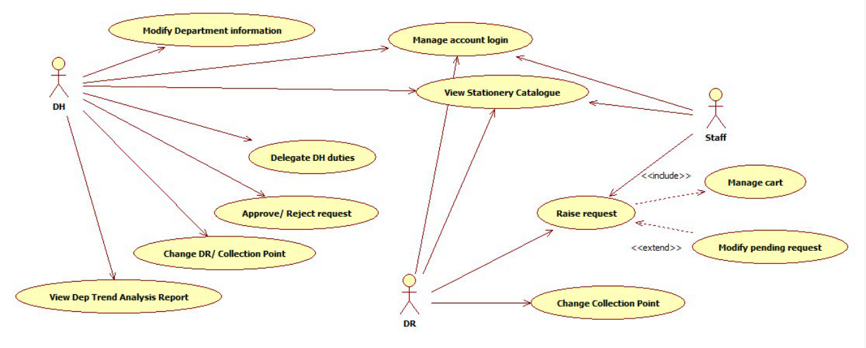

**Mobile Application for Department**

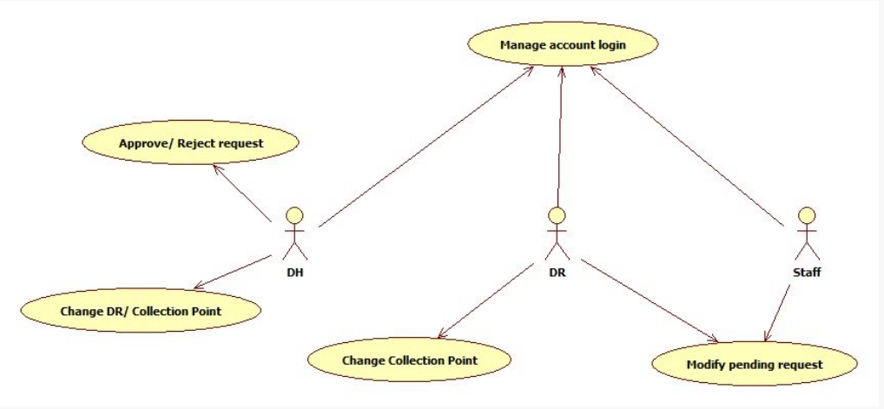

**Web Application for Store**

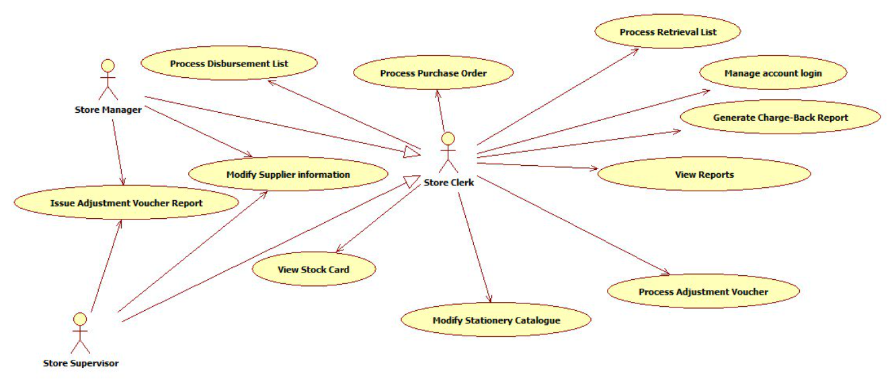

**Mobile Application for Store**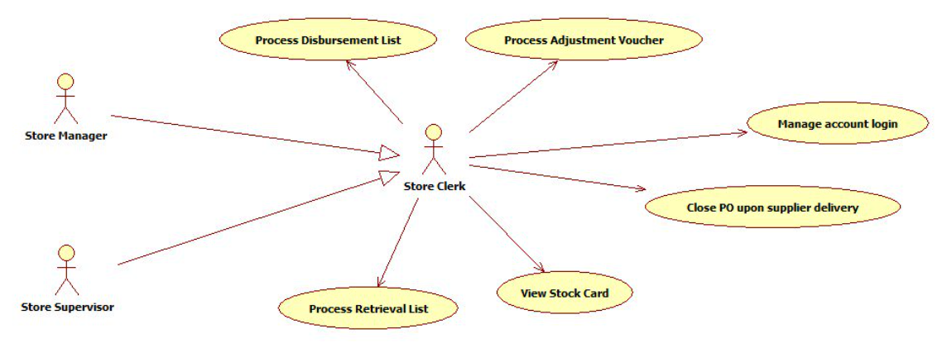

**6. Entity Relationship Diagram**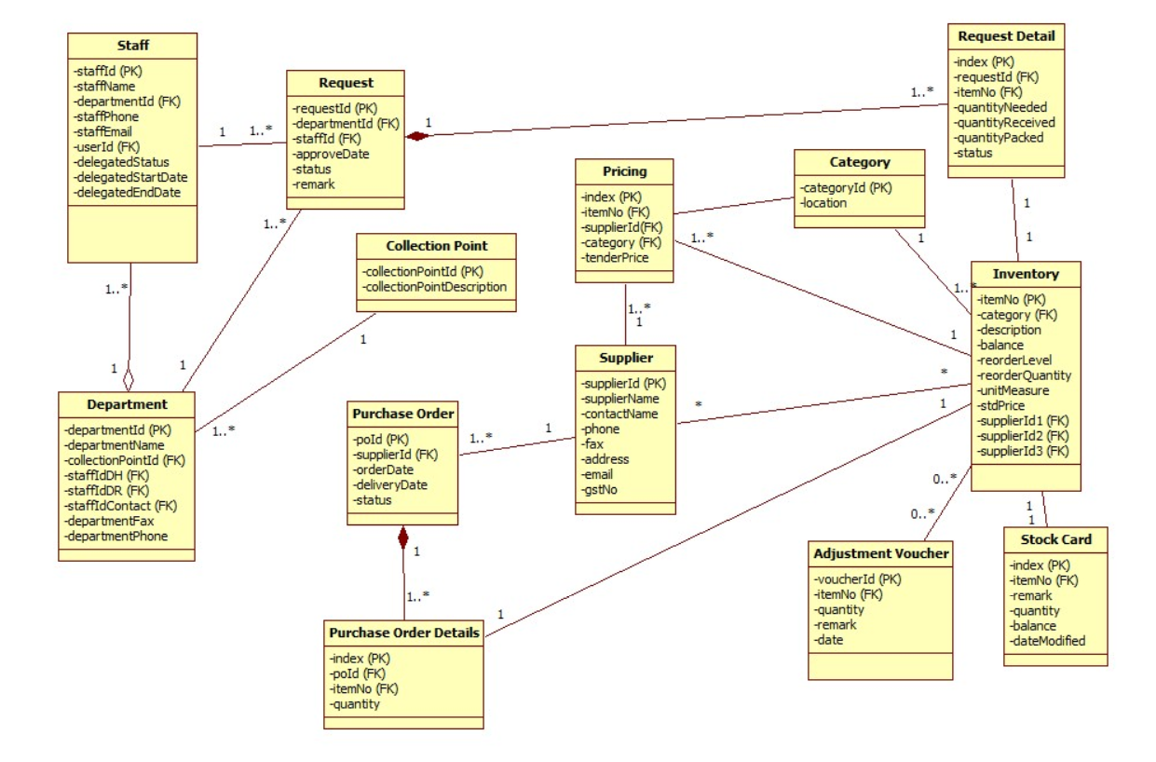

**7. Class Diagram**

**Change Collection Point/Department Representative for Department**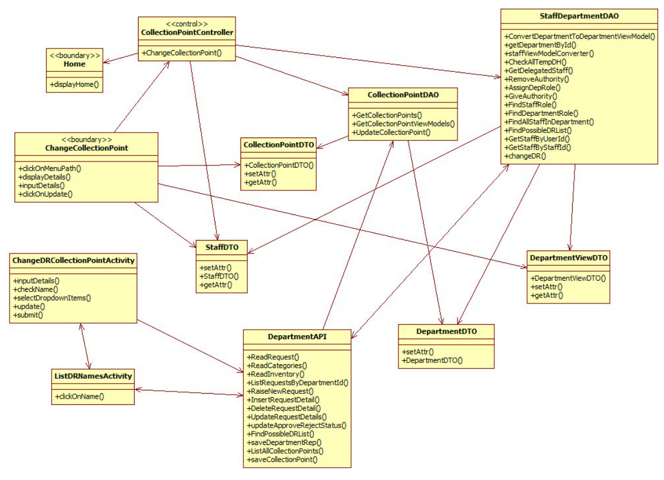

**Role Delegation for Department**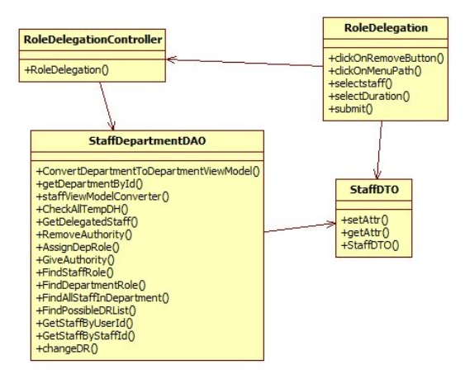

**Approve/Reject for Department**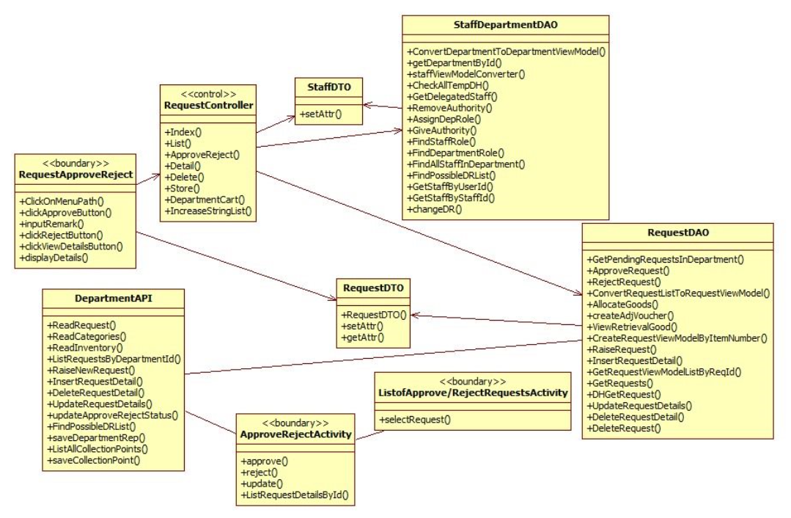

**Request for Department**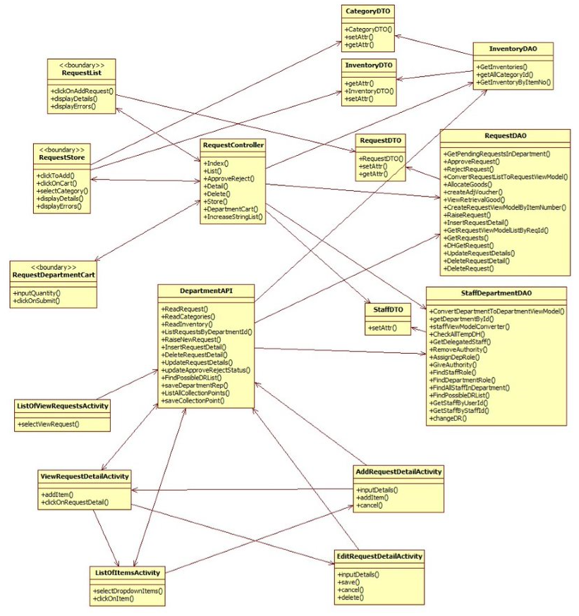

**View Stationery Catalogue for Department**

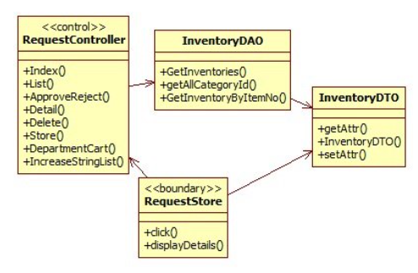

**Modify Department Information for Department**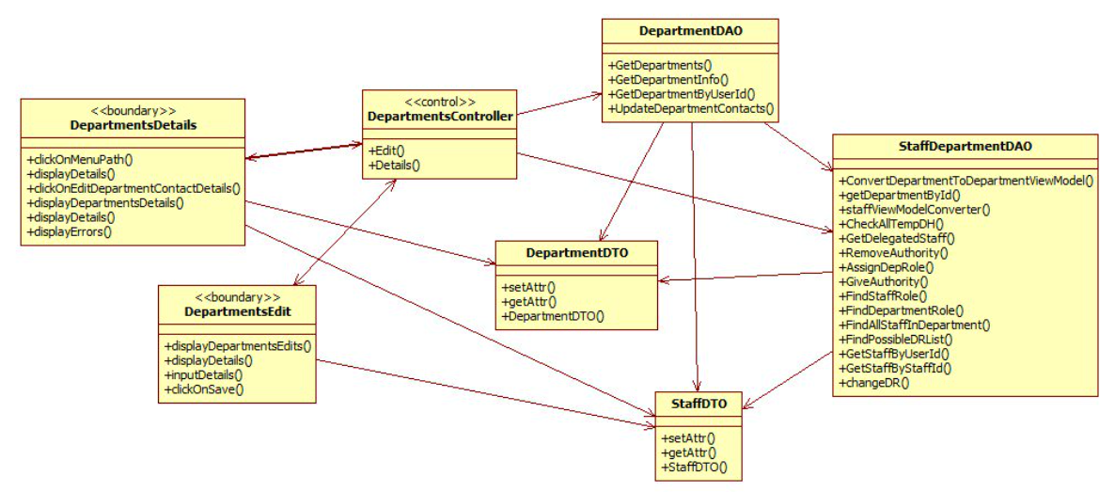

**View Reports for Department and Store**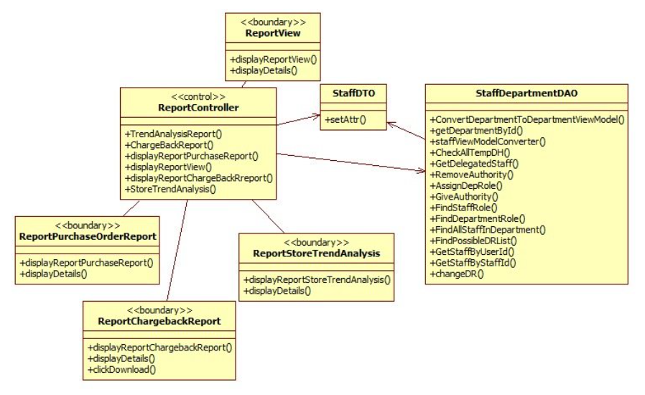

**Retrieval List for Store**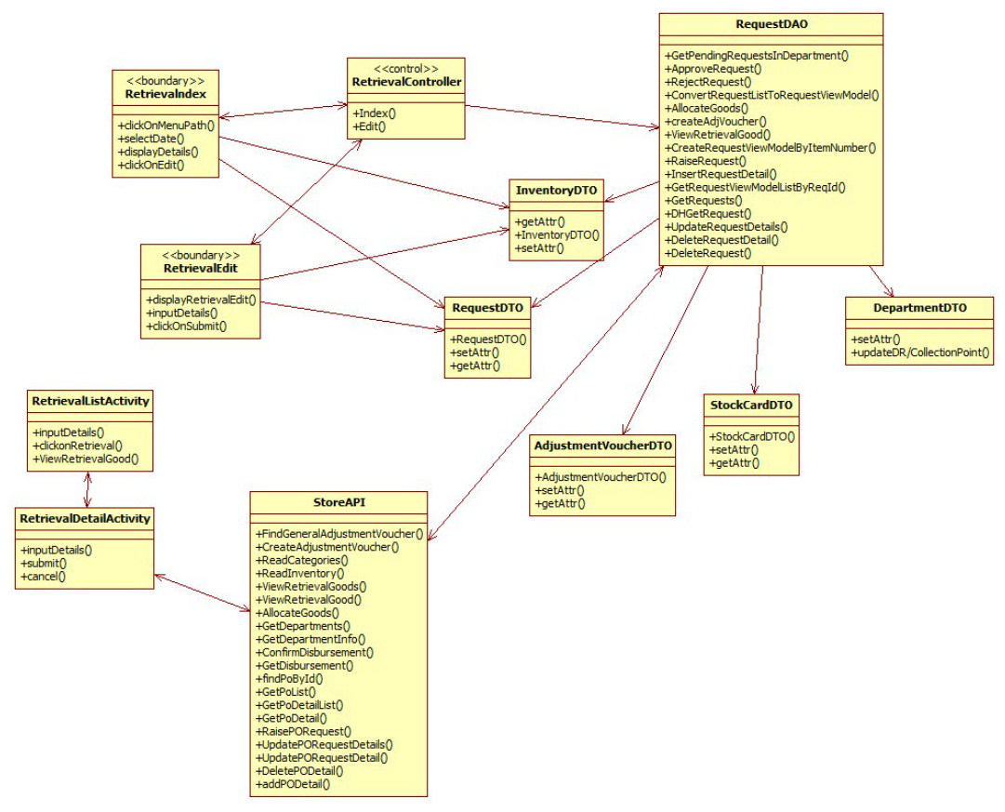

**Disbursement List for Store**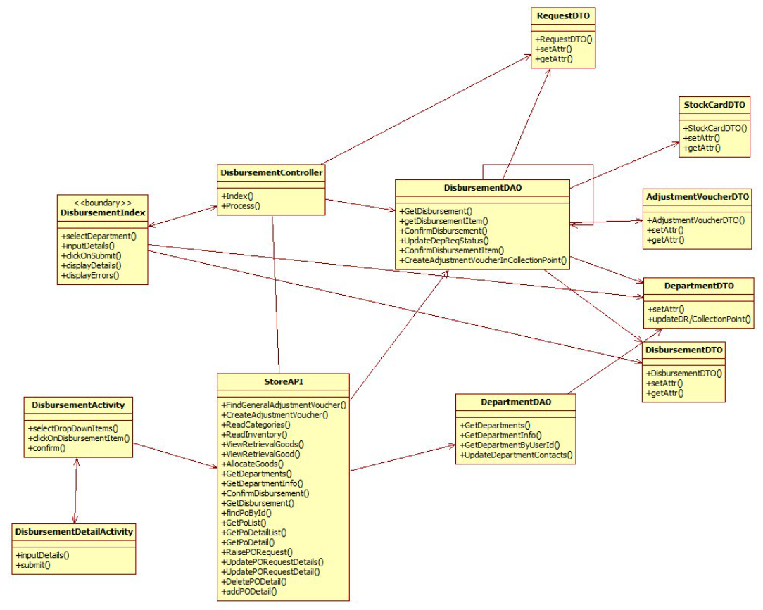

**Modify Supplier Information for Store**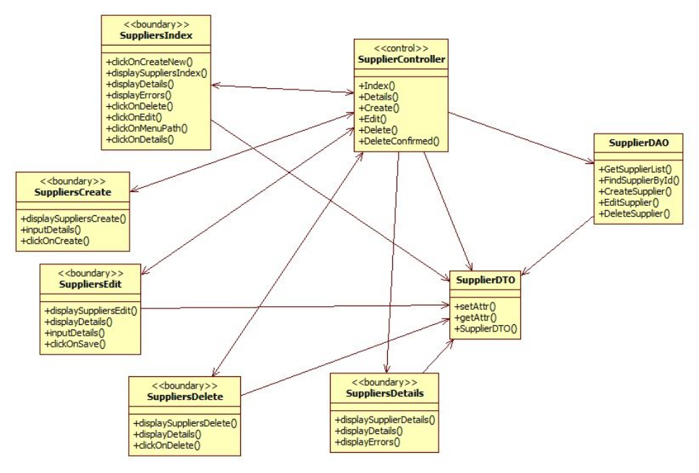

**View Stock Card for Store**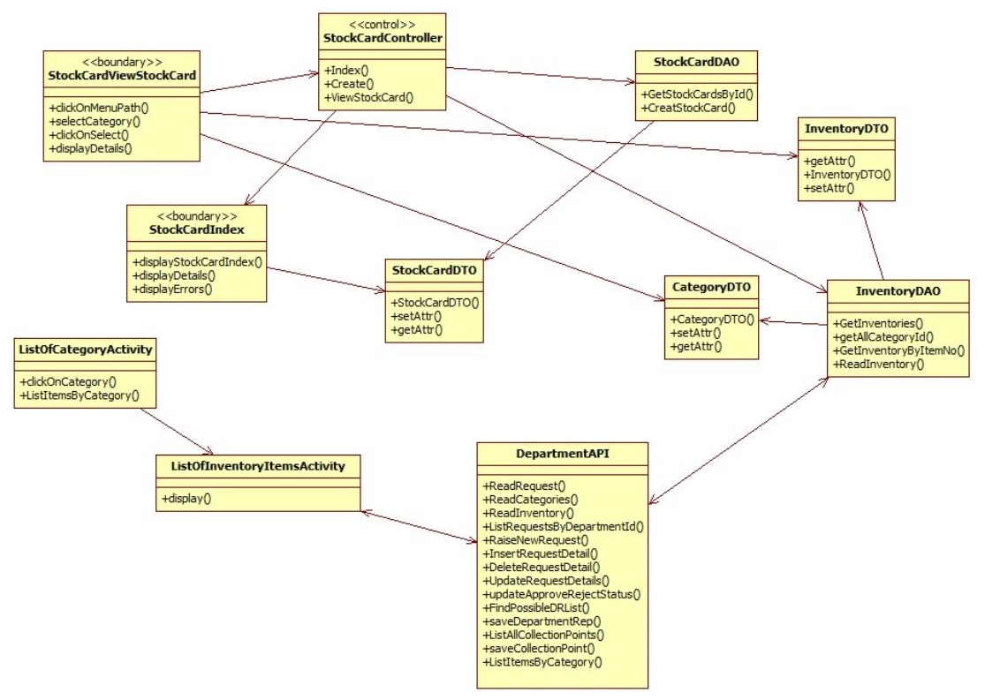

**Modify Stationery Catalogue for Store**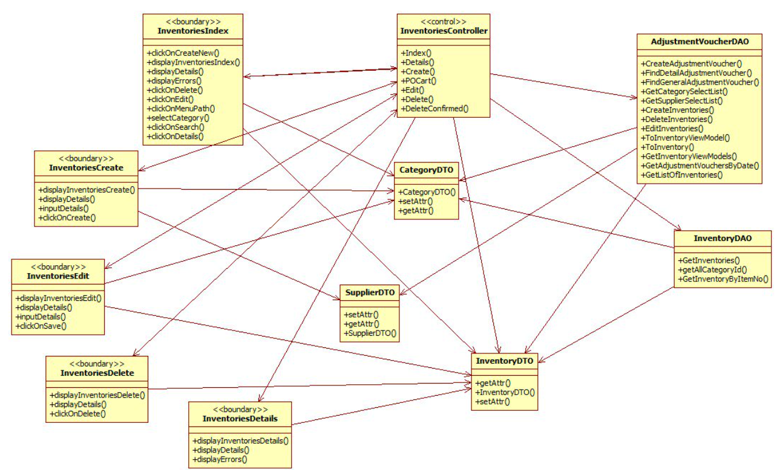

**Process Adjustment Voucher for Store**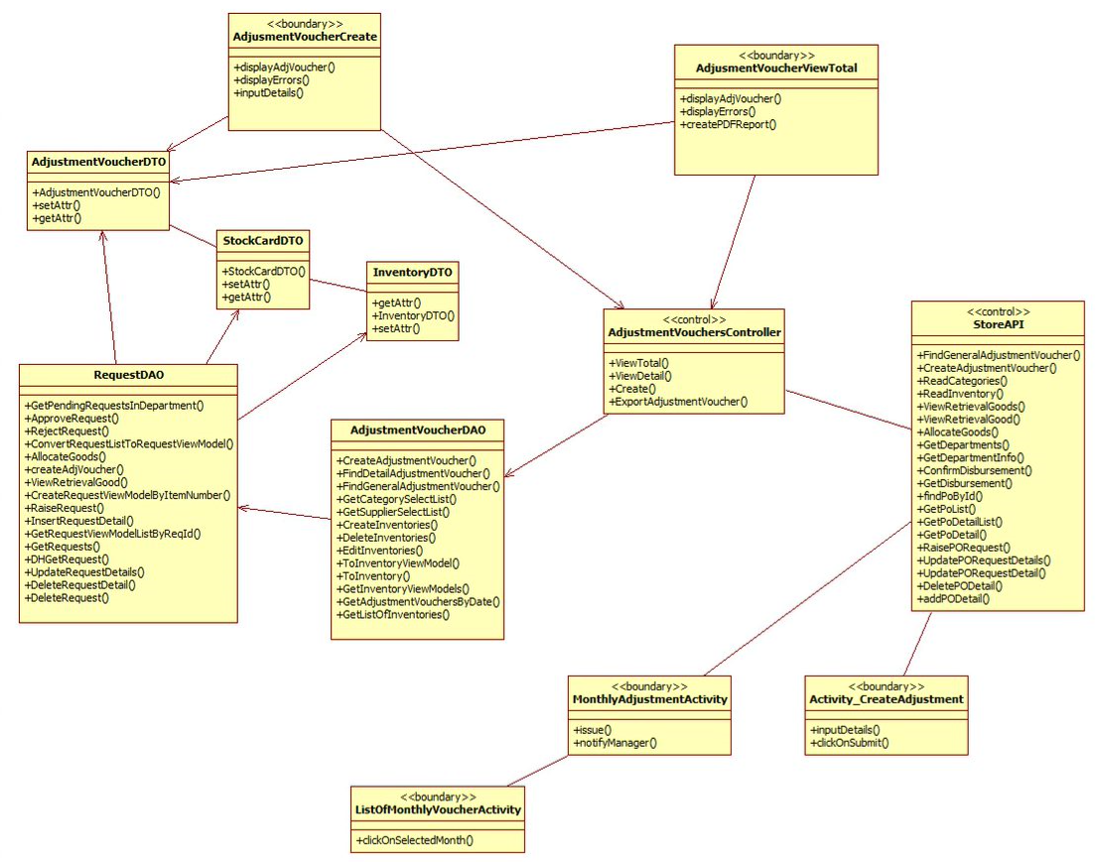

**Process Purchase Order for Store**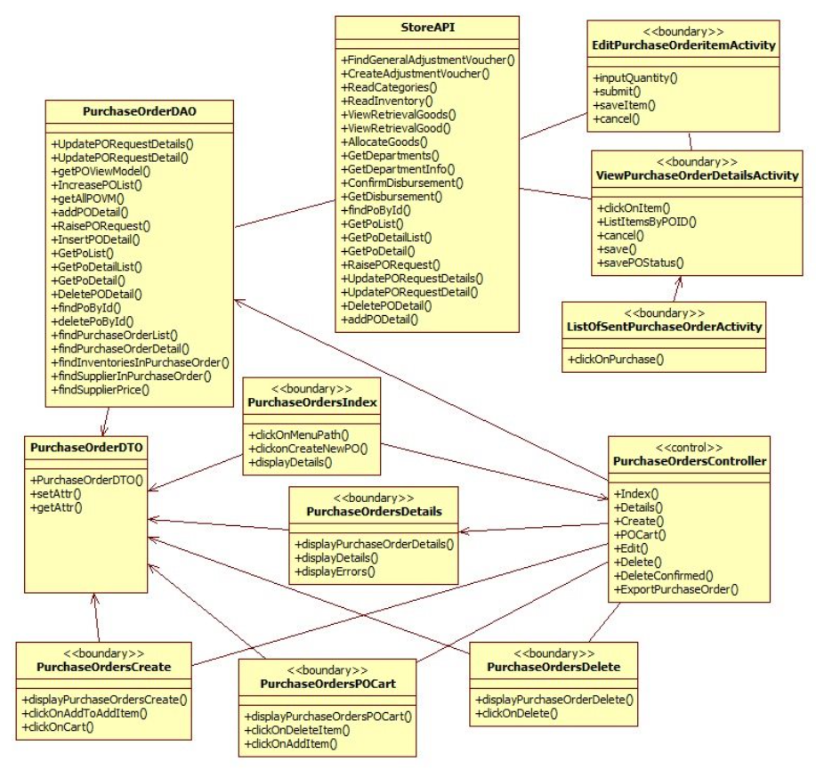

**8. Sequence Diagram**

## 8.1 Web Application for Department Sequence Diagram

**Modify Department Information**

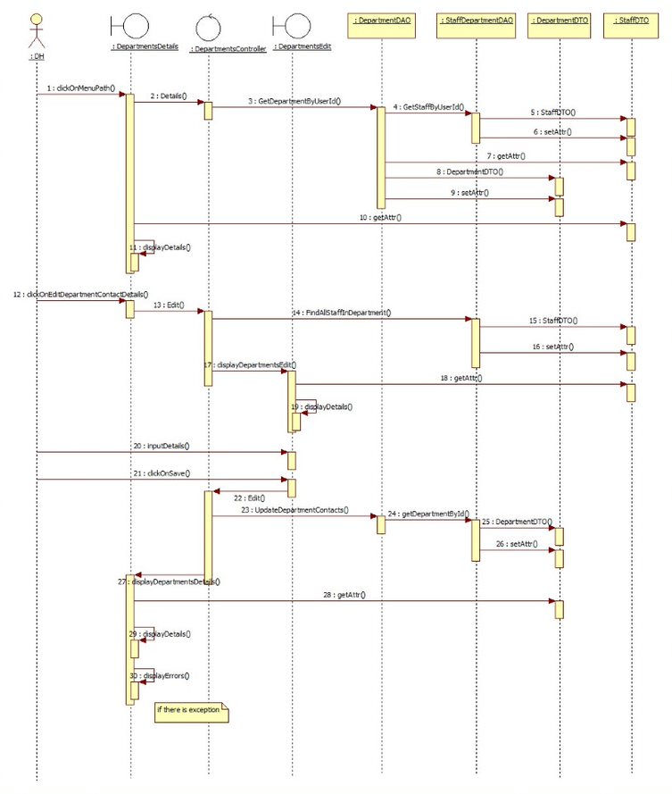

**Delegate DH Duties**

**1. Role Delegation**

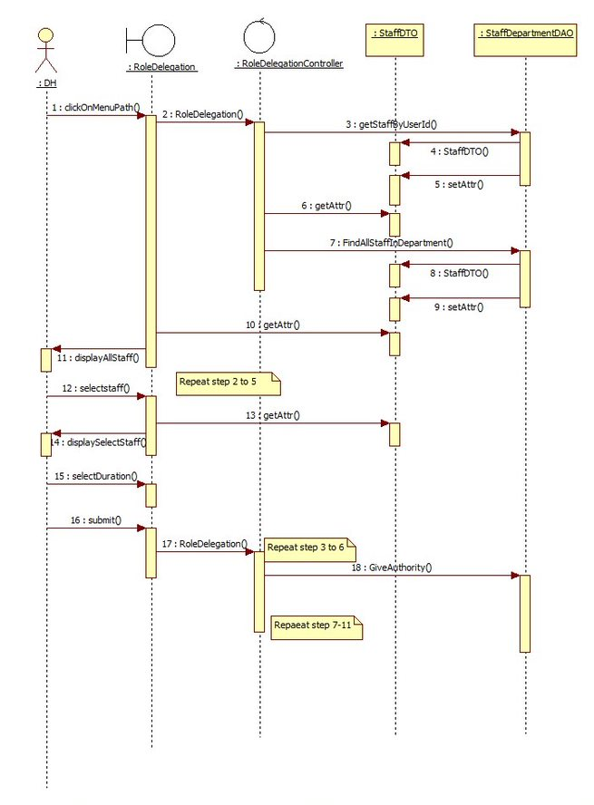

**2.Remove Delegation**

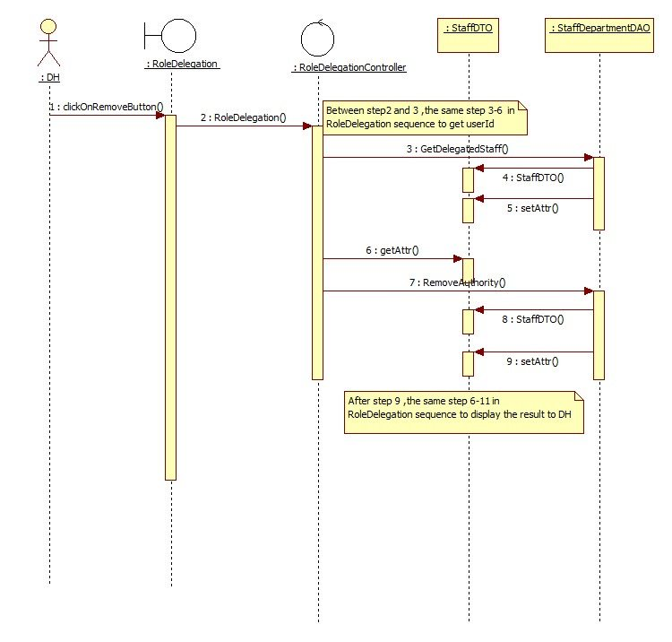

**Approve/Reject Request**

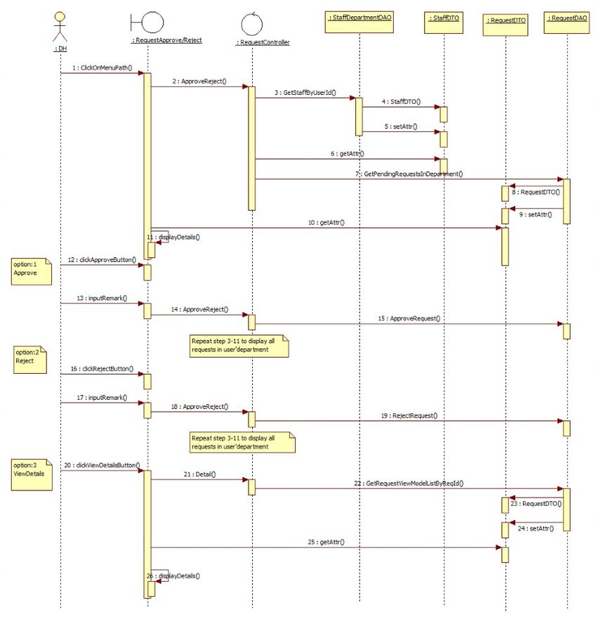

**Change DR/Collection Point**

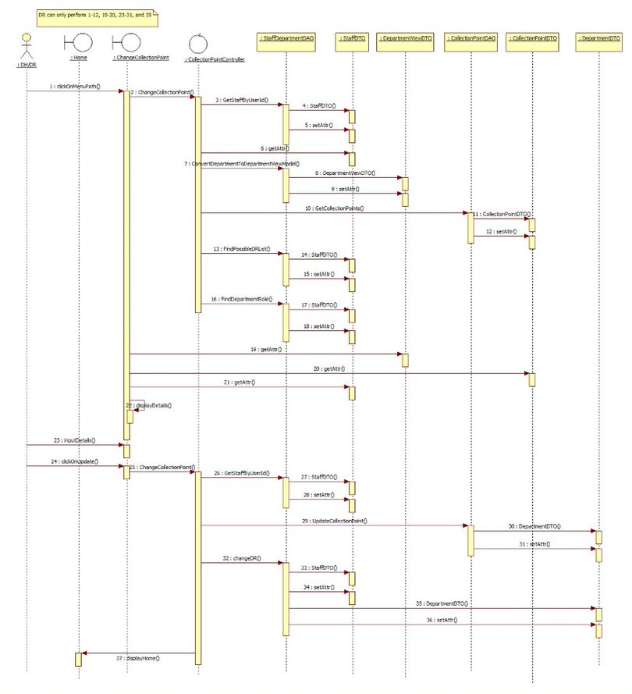

**View Dep Trend Analysis Report**

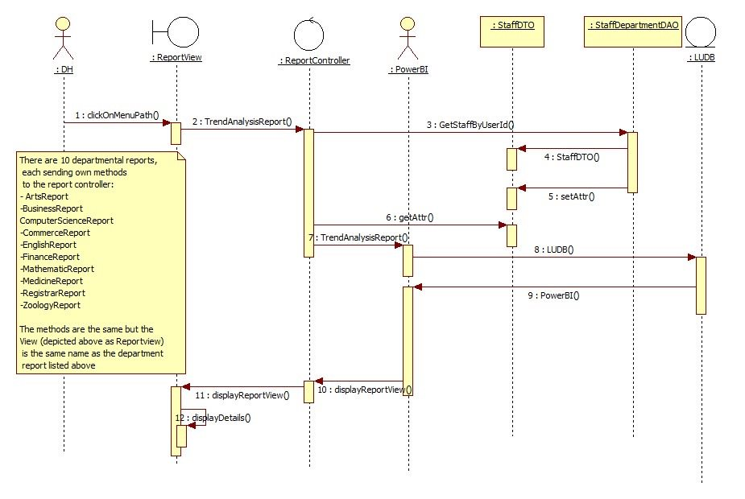

**View Stationery Catalogue**

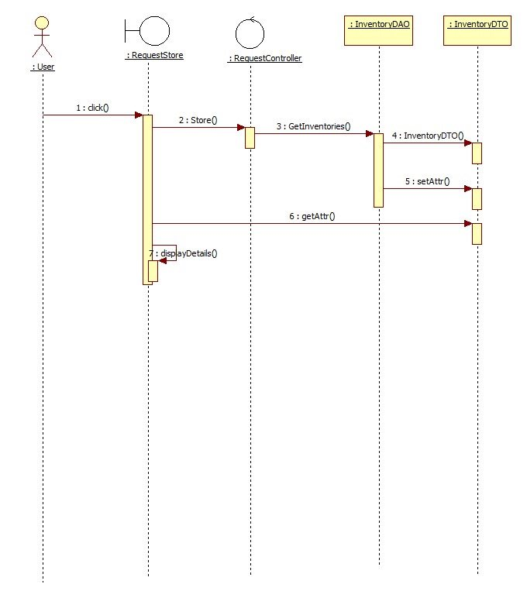

**Raise Request**

**1.Raise Request**

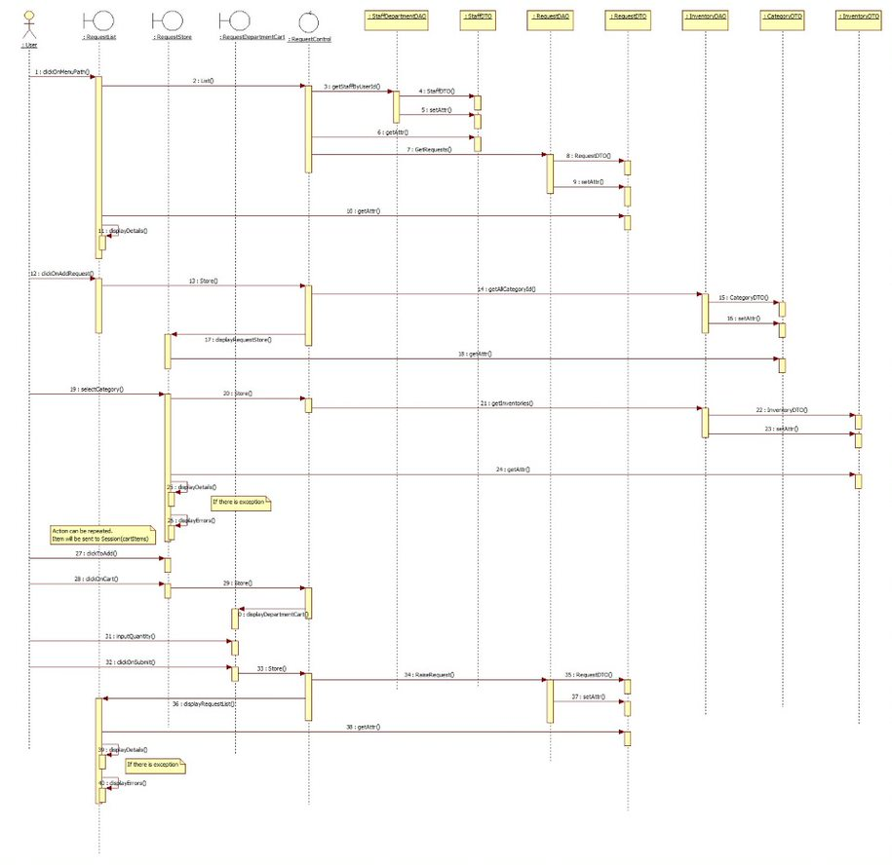

**2.Modify Pending Request**

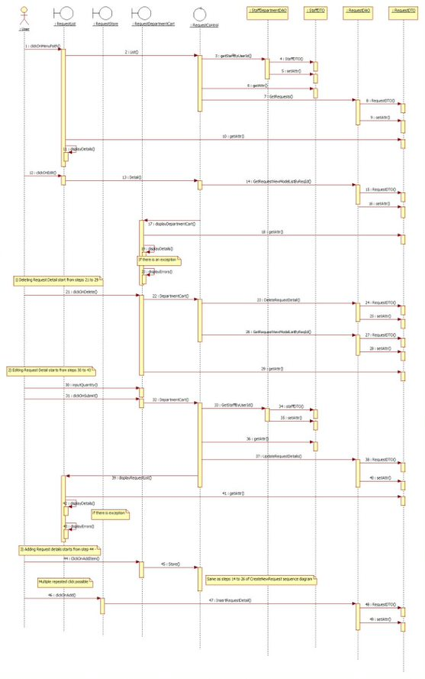

**3.Delete Request**

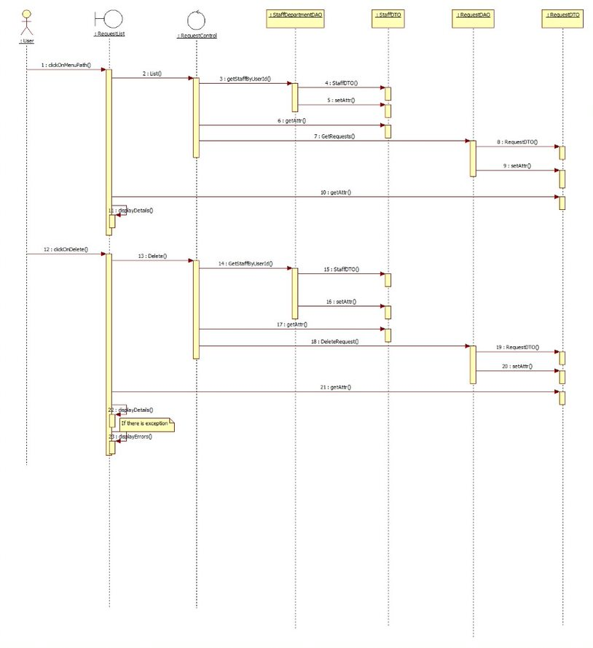

## 8.2 Mobile Application for Department Sequence Diagram

**Approve/Reject Request**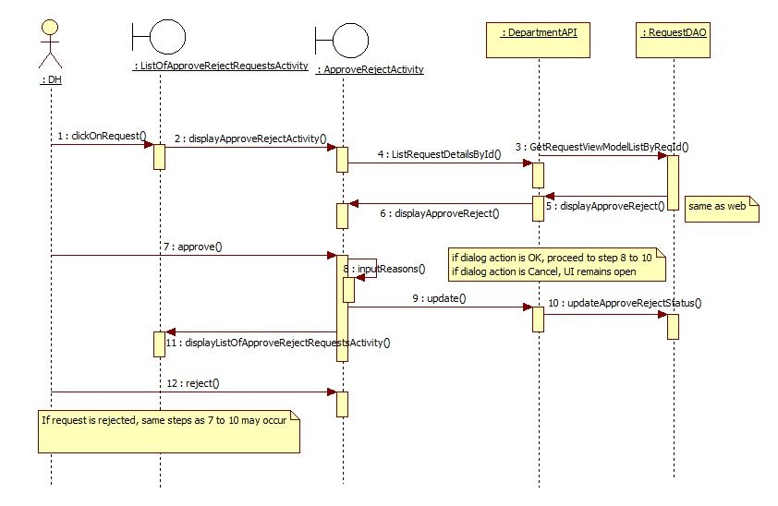

**Change DR/Collection Point**

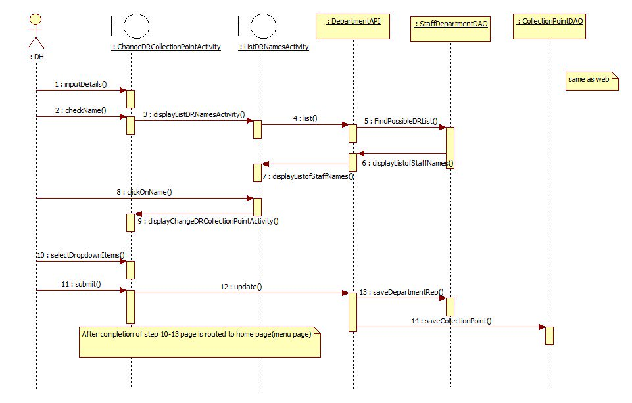

**Change Collection Point**

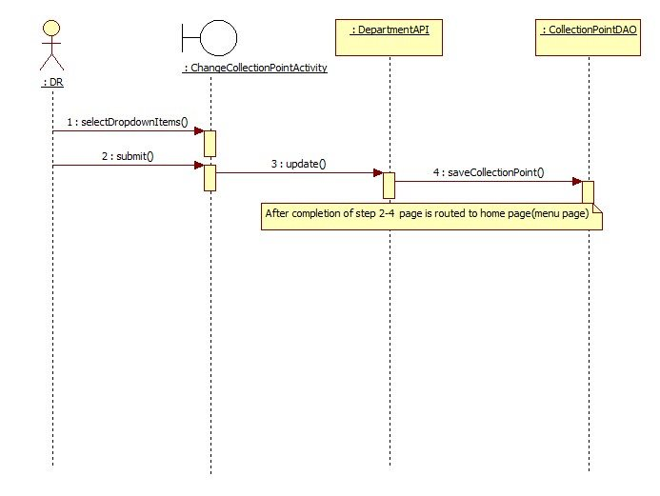

**Modify Pending Request**

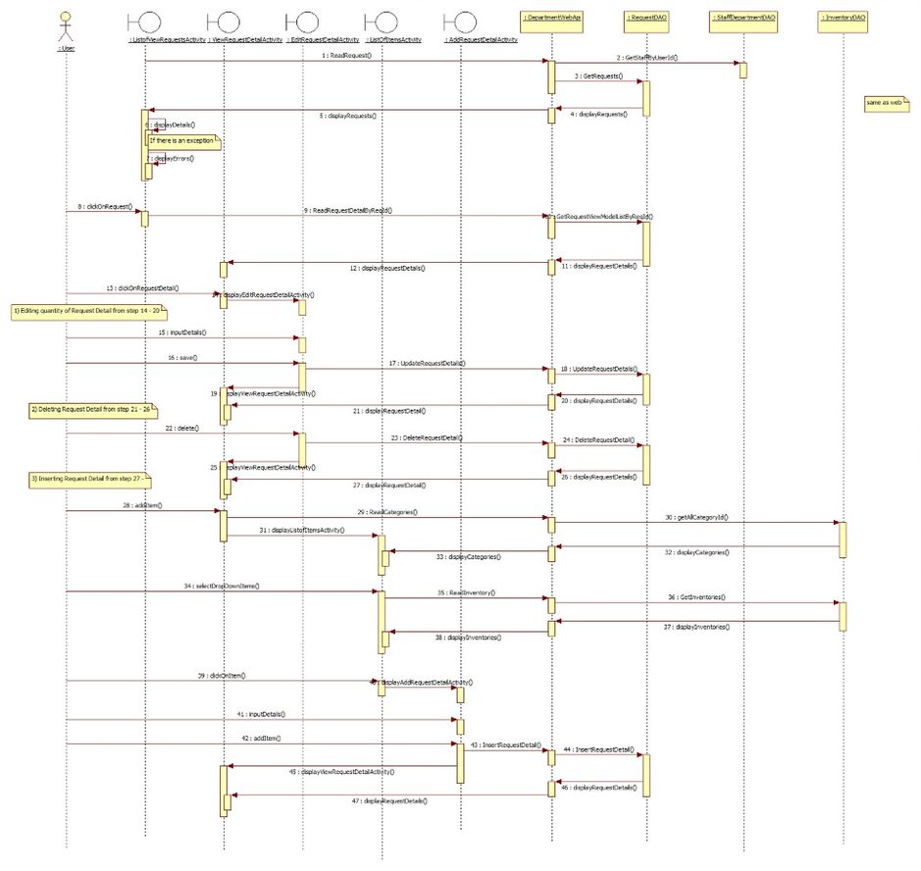

## 8.3 Web Application for Store Sequence Diagram

**Process Disbursement List**

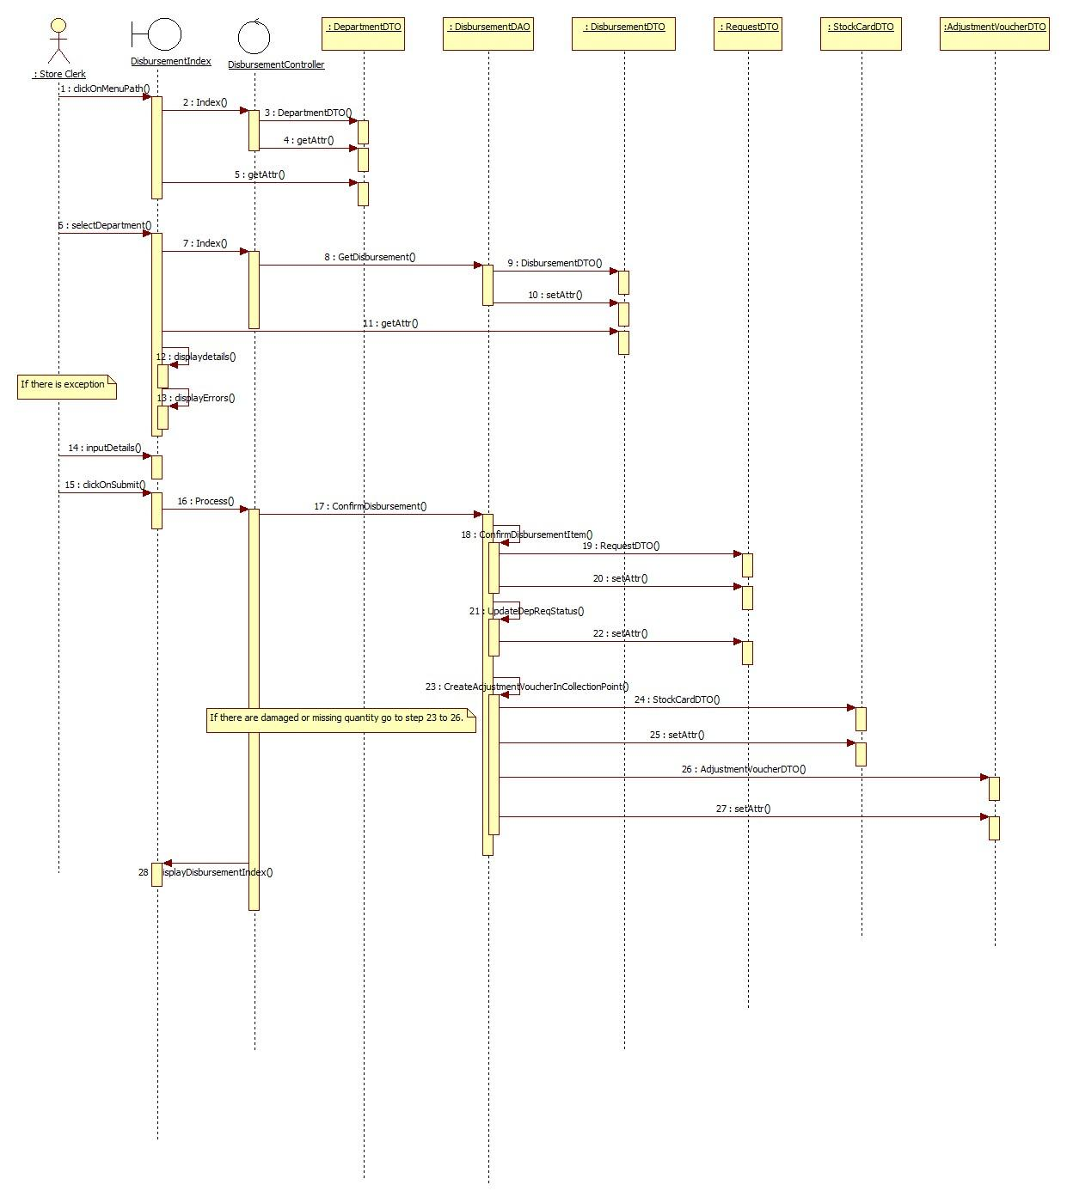

**Generate Charge-Back Report**

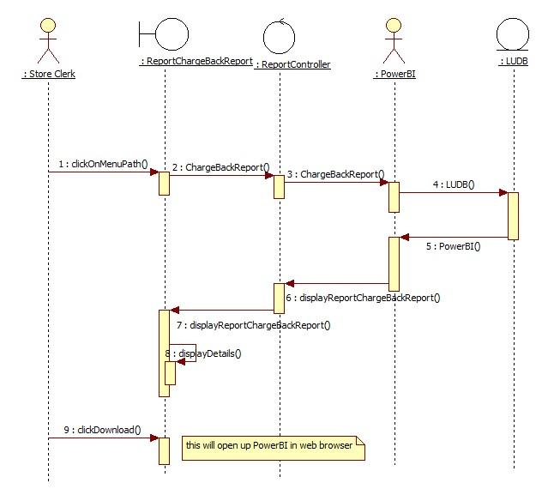

**Modify Stationery Catalogue**

**1. Create Inventory**

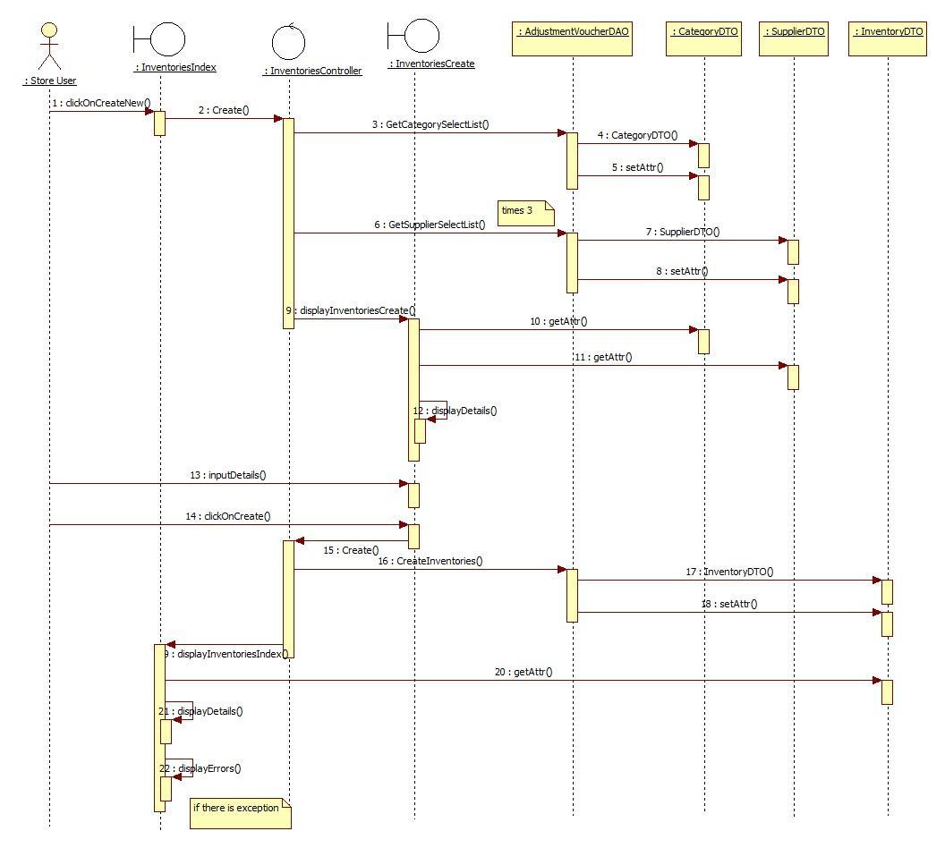

**2. View Inventories**

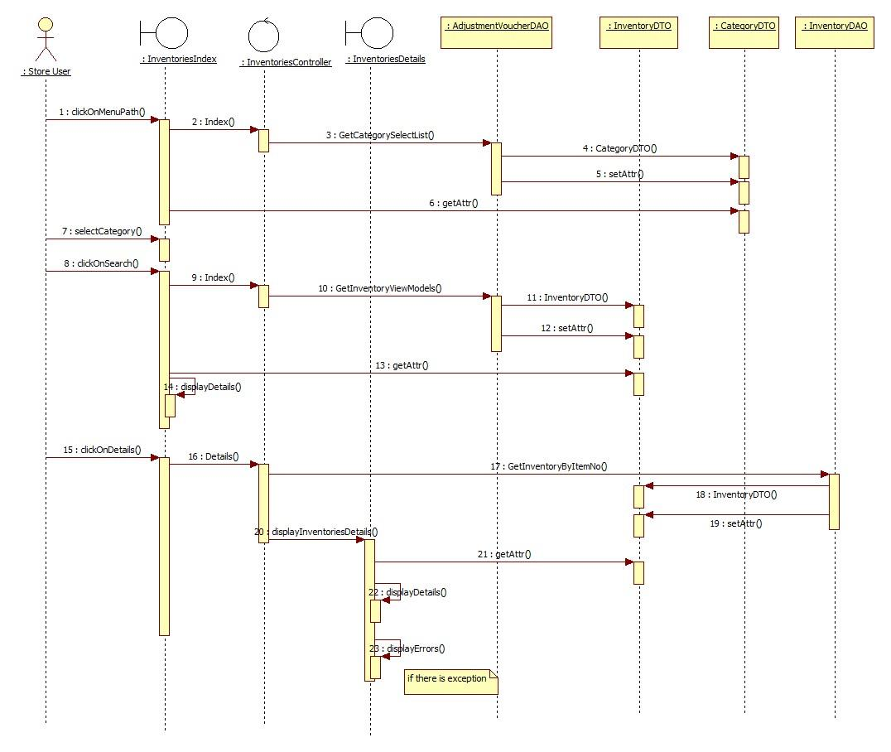

**3. Edit Inventories**

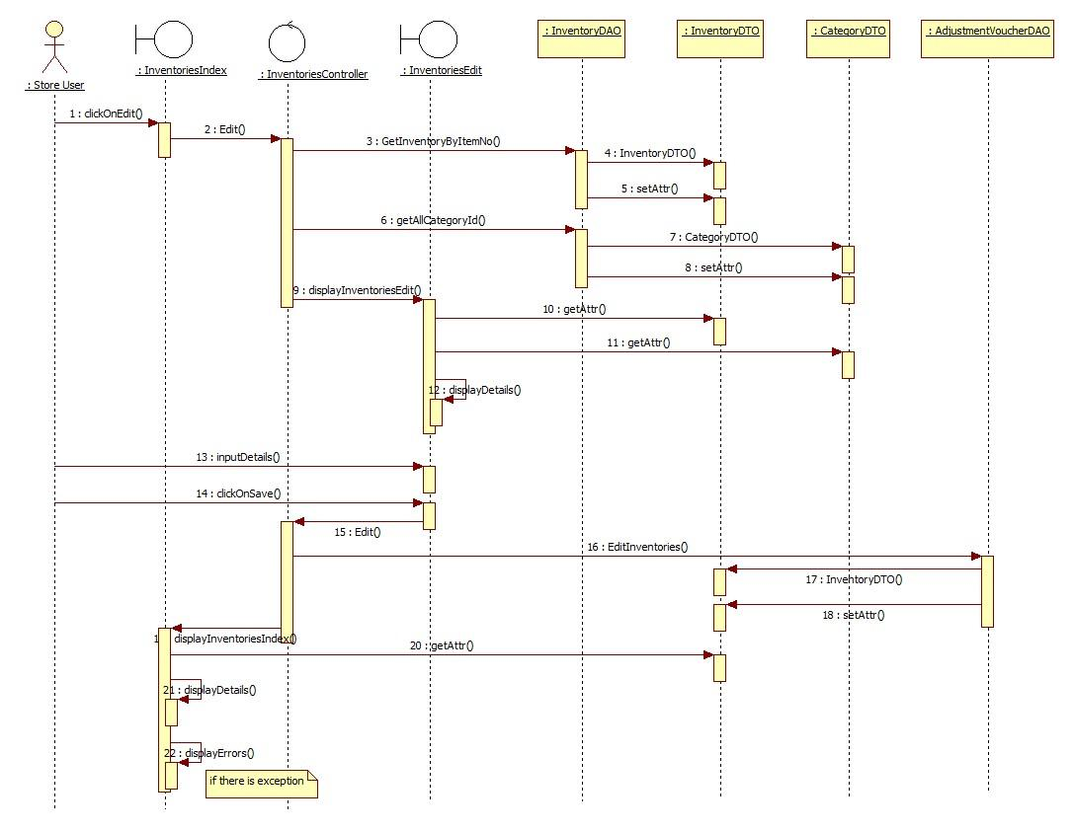

**Modify Supplier Information**

**1. Create Suppliers**

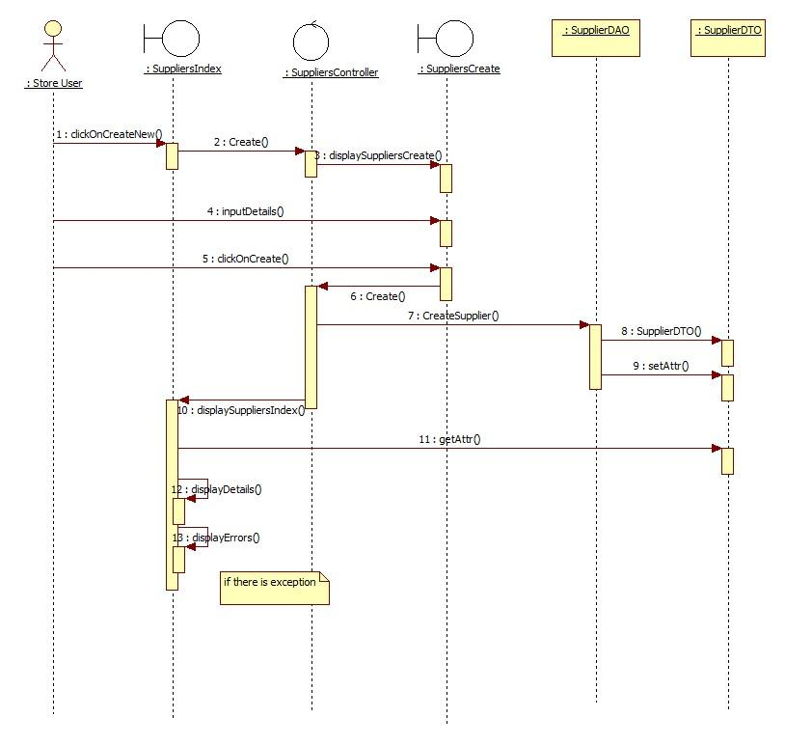

**2. View Suppliers**

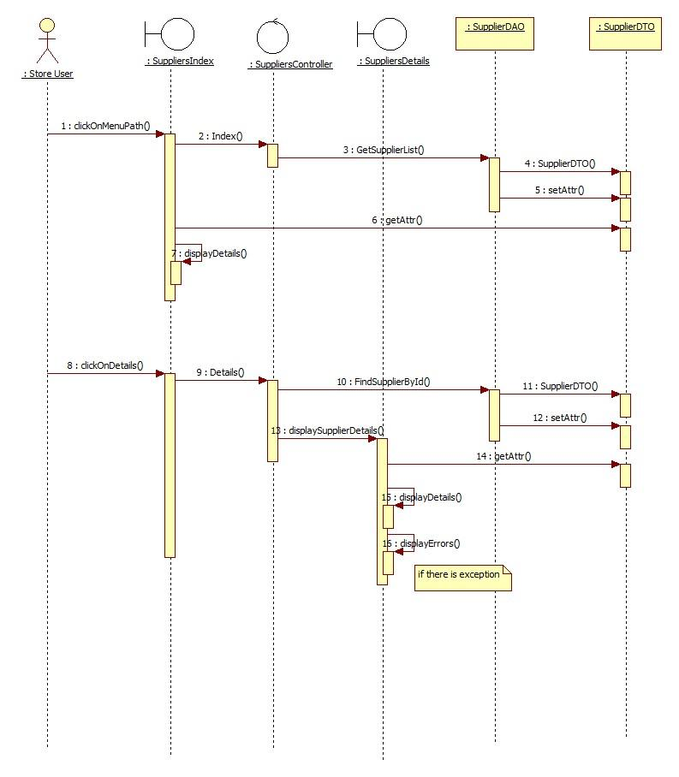

**3. Edit Suppliers**

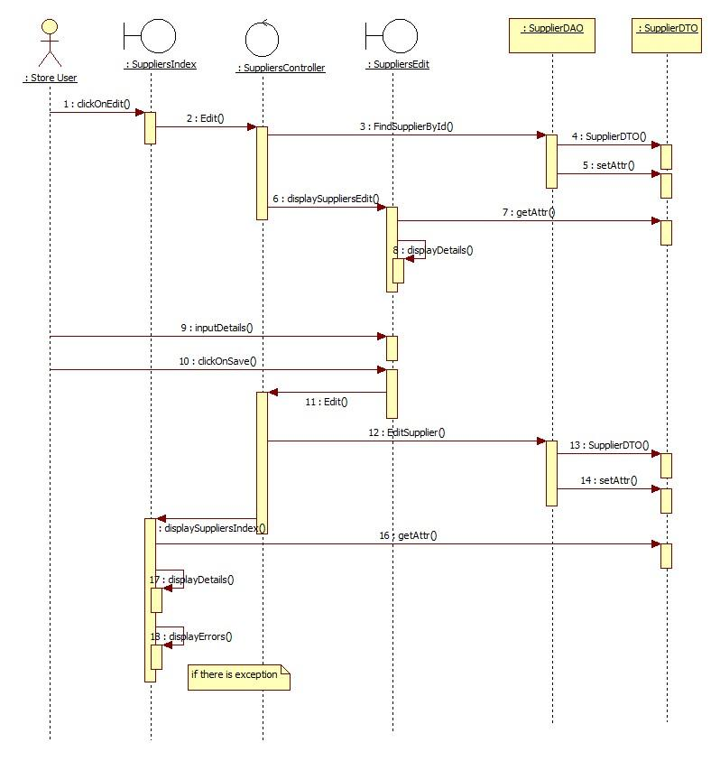

**Process Purchase Order**

**1. View Purchase Order details**

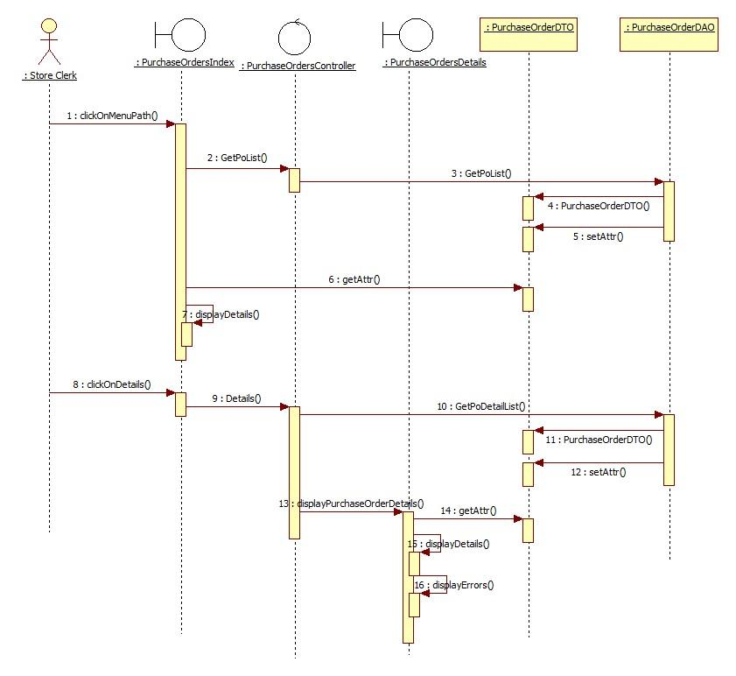

**2. Raise Purchase Order**

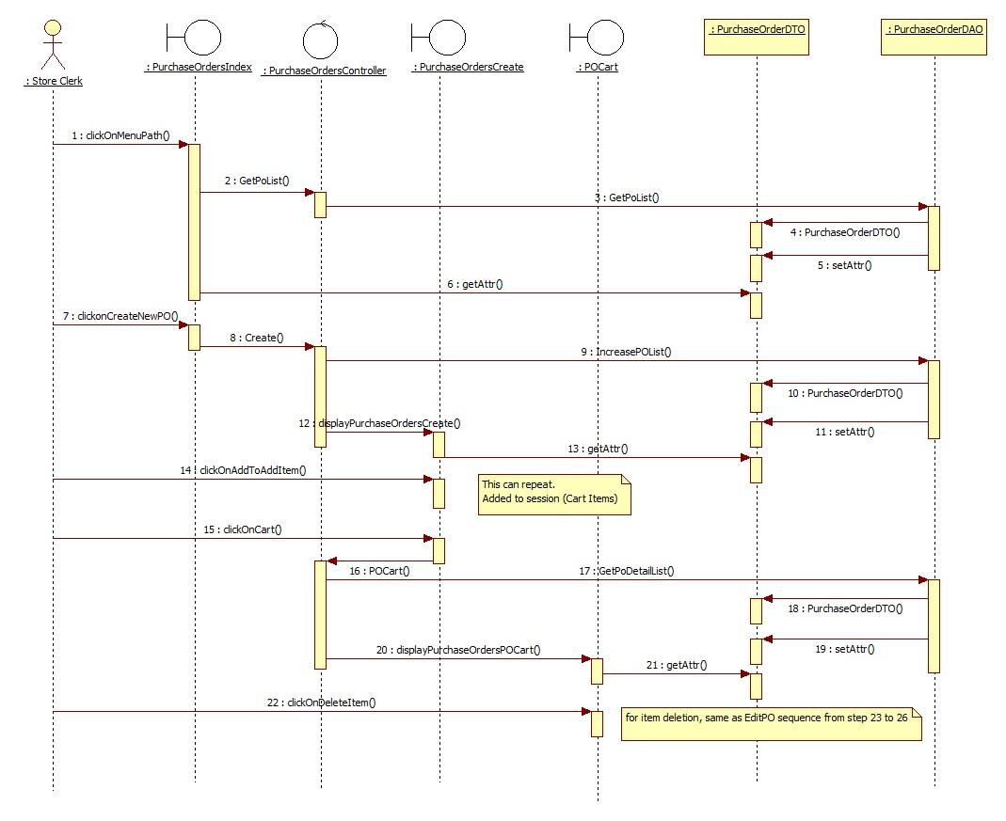

**3. Edit Purchase Order**

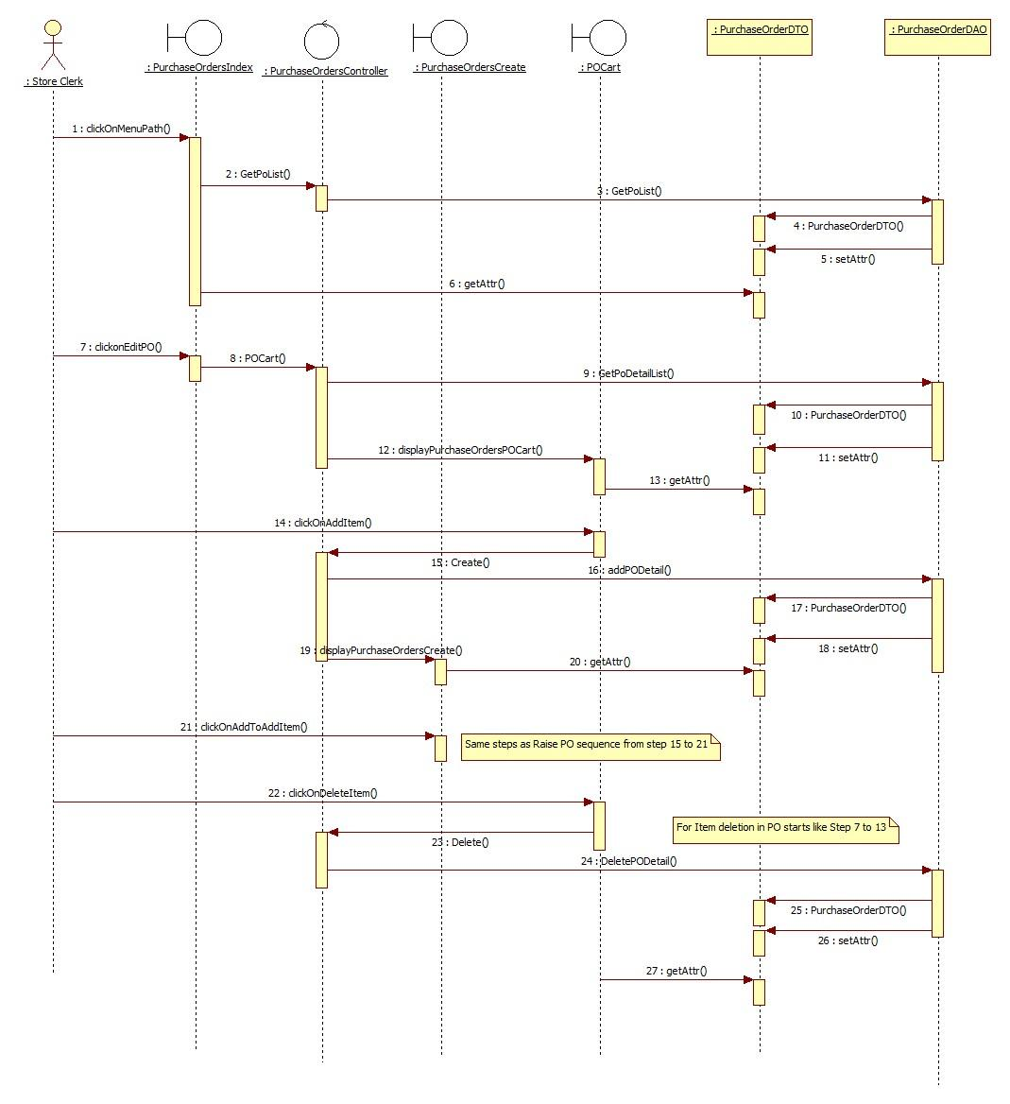

**4. Delete Purchase Order**

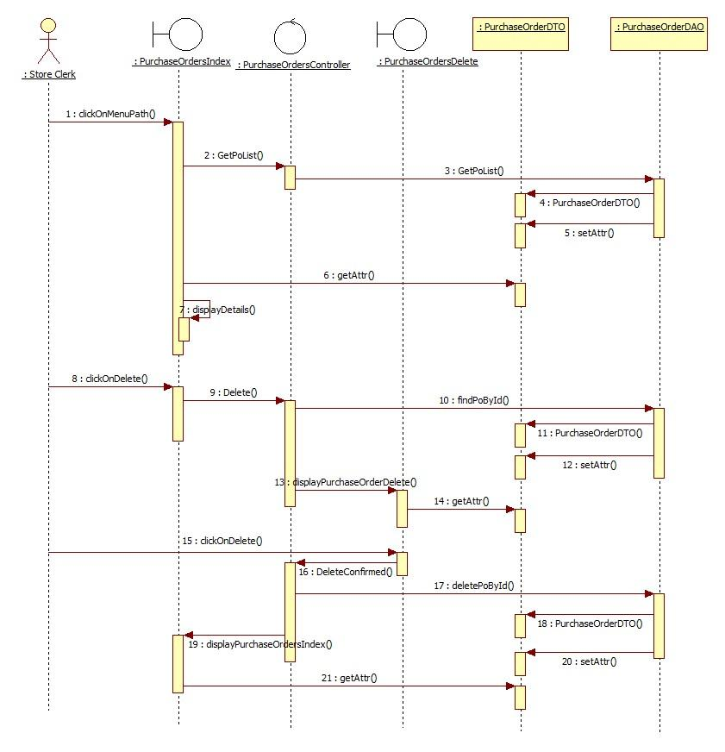

**5. View Purchase Order Report**

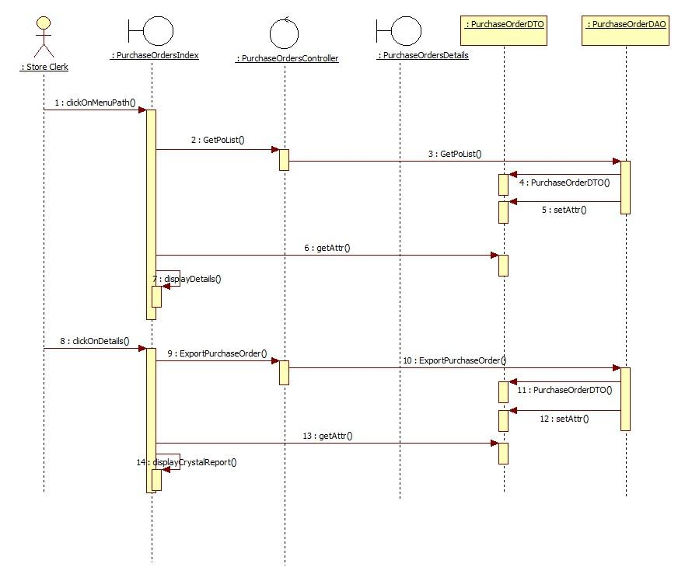

**View Reports**

**1. Generate Purchase Order Analysis**

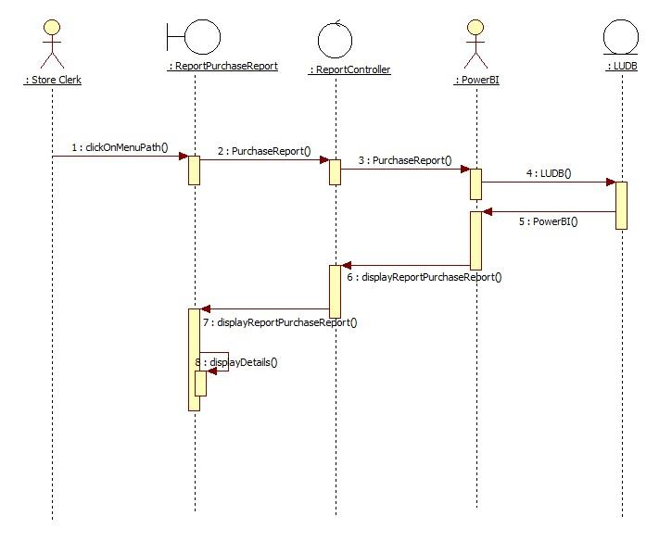

**2. Generate Trend Analysis**

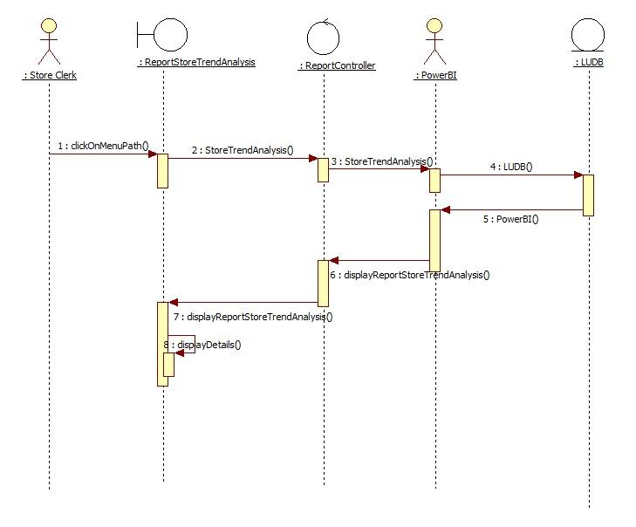

**Process Retrieval List**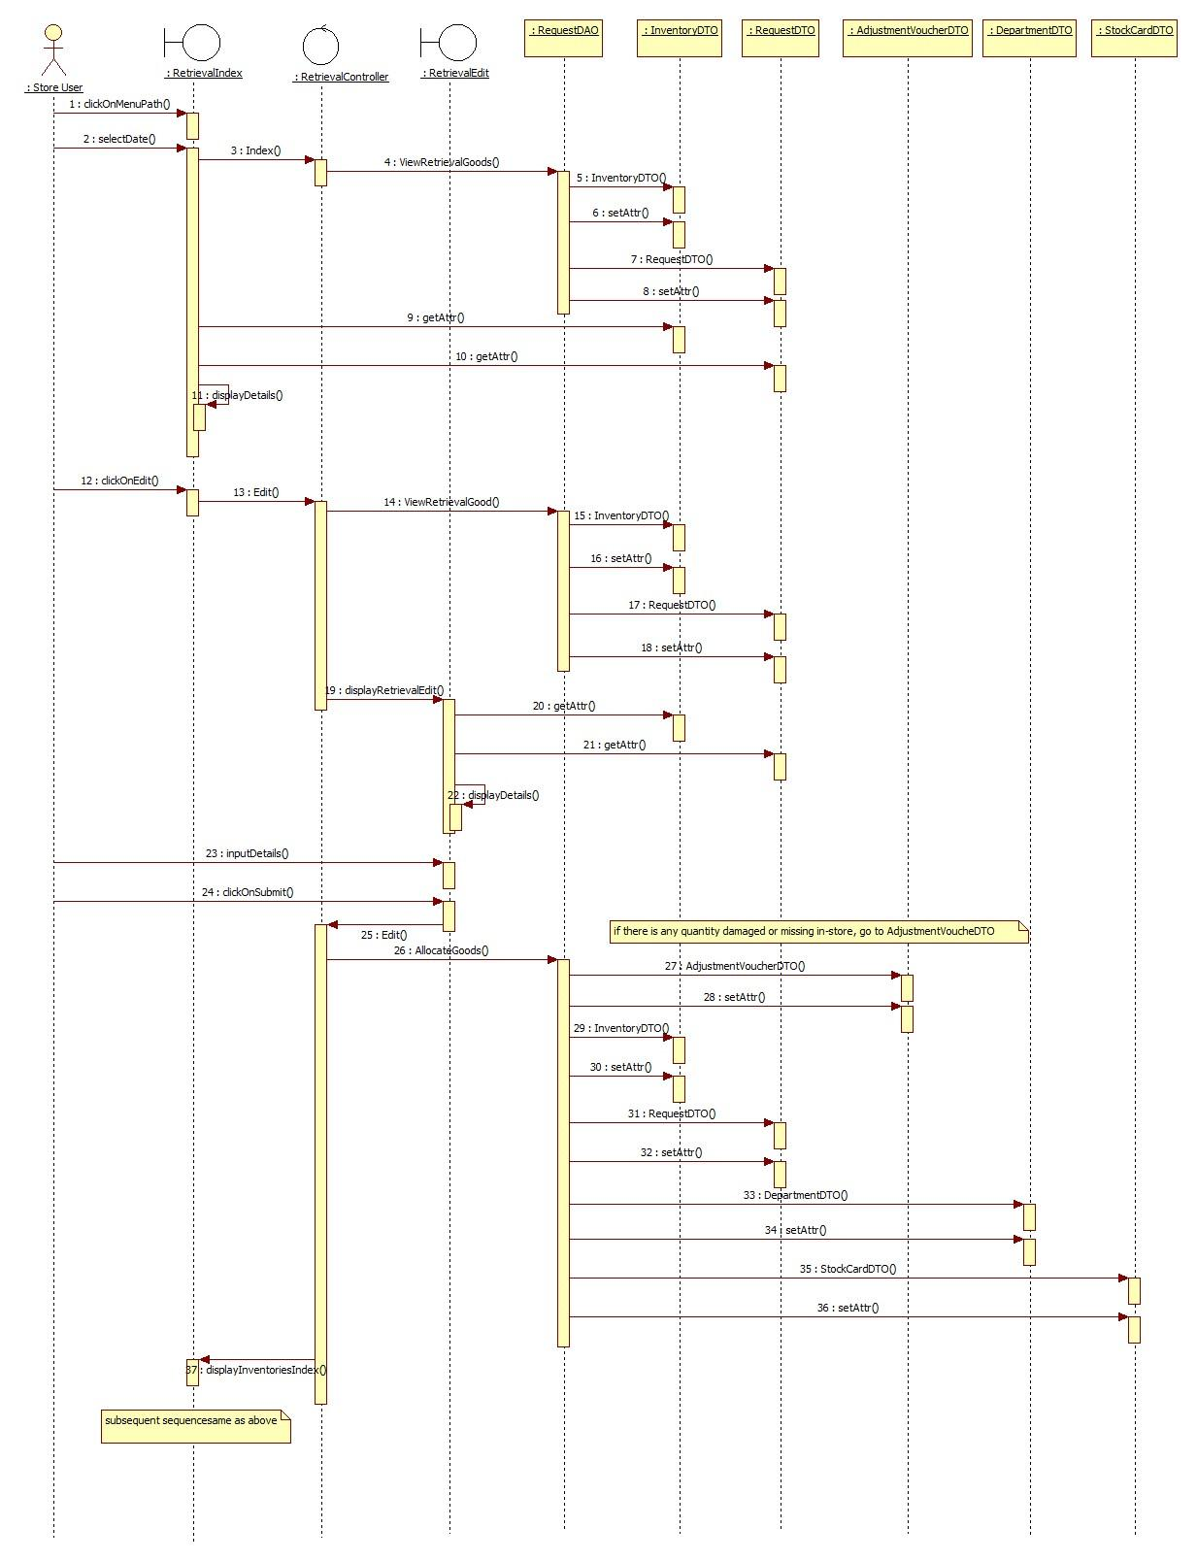

**Process Adjustment Report**

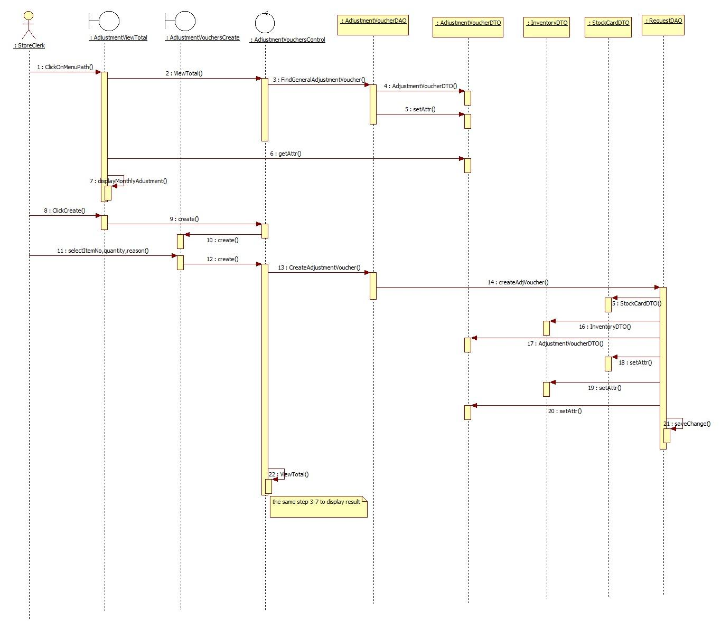

**Issue Adjustment Voucher Report**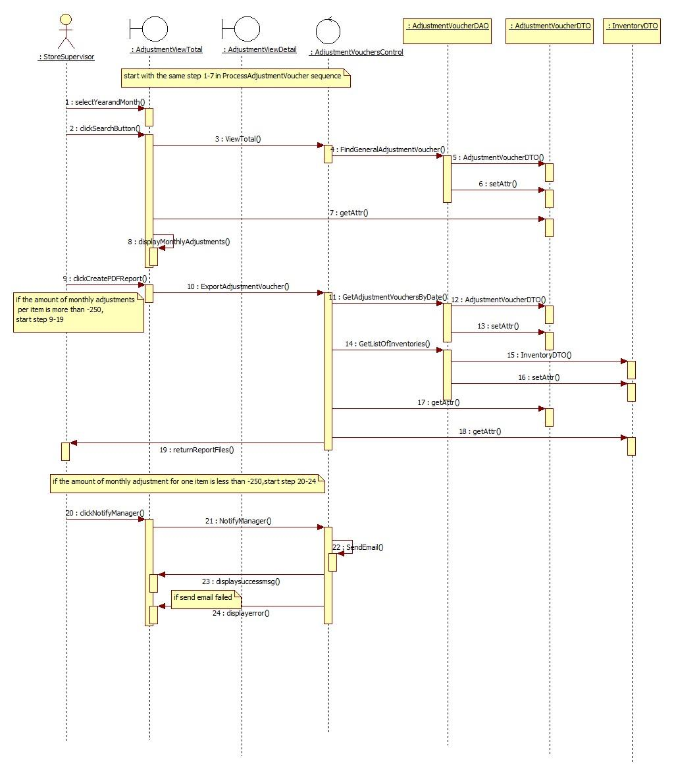

**View Stock Card**

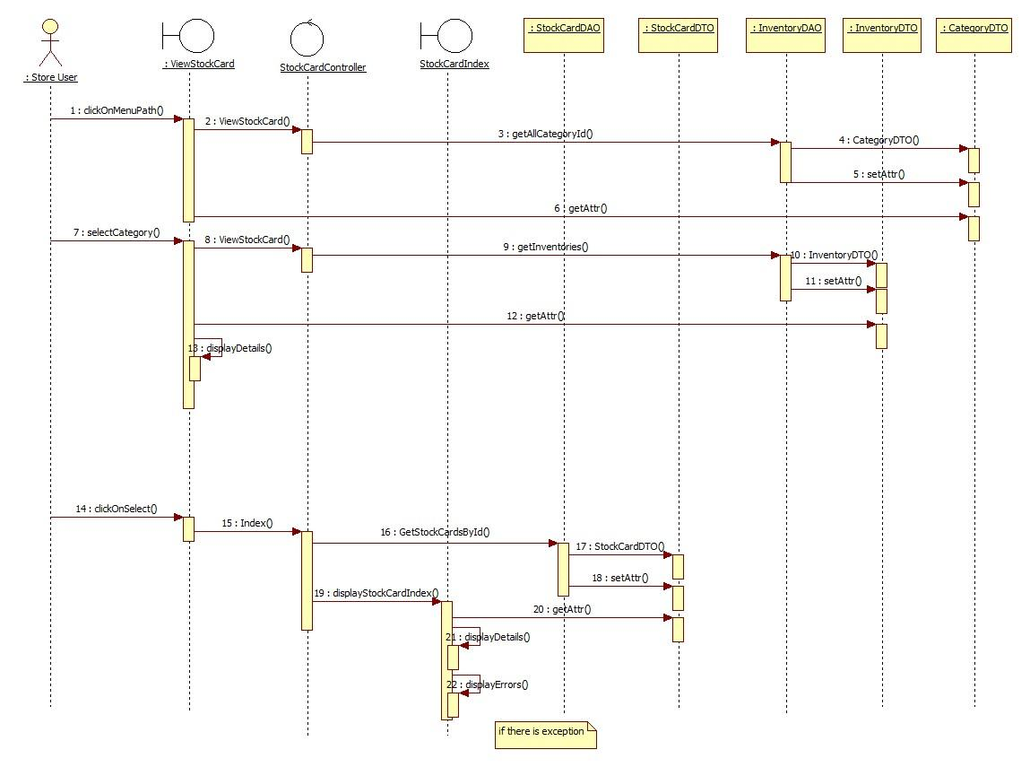

## 8.4 Mobile Application for Store Sequence Diagram

**View Stock Card**

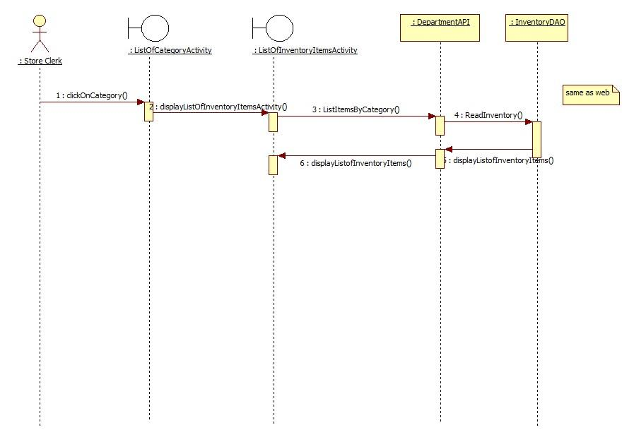

**Process Retrieval List**

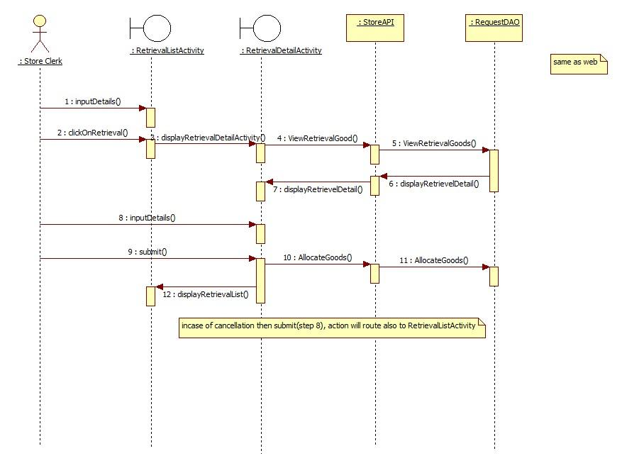

**Process Adjustment Voucher**

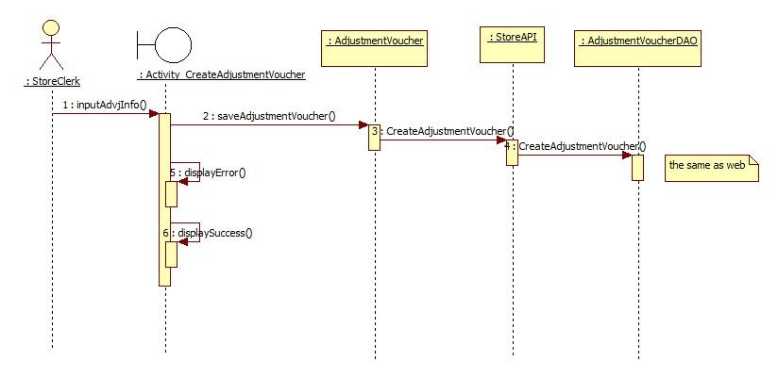

**Process Disbursement List**

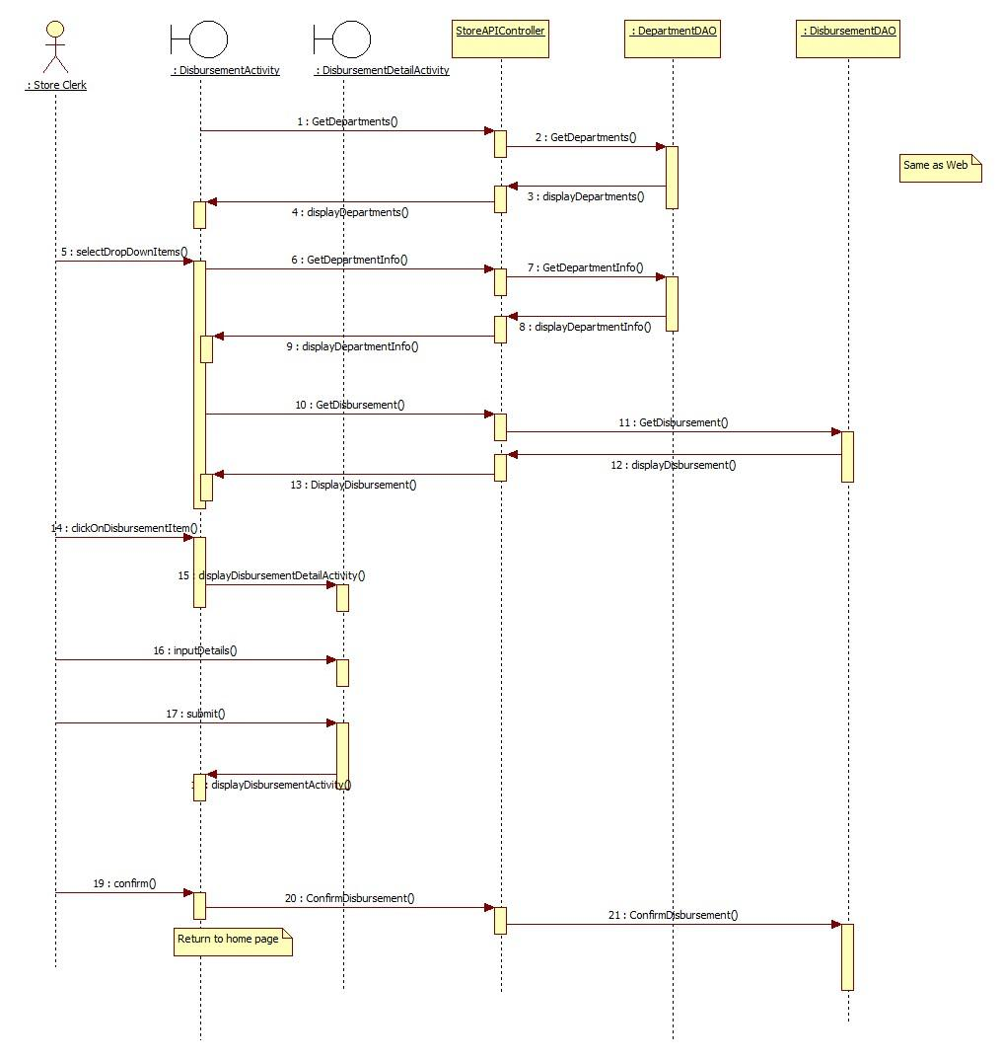

**Close Purchase Order upon supplier delivery**

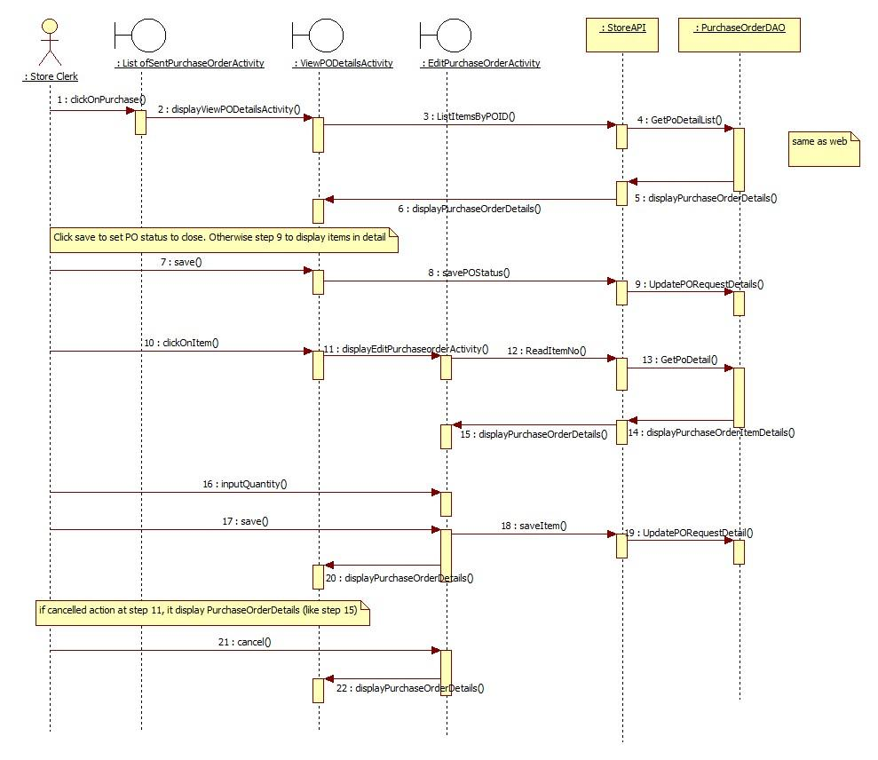

**9. Test Scripts**

| **Test Type: System** | | | | | |
| --- | --- | --- | --- | --- | --- |
| **TestID:1** | | **Prepare by/date: Madhumitha Murali, Aisha Ashiq/10th Feb,2019** | | **Tested by: Madhumitha Murali, Aisha Ashiq /date: 10/02/2019** | |
| **Test Description**    “Process Adjustment Voucher” for Store Clerk    To validate if the user is able to create a new record for the adjustment voucher in the database and view the details of the existing records through the Logic University Web application | | | | **Program tested**  Boundary Class:  AdjustmentViewTotal, AdustmentVouchersCreate, AdjustmentViewDetail  Control Class:  AdjustmentVouchersController  Enity Class:  AdjustmentVoucher, Inventory, StockCard, Request  DB Broker  LUDB | |
| **s/n** | **Test step** | | **Expected Result** | | **Actual Result** |
|  | **Step 1:**Login to the “Logic University Application” using the Store Clerk login    **Step 2:**Select the “Adjustment Voucher” link from the “Stock” dropdown menu          **Step 3:**Select any year from the “Year” dropdown field and click on “Search” button          **Step 4:**Select any year and month from the “Year” and “Month” dropdown fields and click on “Search” button    **Step 5:**Click on “Create New” button          **Step 6:**Select any category from the Category dropdown    **Step 7:**Select any item from the item dropdown list and enter the quantity and remark. Click on “Add Item” button | | Login should be successful without any error and home page for the store clerk should be displayed    Adjustment voucher home page should be displayed with the table displaying the existing adjustment voucher details and the following dropdown fields: Year: Month:      Table should be refreshed with the details as per the selected year and for all months with the rows highlighted, if the “Total Amount” is greater than $250      Table should be refreshed with the details as per the selected year and month with the rows highlighted, if the “Total Amount” is greater than $250    Create Adjustment Voucher page should be displayed with the following fields:  Category: Item Name: Quantity: Date: Remark: Add Item    “Item Name” dropdown should be populated as per the selected category    Details should be added successfully in the adjustment voucher table and should be reflected in the details displayed without any errors | | Login was successful without any error and home page for store clerk was displayed    Adjustment voucher home page was displayed with the table displaying the existing adjustment voucher details and the following dropdown fields: Year: Month:      Table was refreshed with the details as per the selected year and for all months with the rows highlighted, if the “Total Amount” is greater than $250      Table was refreshed with the details as per the selected year and month with the rows highlighted, if the “Total Amount” is greater than $250  Create Adjustment Voucher page was displayed with the following fields:  Category: Item Name: Quantity: Date: Remark: Add Item    “Item Name” dropdown was populated as per the selected category    Details was added successfully in the adjustment voucher table and was reflected in the details displayed without any errors |

| **Test Type: System** | | | | | |
| --- | --- | --- | --- | --- | --- |
| **TestID:2** | | **Prepare by/date: Madhumitha Murali,Aisha Ashiq/10th Feb,2019** | | **Tested by:/date: Madhumitha Murali, Aisha Ashiq /date: 10/02/2019** | |
| **Test Description**    “Raise Request” for Department Staff    To validate if the user is able to raise new stationery request and modify existing stationery request through the Logic University Web application | | | | **Program tested**  Boundary Class:  RequestList, RequestStore, RequestDepartmentCart  Control Class:  RequestController  Enity Class:  Department, Staff, Inventory, Category, Request  DB Broker  LUDB | |
| **s/n** | **Test step** | | **Expected Result** | | **Actual Result** |
|  | **Step 1:**Login to the “Logic University Application” using the Department Staff login      **Step 2:**Add New Request: Select the “Request List” link from the “Catalogue” dropdown menu    **Step 3:**Click on “Add Request” button          **Step 4:**Select any category from the Category dropdown    **Step 5:**Click on “+” button (Add to Cart) to add the required items to the cart      **Step 6:**Click on “Cart” button to view the items in the cart    **Step 7:**Click on “-” button to delete any item from the cart    **Step 8:**Click on “Submit” button to submit the request for Department Head’s approval        **Step 9:**Modify existing Request: Login and Select “Request List” link from the “Catalogue” dropdown menu    **Step 10:**Click “Edit” link on any “Pending” requests    **Step 11:**Click on “Add item” or “-” button to add or delete the items for the selected request    **Step 12:**Click “Submit” button to update the request      **Step 13:**Click “Delete” link on any “Pending” requests | | Login should be successful without any error and home page for the department staff should be displayed      Request List home page should be displayed with the existing request details      Page should be navigated to the “Items” page displaying all the items in the catalogue from where it can be added to the cart      Catalogue items should be refreshed based on the selected category    Items should be added to the cart when the “+” button is clicked and the “Cart” icon should display the number of items in the cart    “Cart” page should be displayed with the details of the items added    Items should be deleted from the cart successfully without any error    Request should be submitted for approval and new record should be created in the database with status as “Pending” and the same should be displayed in the “Request List” landing page    Request List home page should be displayed with the existing request details and with the following links for the “Pending” requests: Edit Details Delete    “Cart” page of the selected Request Id should be displayed with the item details    Items should be added or deleted in the cart page as per the user’s selection      Request list should be updated in the database and submitted for approval and Request List home page should be displayed    Request should be deleted from the database and Request List page should be refreshed | | Login was successful without any error and home page for the department staff was displayed      Request List home page was displayed with the existing request details      Page navigates to the “Items” page displaying all the items in the catalogue from where it can be added to the cart      Catalogue items was refreshed based on the selected category    Items were added to the cart when the “+” button is clicked and the “Cart” icon displays the number of items in the cart    “Cart” page was displayed with the details of the items added    Items were deleted from the cart successfully without any error    Request was submitted for approval and new record was created in the database with status as “Pending” and the same was displayed in the “Request List” landing page  Request List home page was displayed with the existing request details and with the following links for the “Pending” requests: Edit Details Delete  “Cart” page of the selected Request Id was displayed with the item details    Items were added or deleted in the cart page as per the user’s selection      Request list was updated in the database and submitted for approval and Request List home page was displayed    Request was deleted from the database and Request List page was refreshed |

| **Test Type: System** | | | | | |
| --- | --- | --- | --- | --- | --- |
| **TestID:3** | | **Prepare by/date: Madhumitha Murali,Aisha Ashiq/10th Feb,2019** | | **Tested by:/date: Madhumitha Murali, Aisha Ashiq /date: 10/02/2019** | |
| **Test Description**    “Change DR/Collection Point” for Department Head    To validate if the user is able to change the department representative or the department collection point through the Logic University Android application | | | | **Program tested**  Boundary Class:  Home, ChangeCollectionPoint  Control Class:  CollectionPointController  Enity Class:  Department, Staff, CollectionPoint  DB Broker  LUDB | |
| **s/n** | **Test step** | | **Expected Result** | | **Actual Result** |
|  | **Step 1:**Login to the “Logic University Application” using the Department Head login      **Step 2:**Click on "Change of Rep/collection Point" from the list        **Step 3:**Click on "Check Names" button      **Step 4:**Select any employee name        **Step 5:**Enter text in the "Select Employee" input field and click on "Check Names" button    **Step 6:**Select any employee name        **Step 7:**Select any option from the "Collection Point" dropdown list    **Step 7:**Click on "Submit" | | Login should be successful without any error and home page for the department head should be displayed      Change of Rep/collection Point screen should be displayed showing the current department rep and collection point      Page should be navigated to the ListDRNames page which displays all the employee names available    Control goes back to the previous page with the selected employee name populated in the "Select Employee" text field    Page should be navigated to the ListDRNames page which displays the employee names starting with the entered text    Control goes back to the previous page with the selected employee name populated in the "Select Employee" text field    Collection Point should be selected from the dropdown list    Selected department rep and collection point should be saved and navigates to the home page | | Login was successful without any error and home page for the department head was displayed      Change of Rep/collection Point screen was displayed showing the current department rep and collection point      Page was navigated to the ListDRNames page which displays all the employee names available  Control goes back to the previous page with the selected employee name populated in the "Select Employee" text field    Page navigates to the ListDRNames page which displays the employee names starting with the entered text    Control goes back to the previous page with the selected employee name populated in the "Select Employee" text field    Collection Point was selected from the dropdown list    Selected department rep and collection point was saved and navigates to the home page |

**10. Wire Frames and UI Specifications**

## 10.1 Department web User interface

Approve/Reject Requests

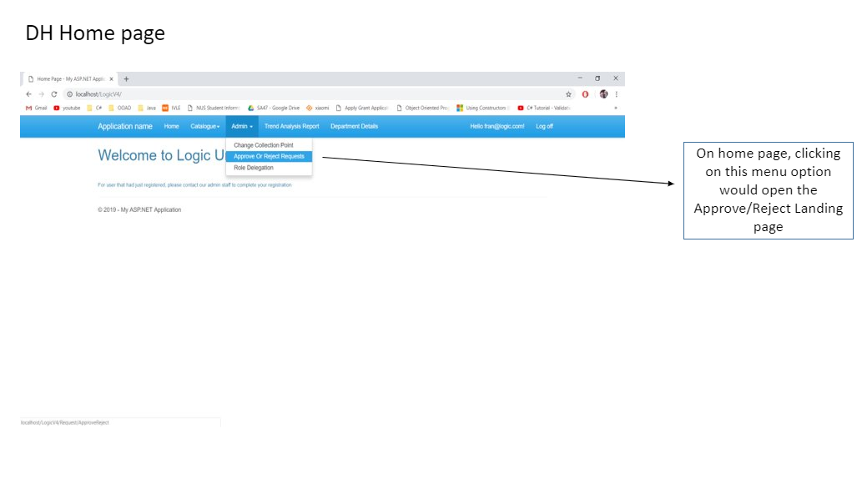

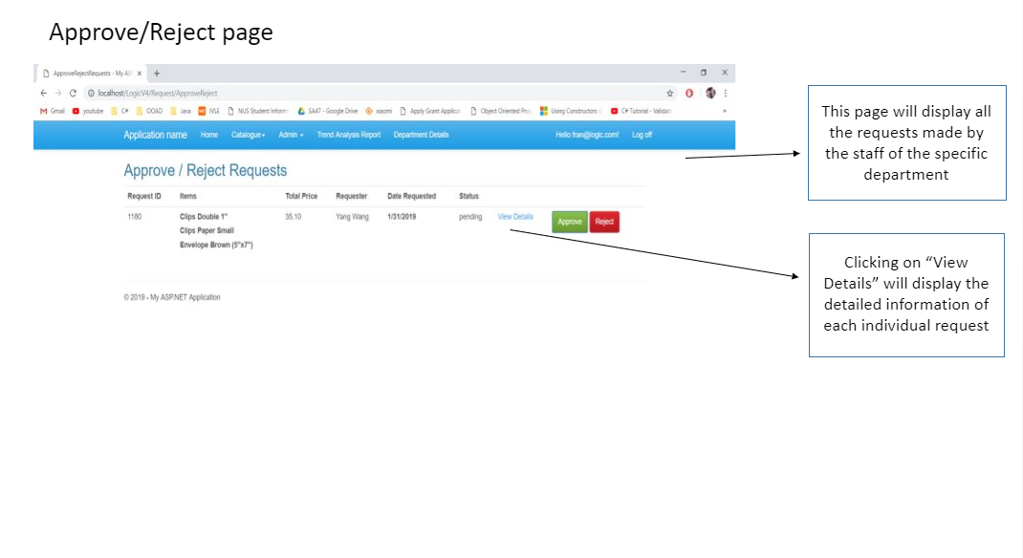

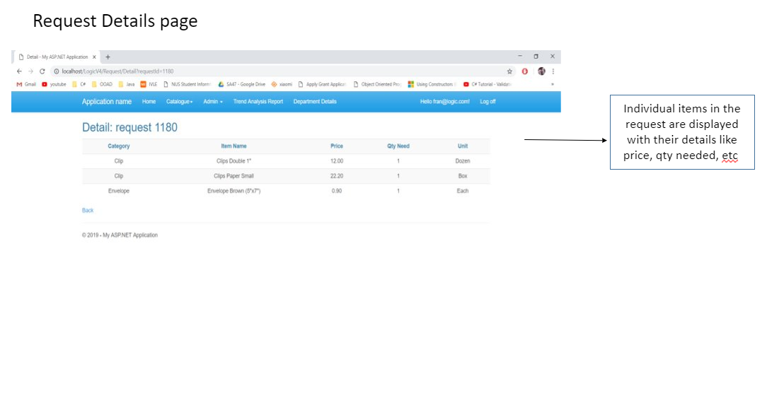

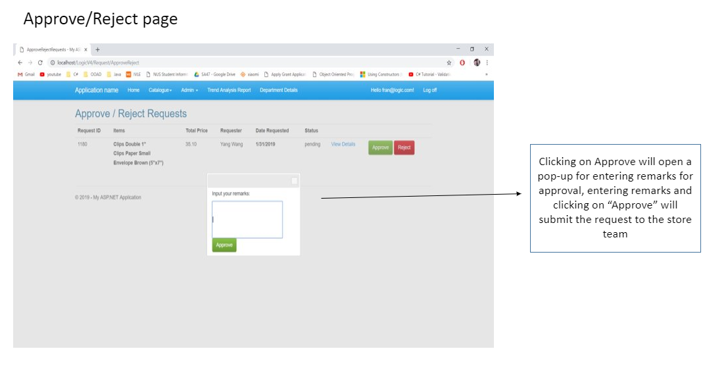

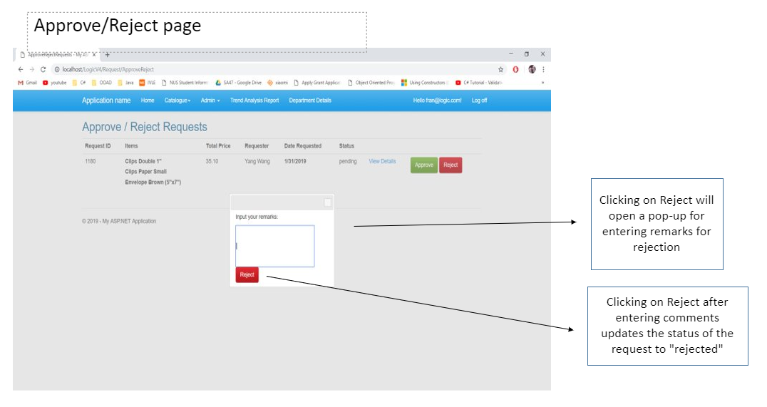

Change DR/Collection Point – DH

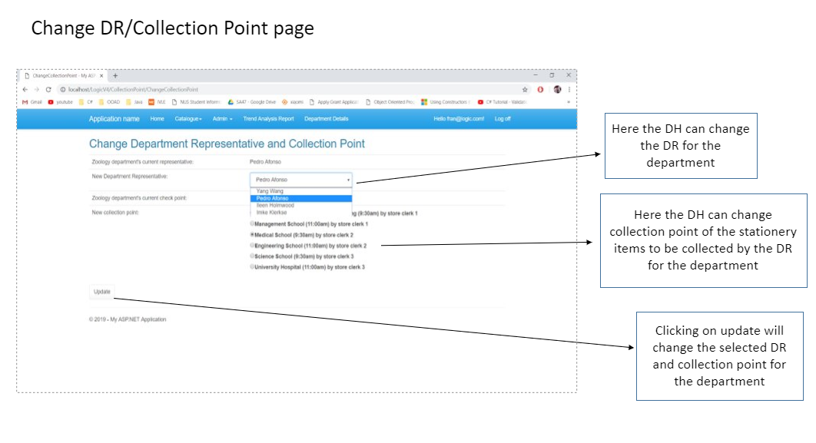

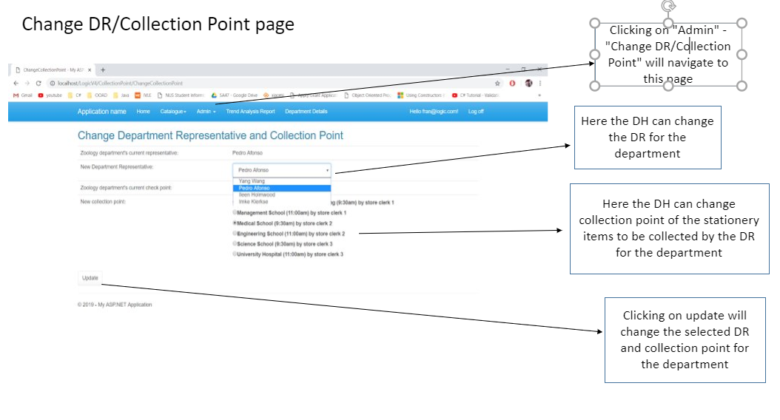

Change Collection Point – DR

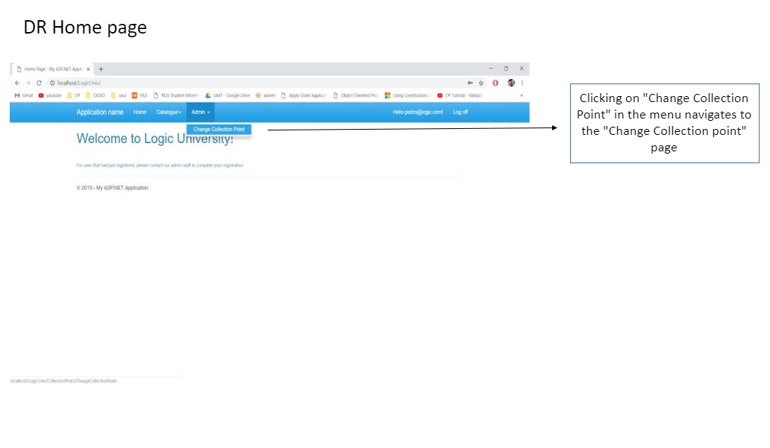

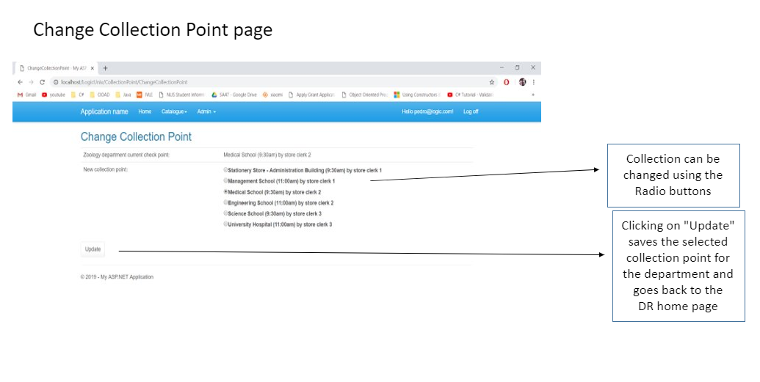

Role Delegation

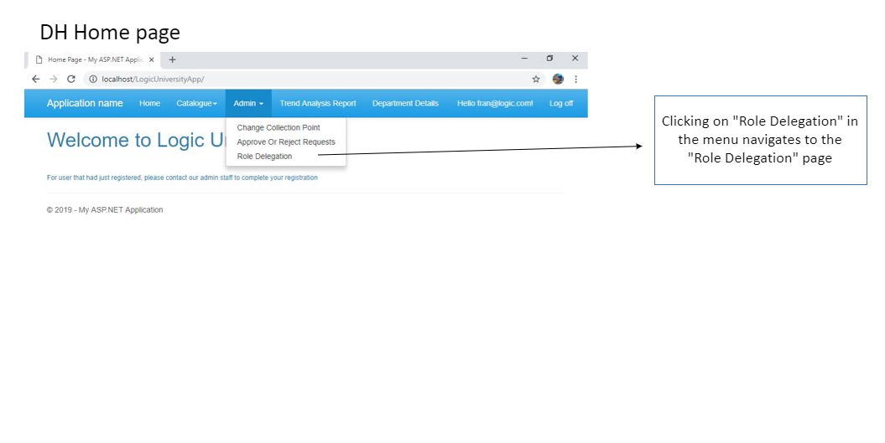

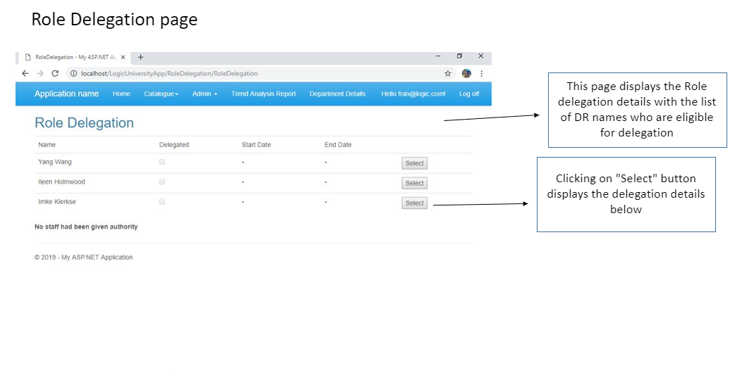

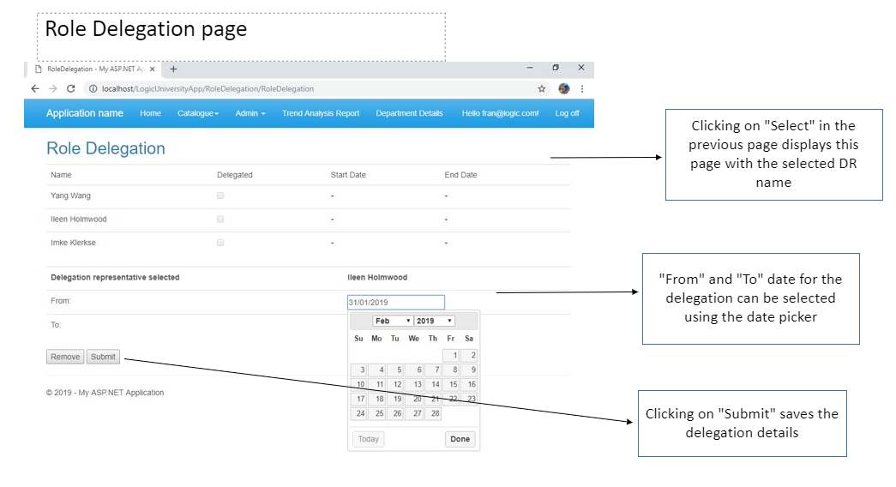

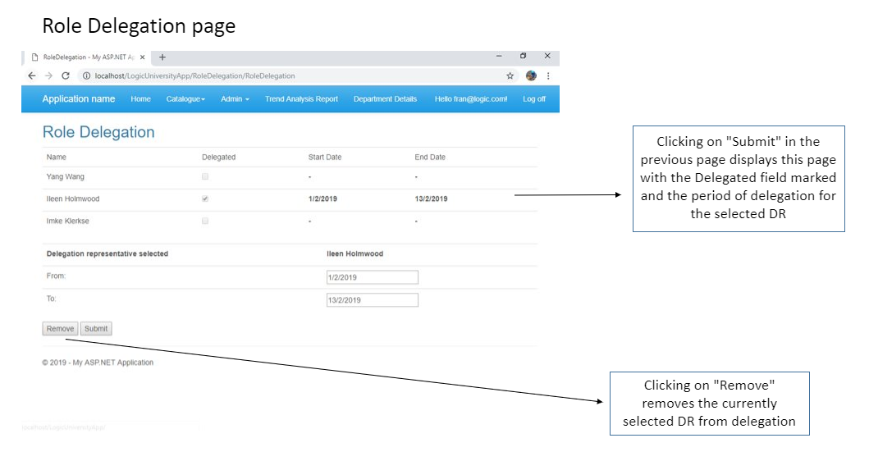

View Stationery Catalogue

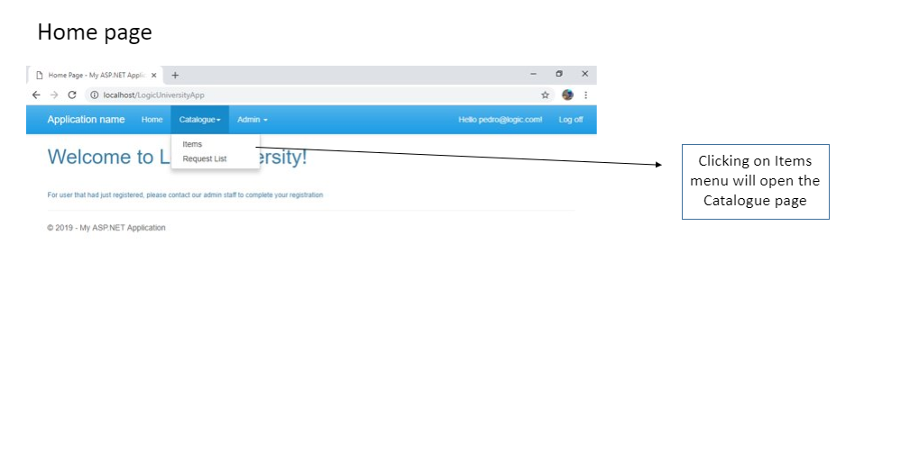

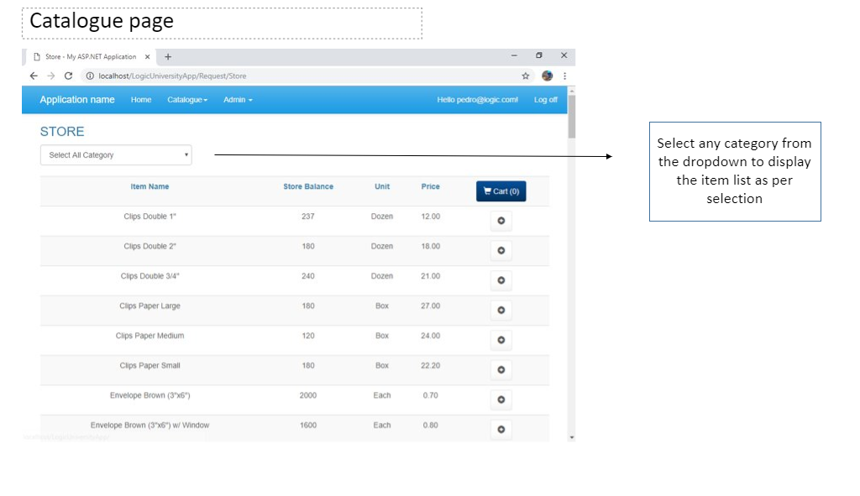

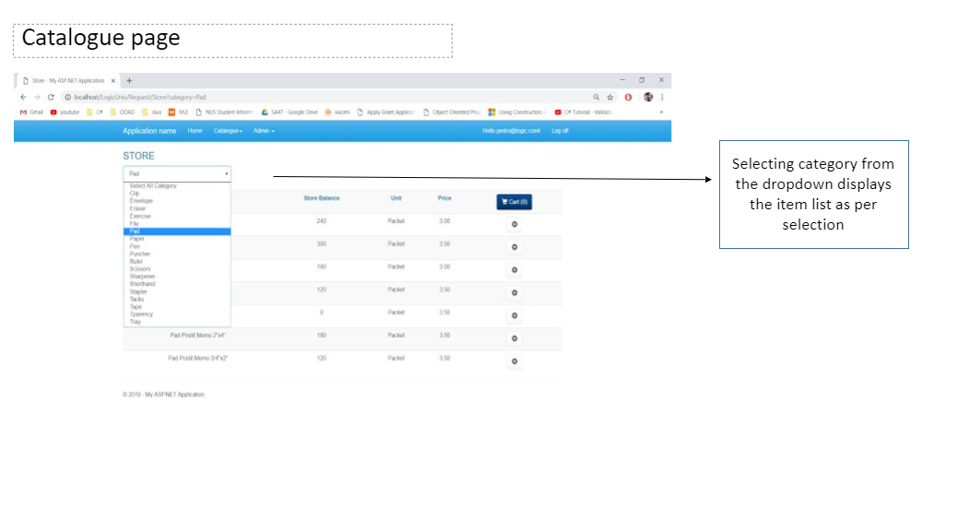

Raise Request – DR/Staff

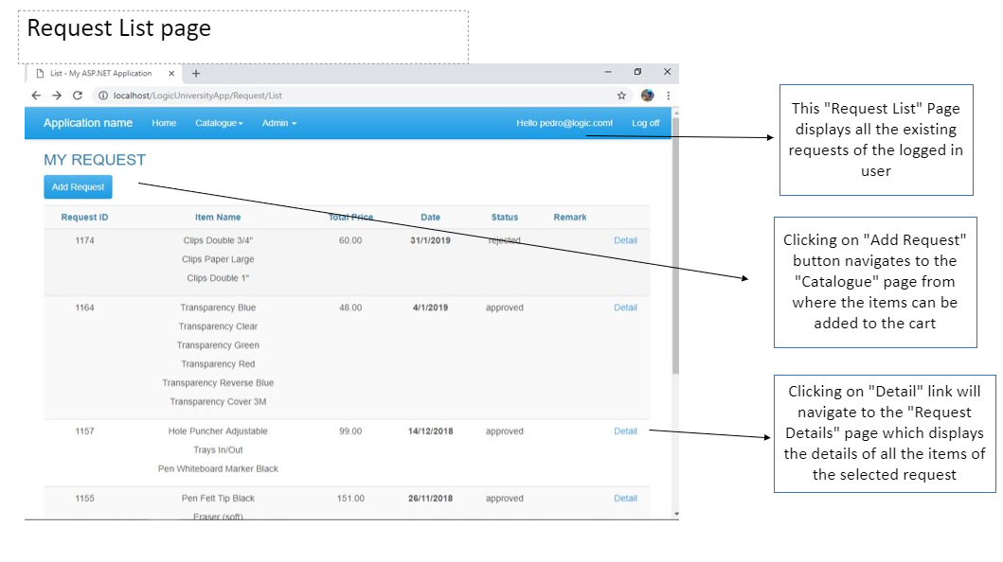

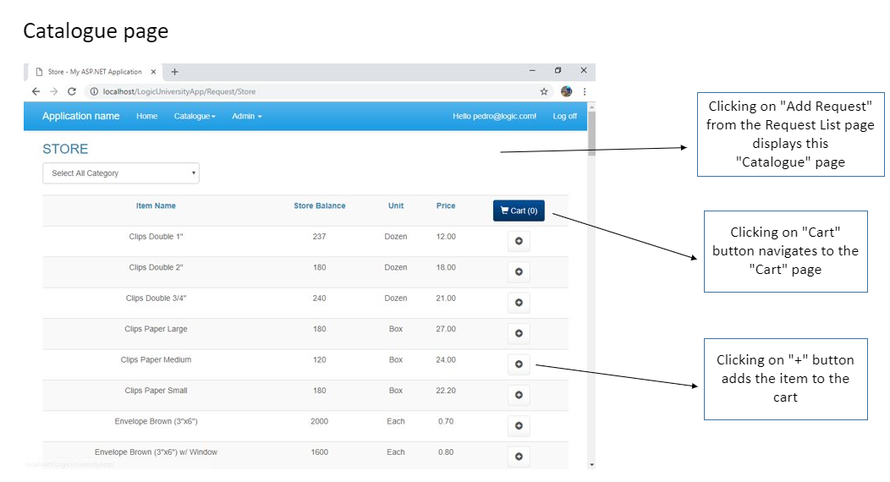

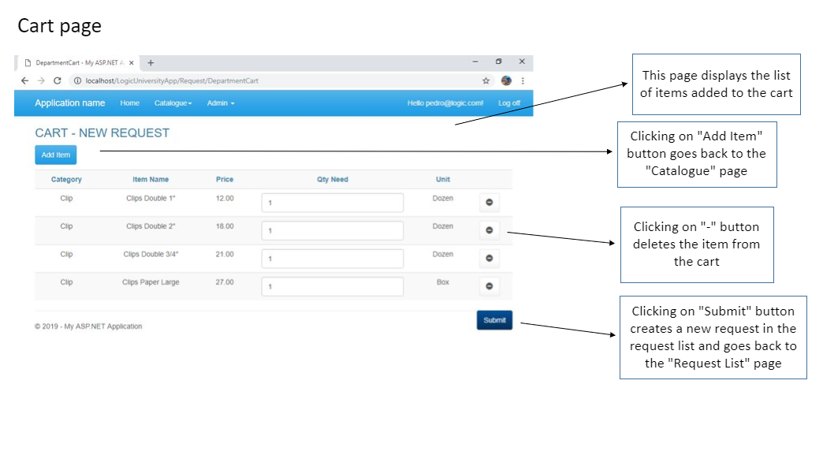

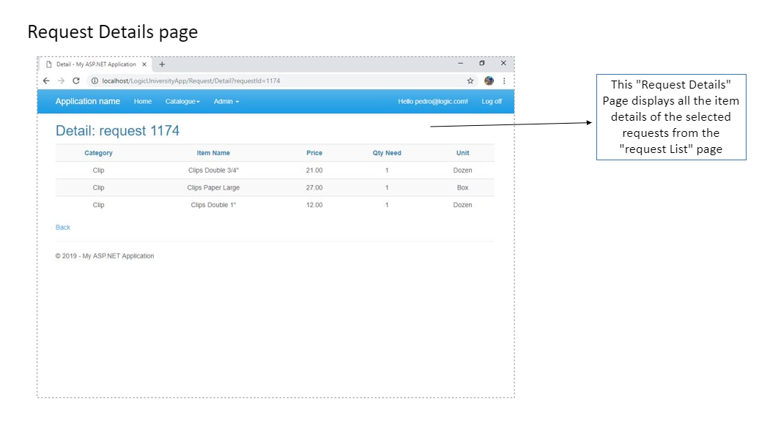

View Department Trend Analysis Report- DH

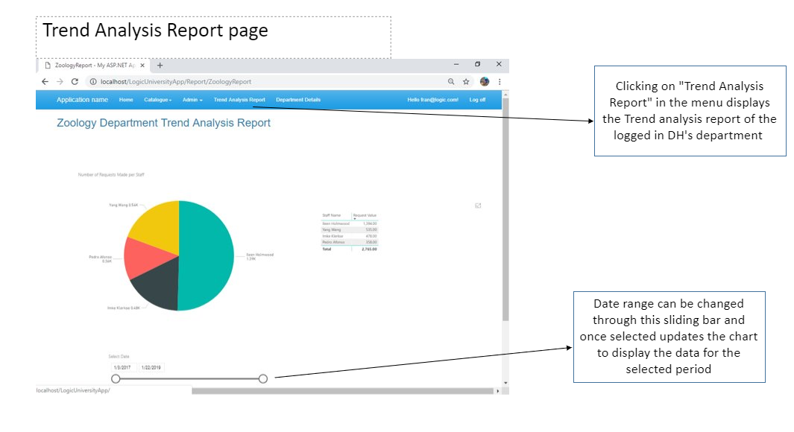

Modify Department Information

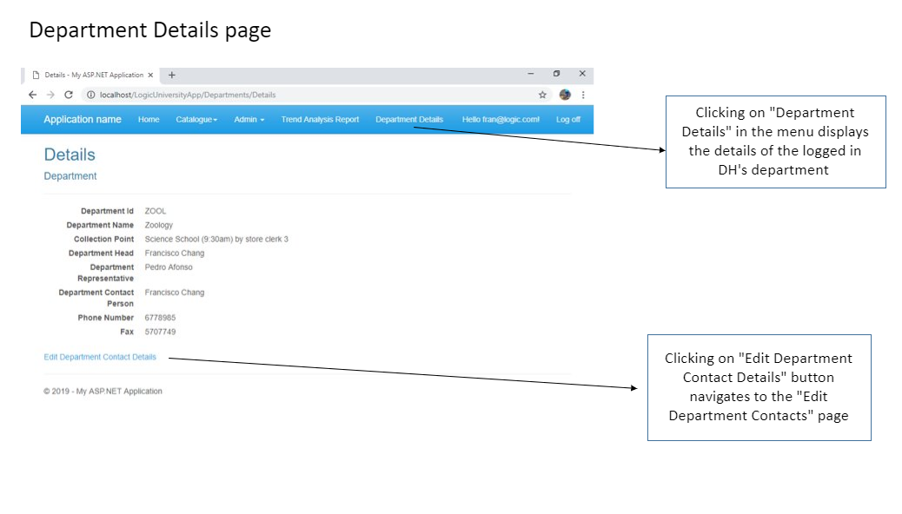

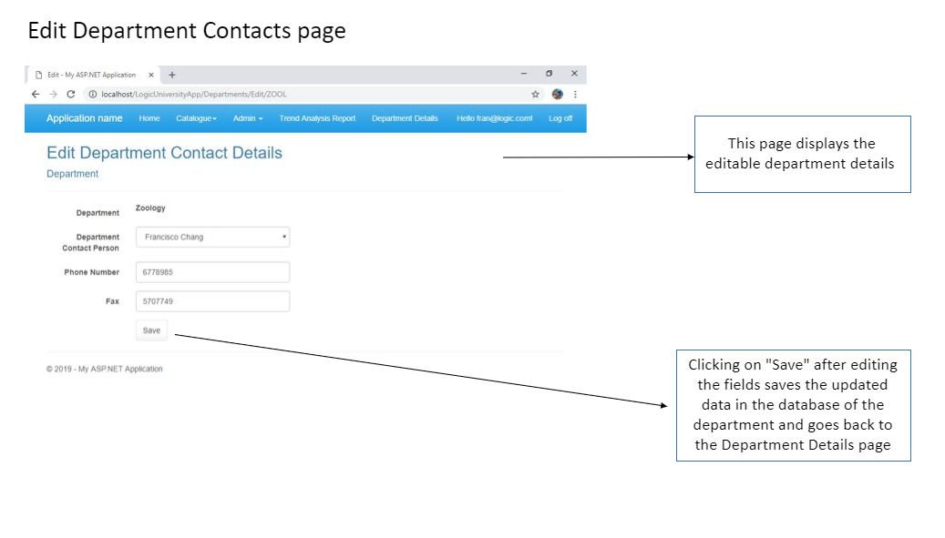

## 10.2 Store web User interface

Process Disbursement List​

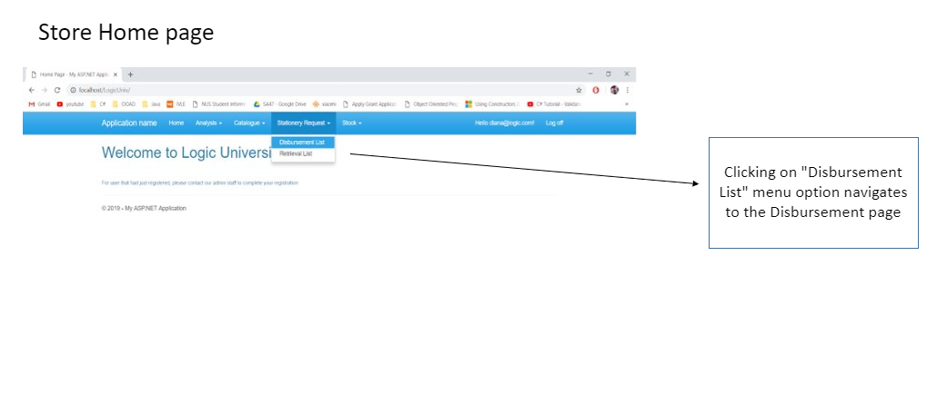

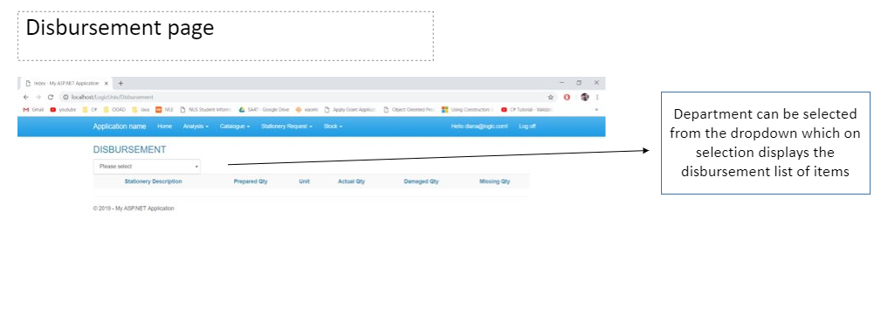

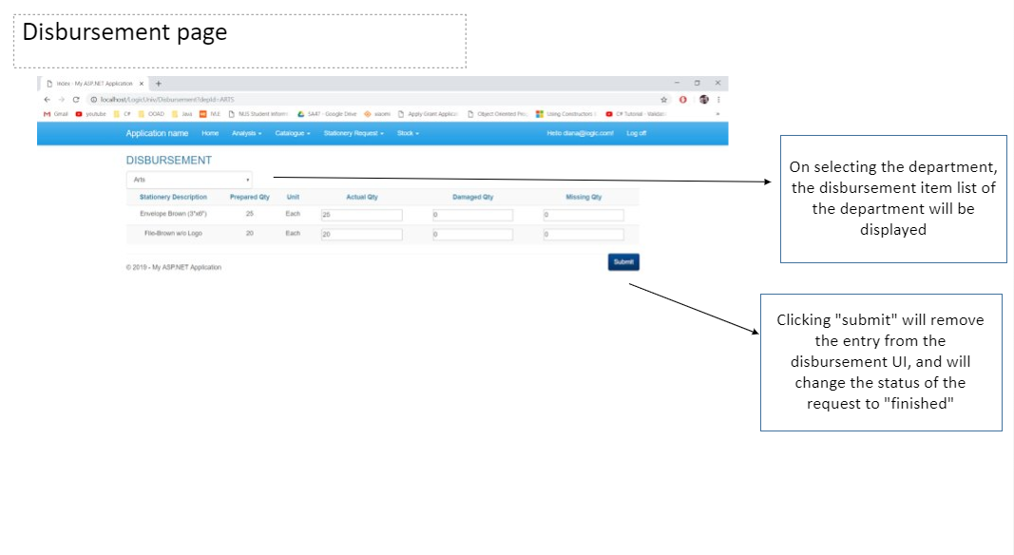

View Stock Card

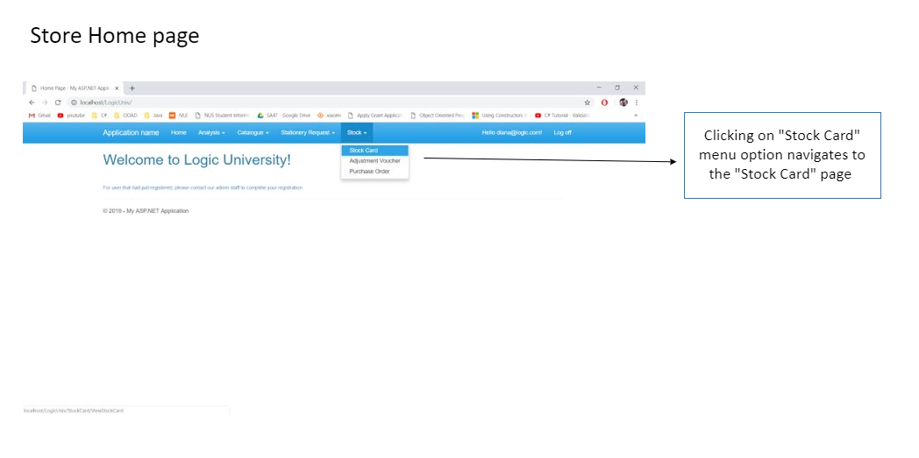

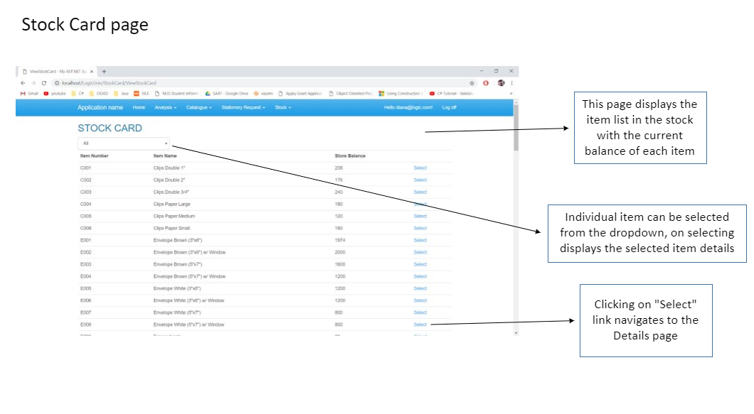

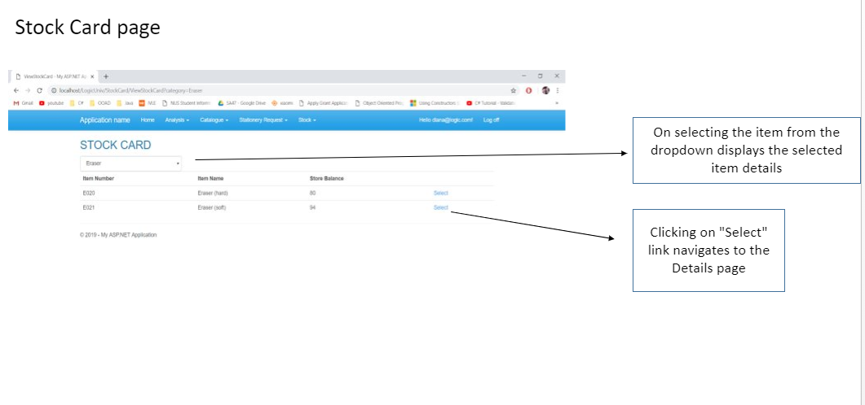

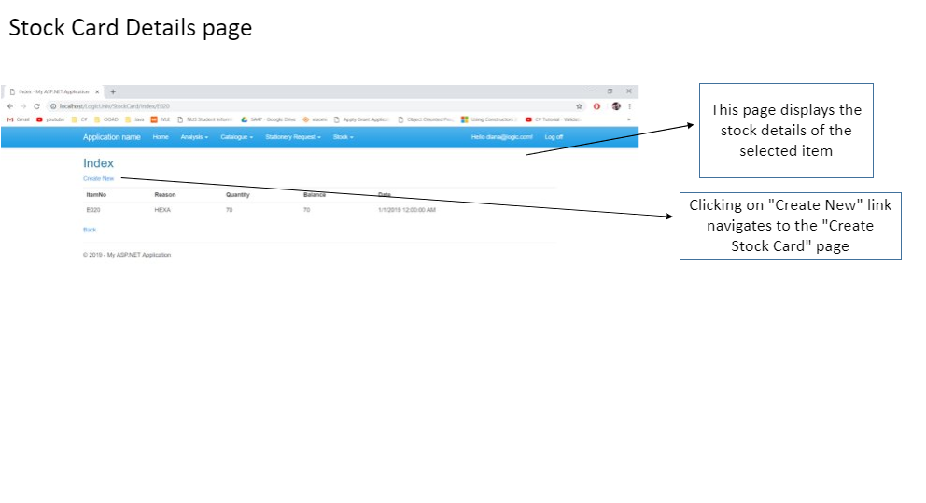

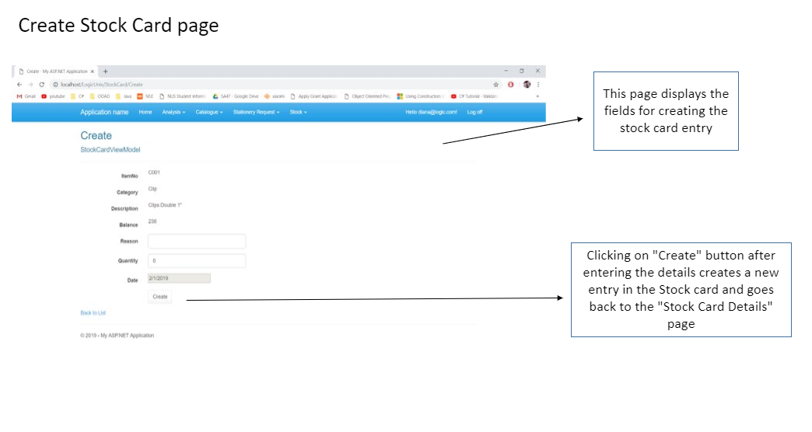

Process Retrieval List

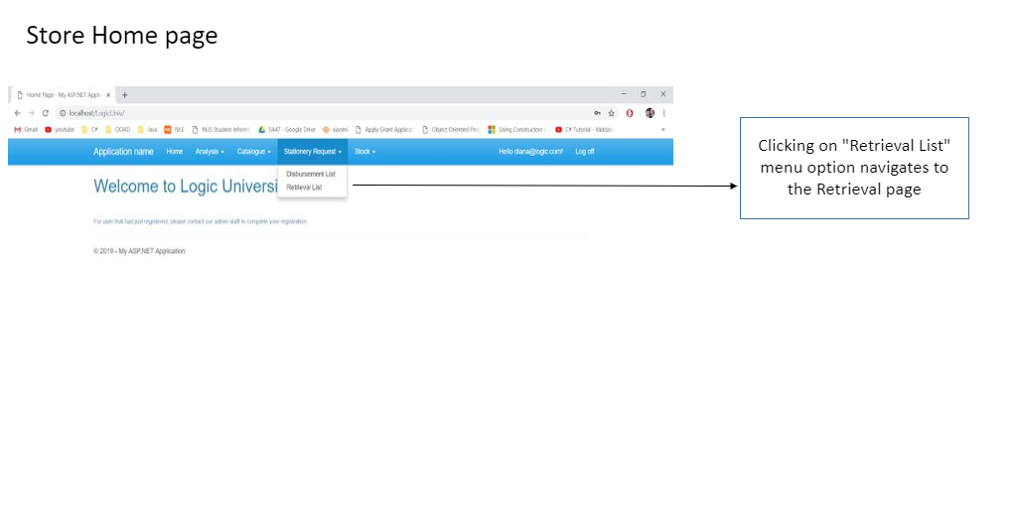

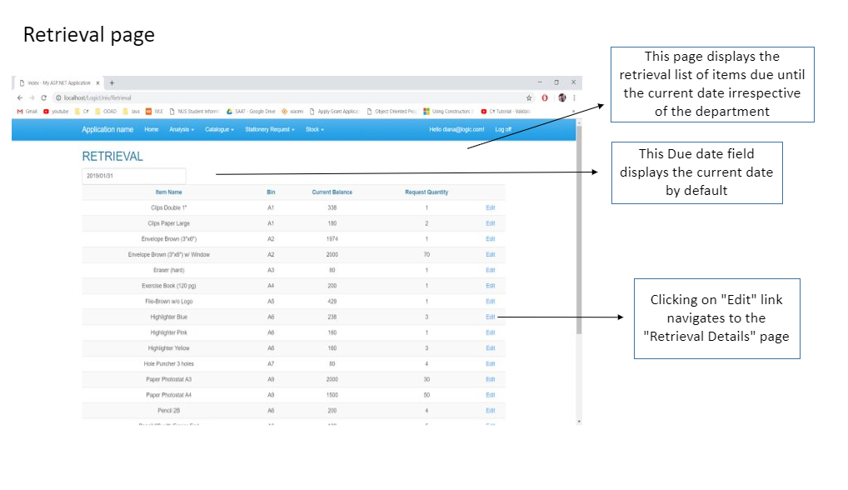

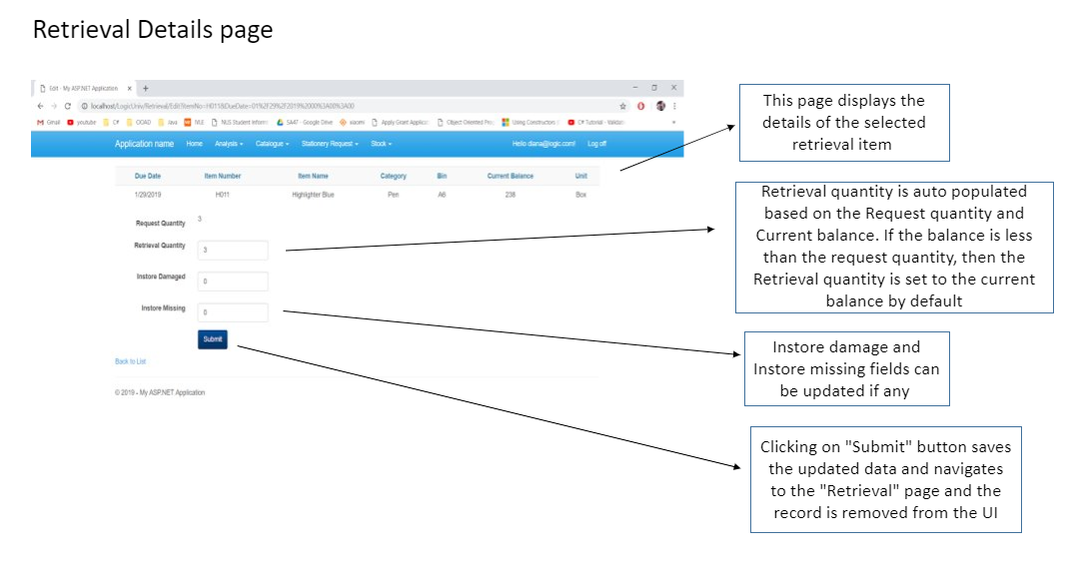

Modify Supplier Information:

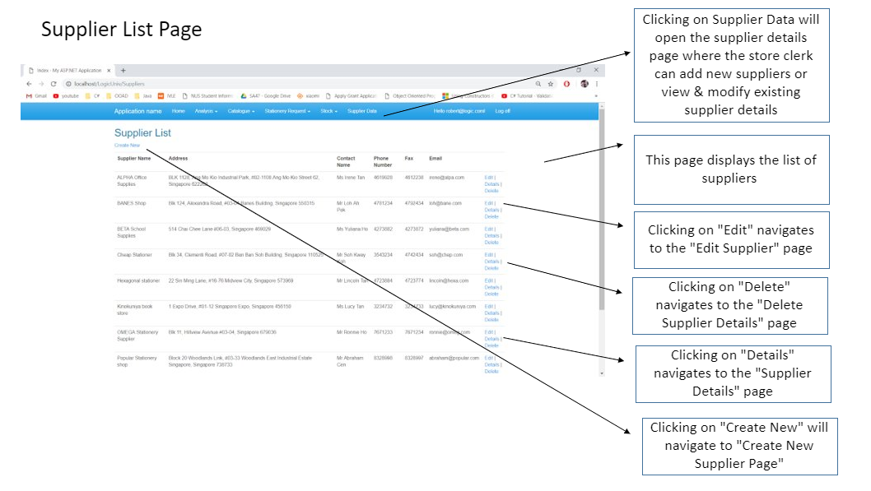

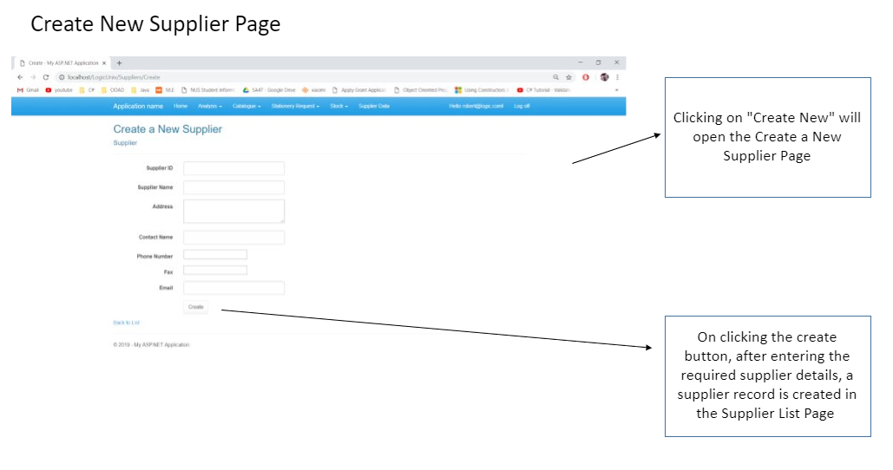

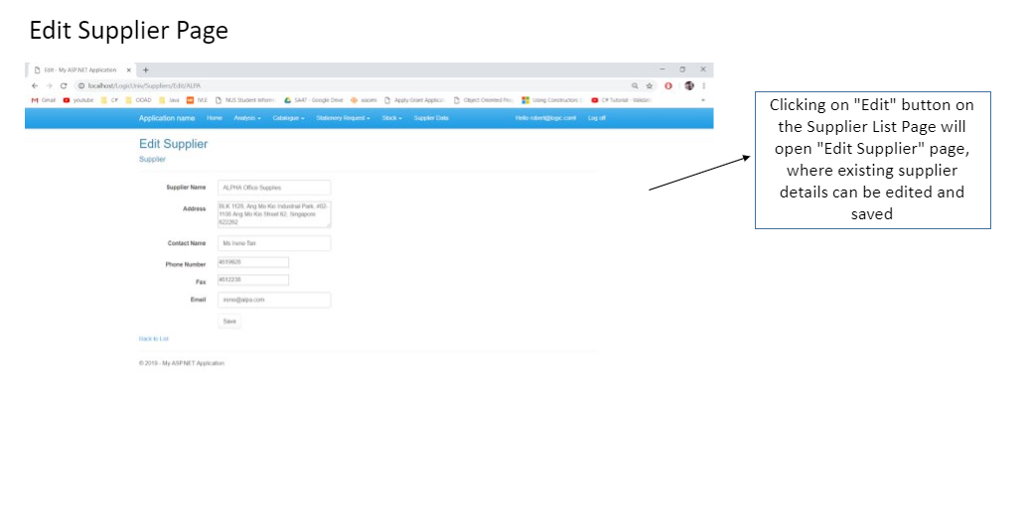

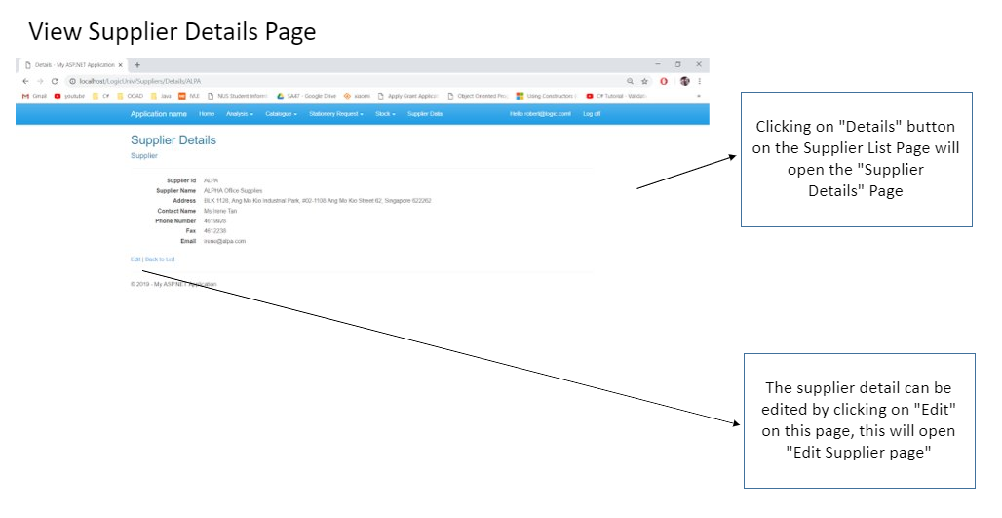

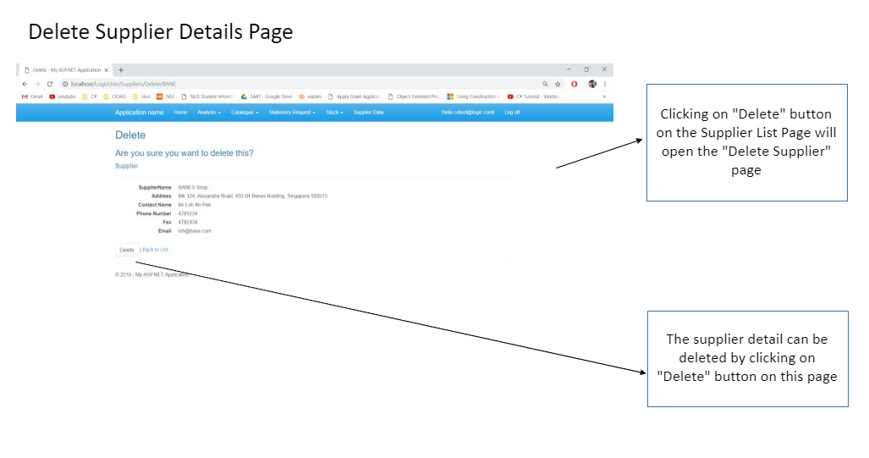

Issue Adjustment Voucher

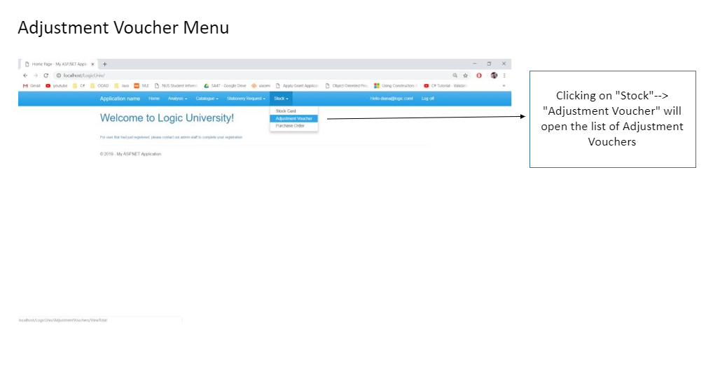

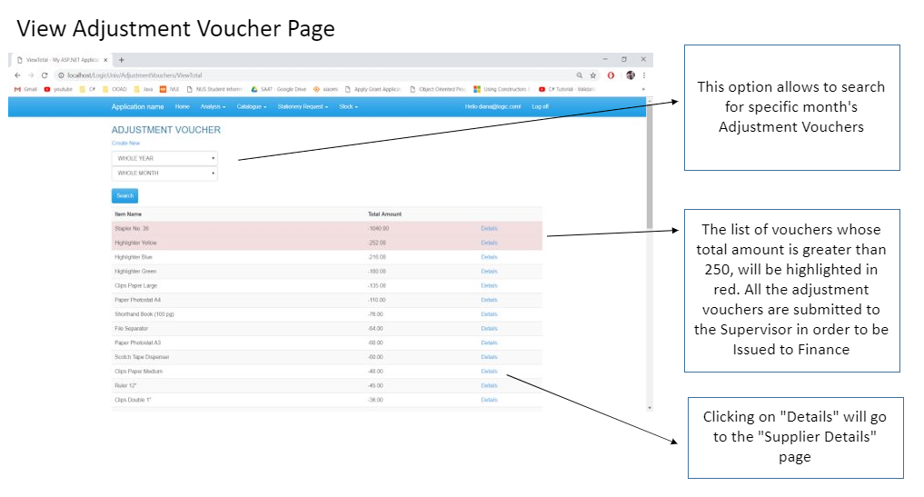

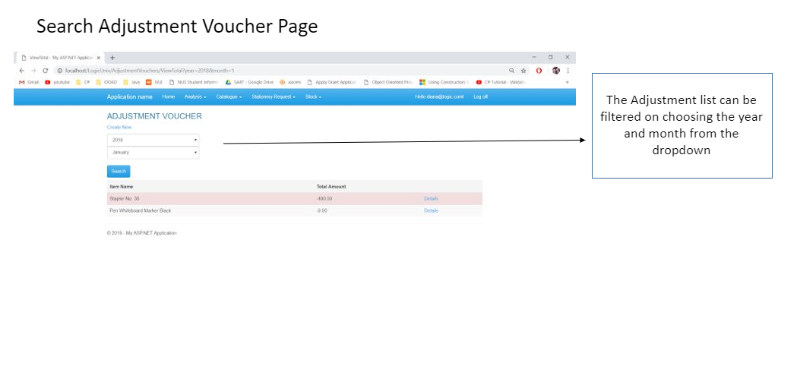

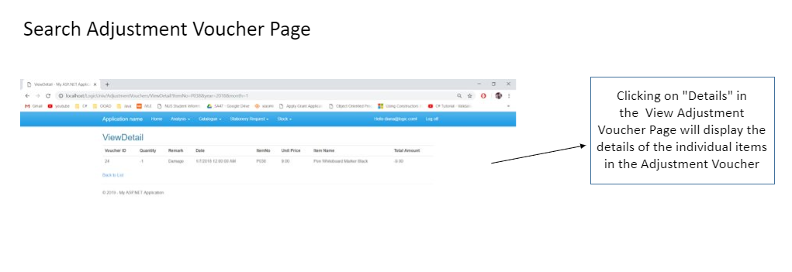

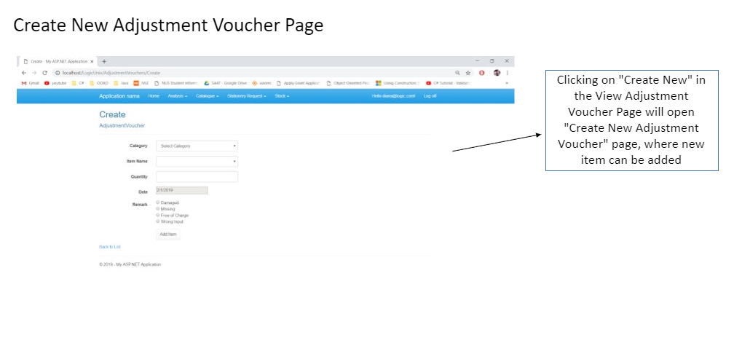

Issue Adjustment Voucher – Manager and Supervisor

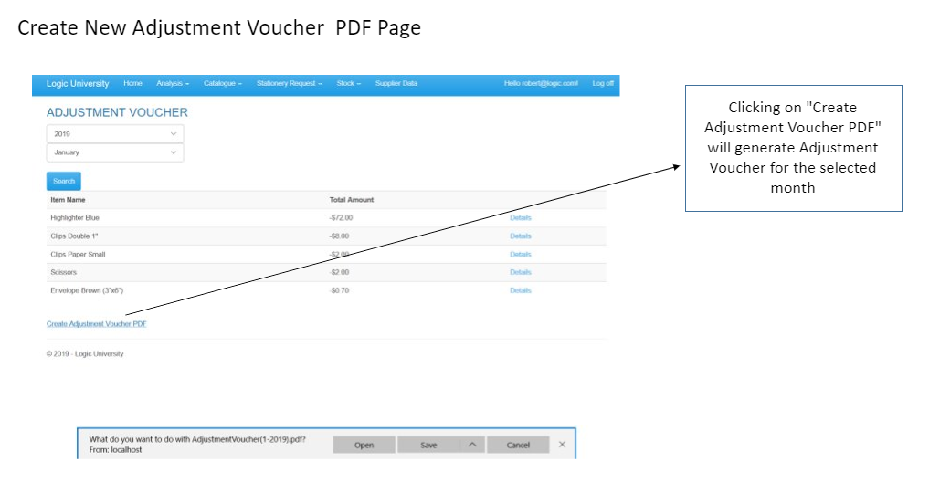

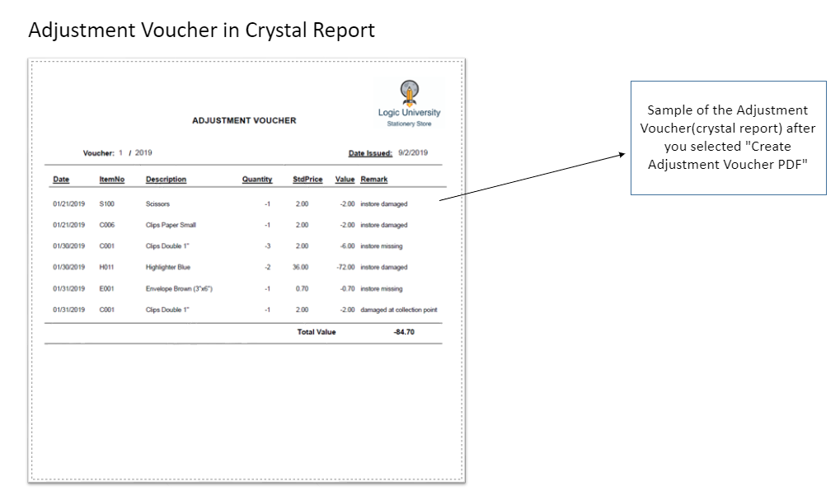

Process Purchase Order

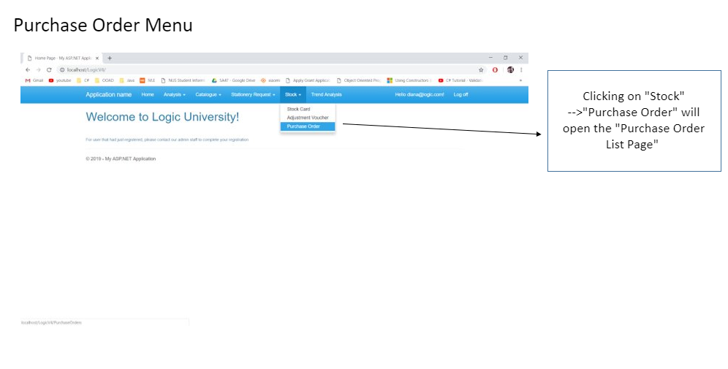

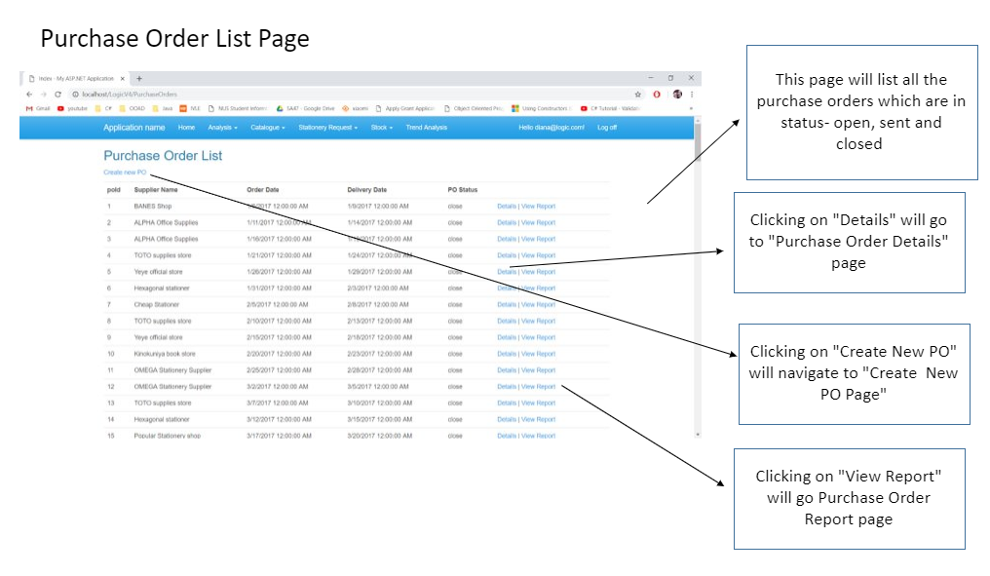

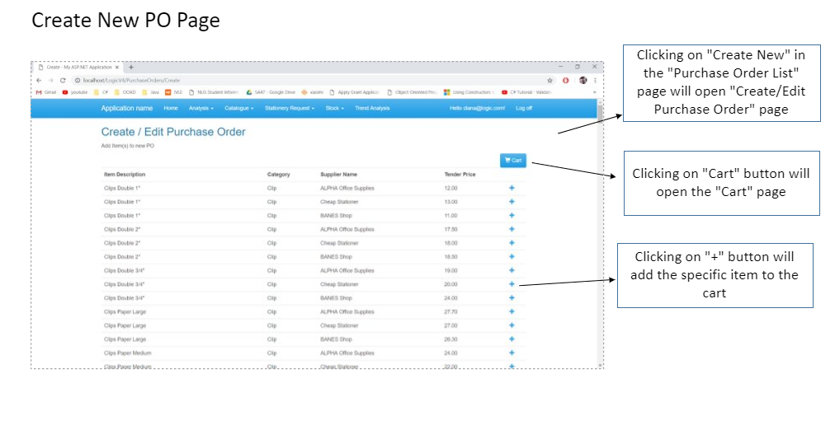

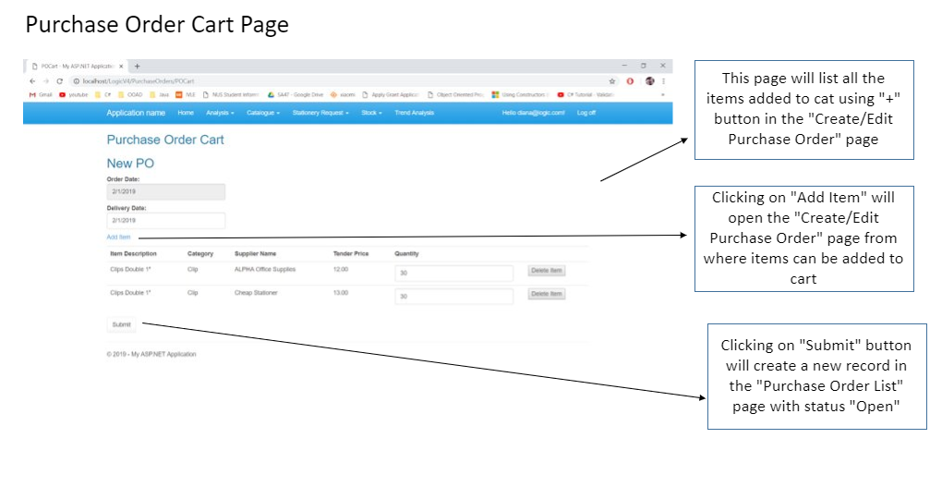

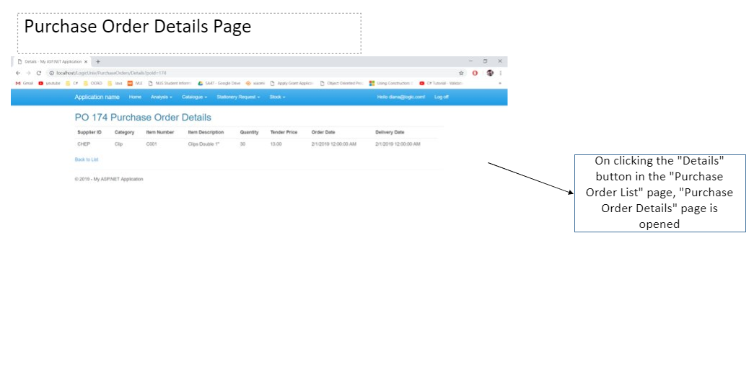

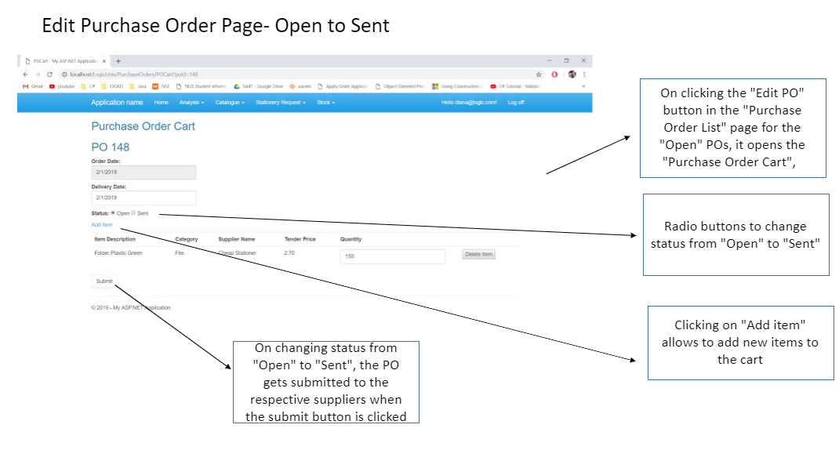

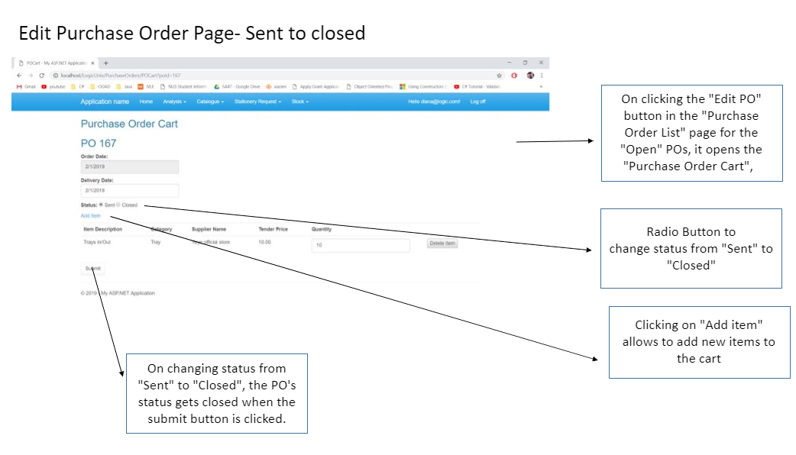

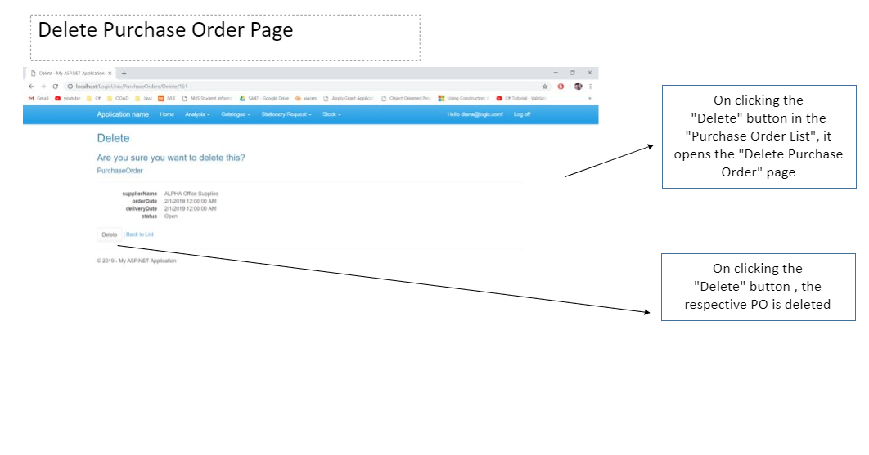

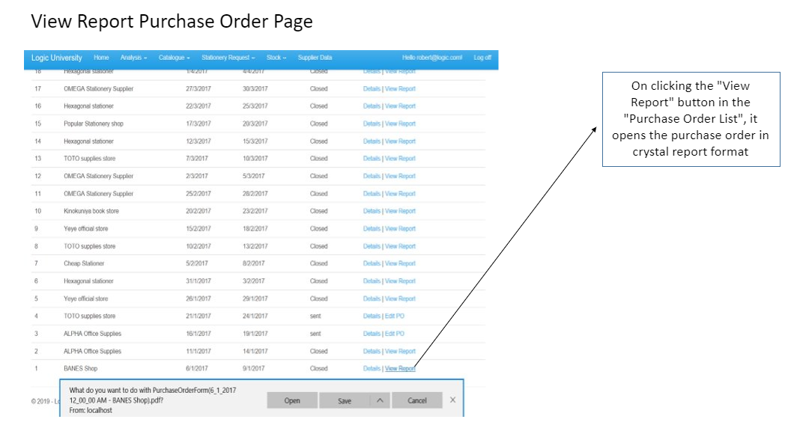

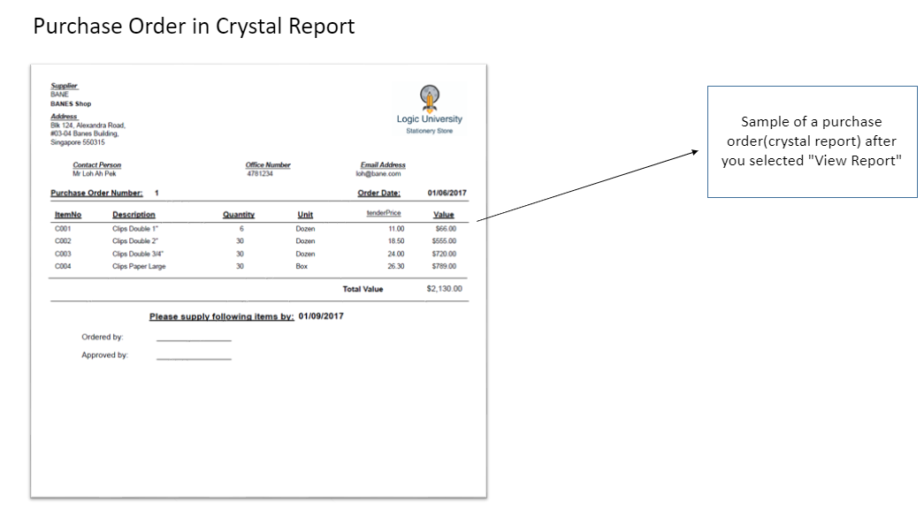

Modify Stationery Catalogue

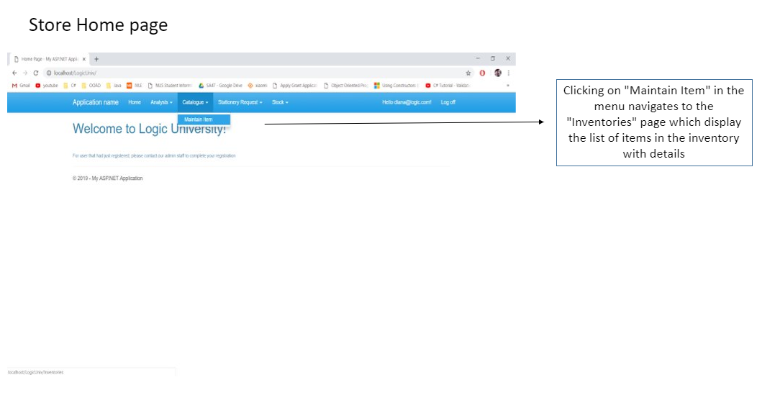

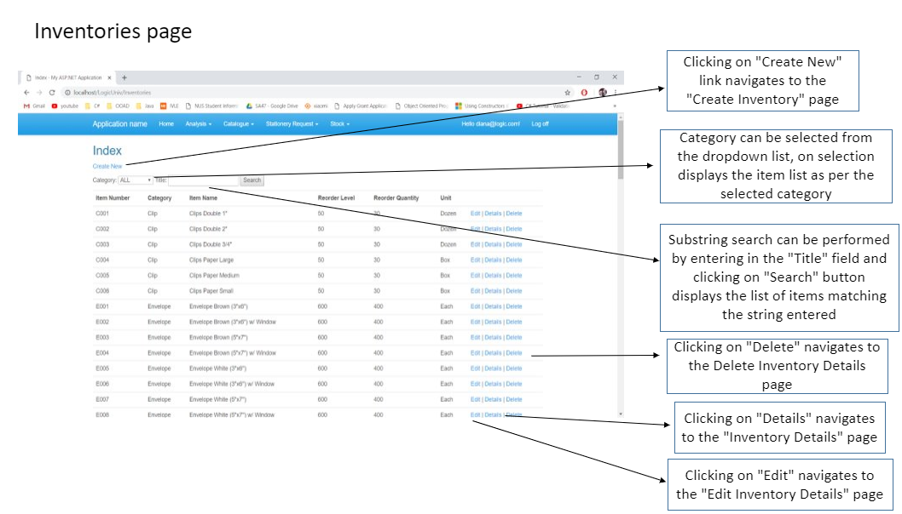

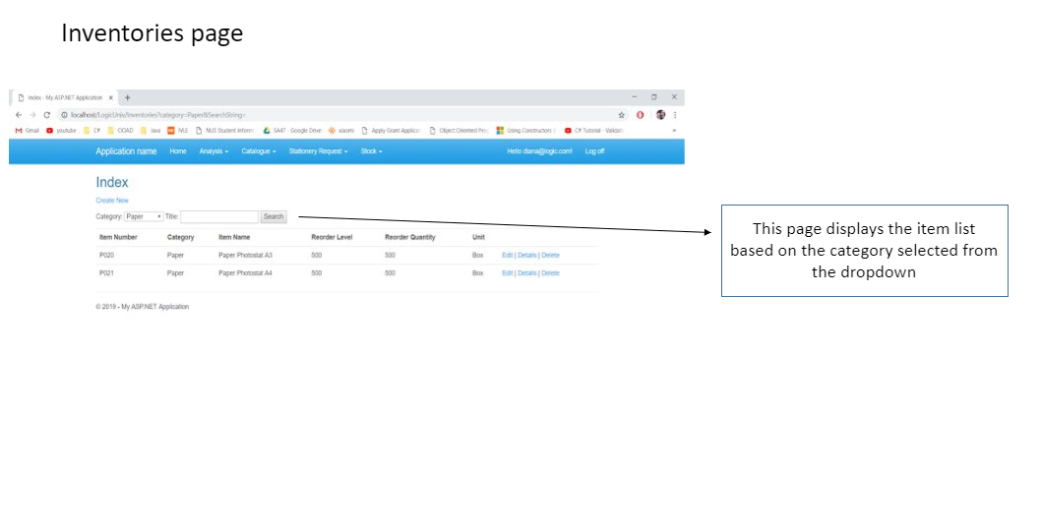

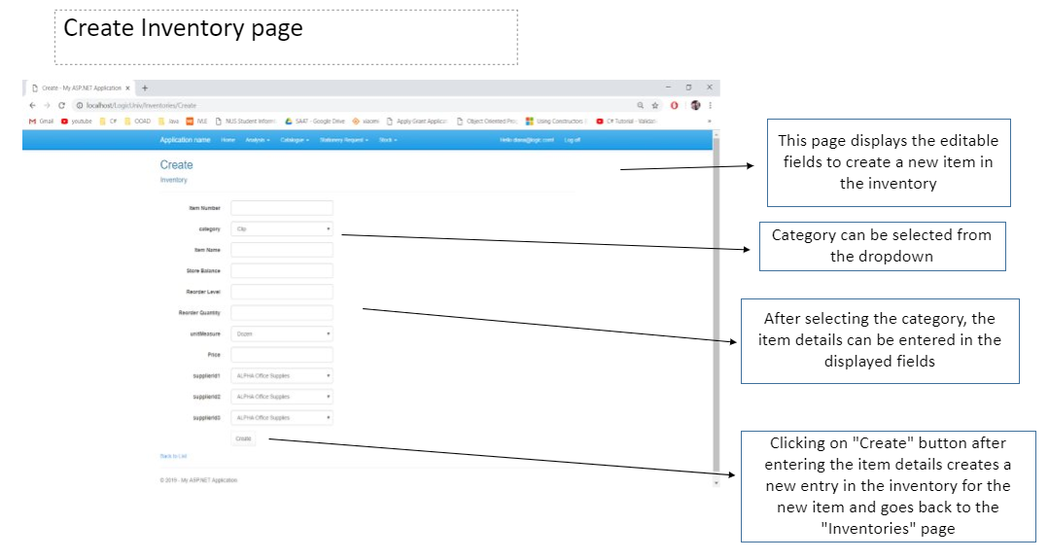

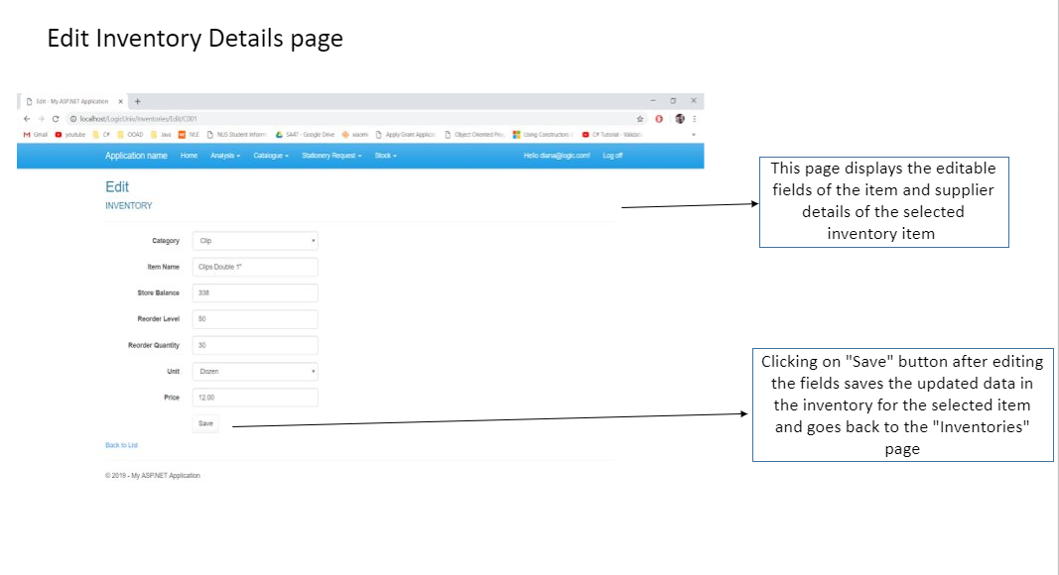

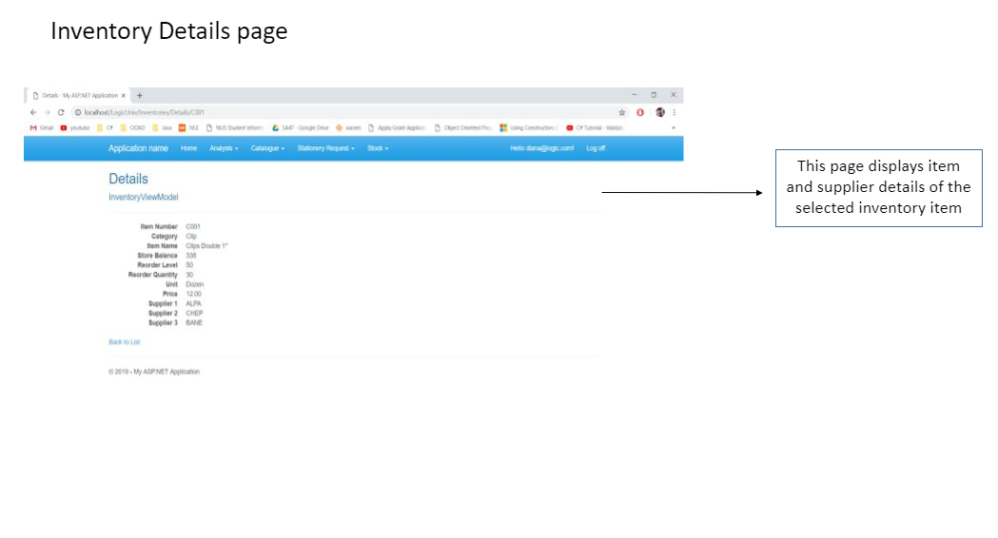

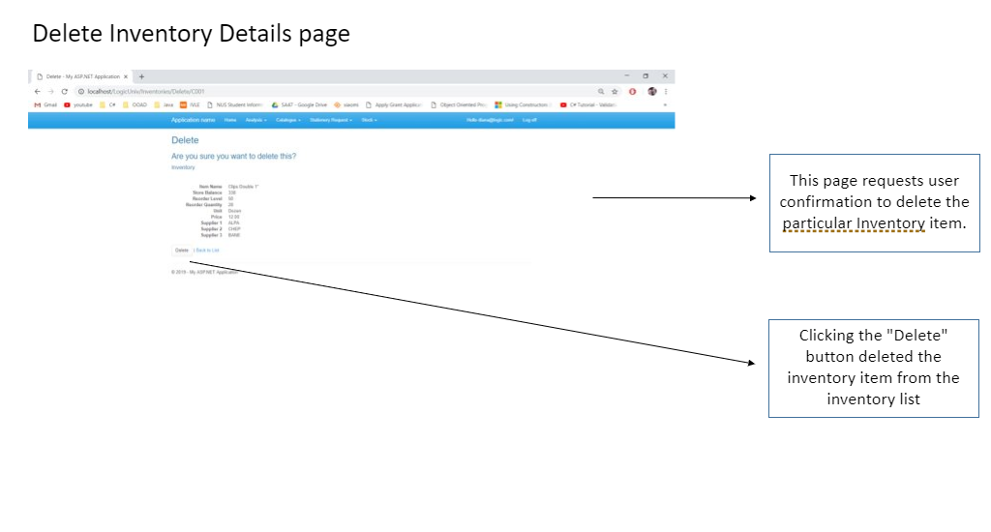

View Reports

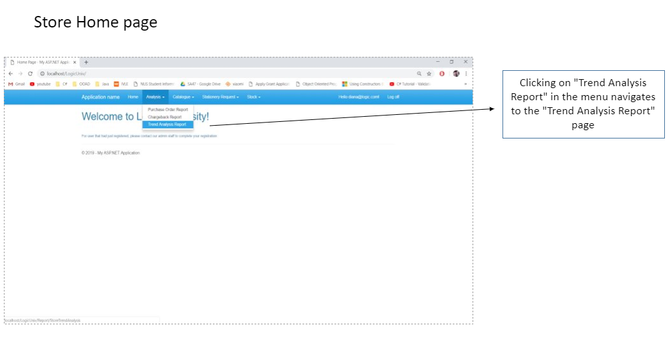

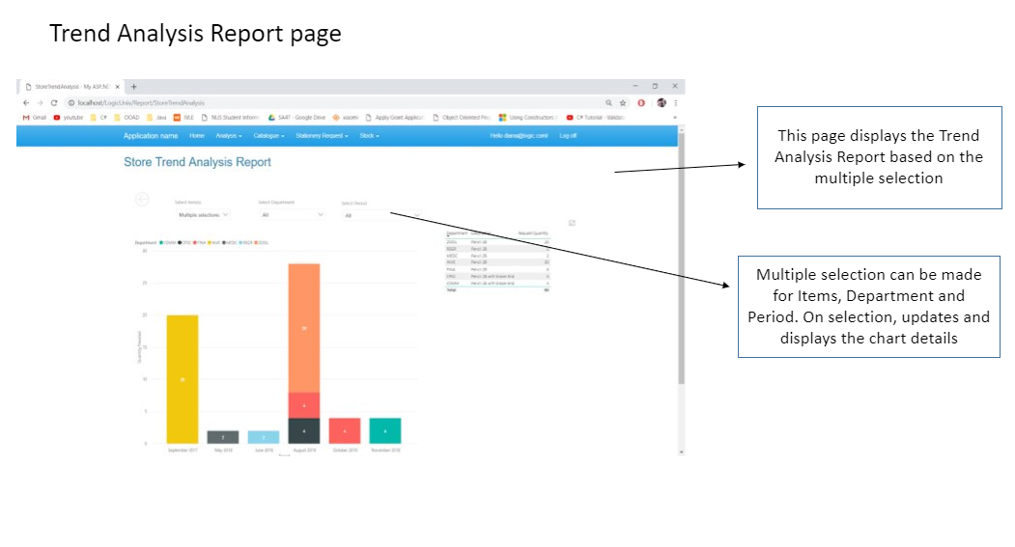

Generate Charge-back Report

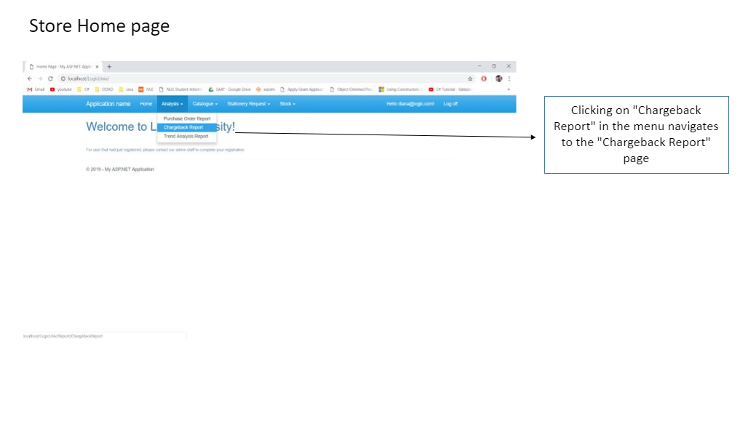

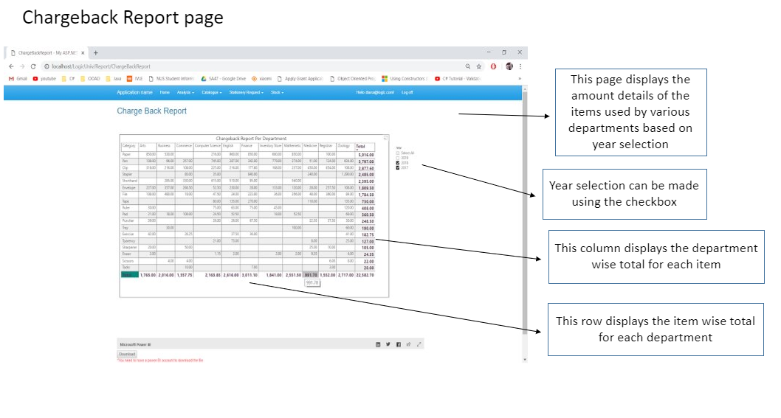

View Reorder List

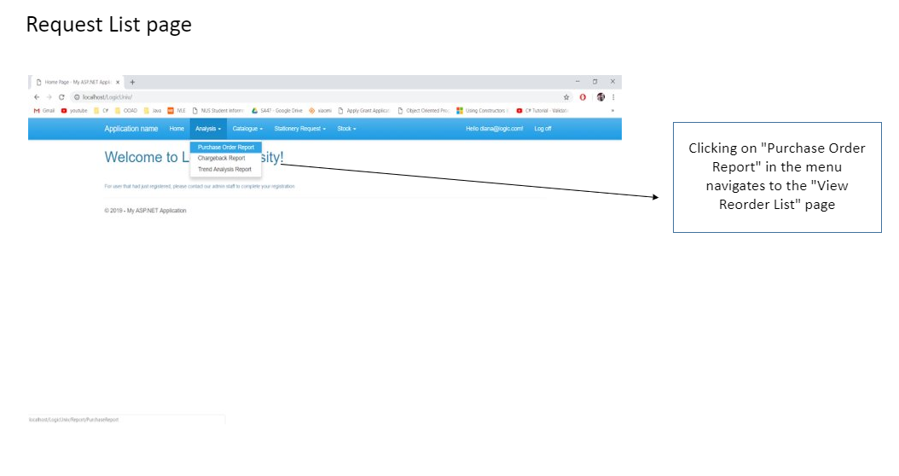

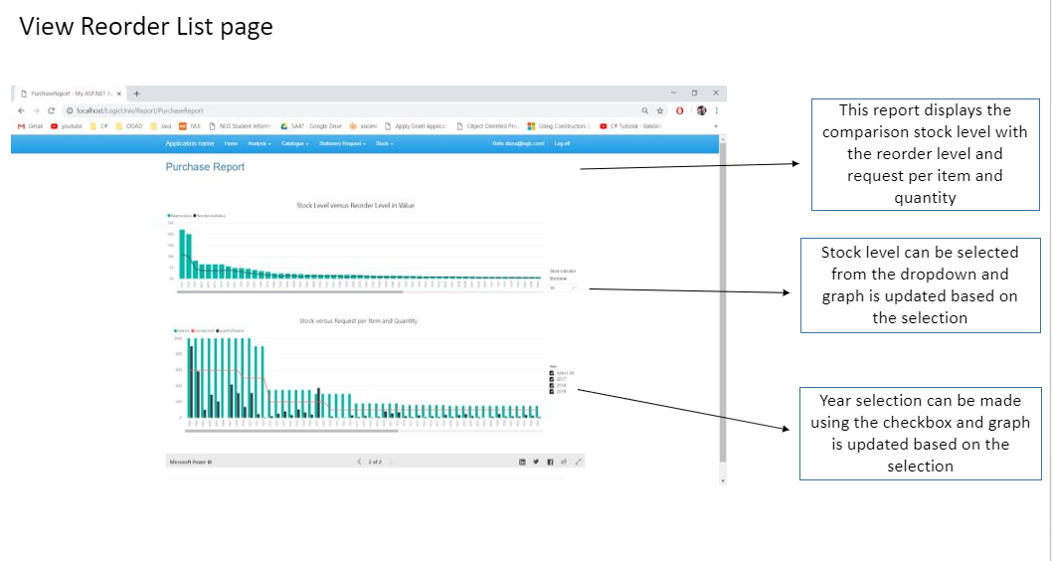

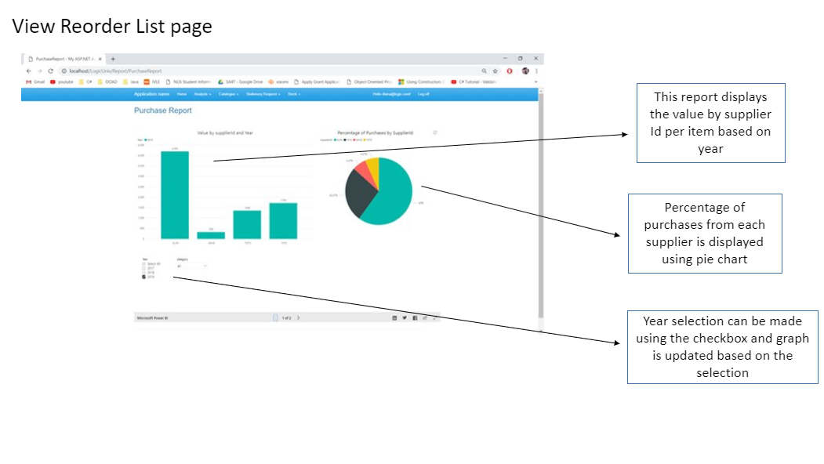

## 10.3 Department Mobile User Interface

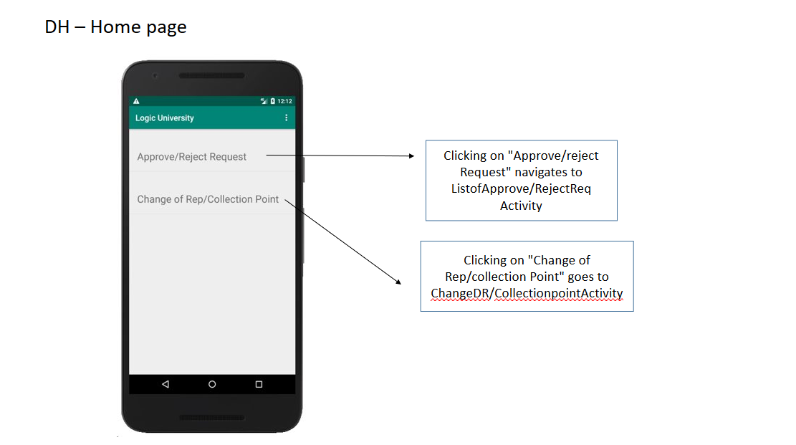

Approve/Reject Request

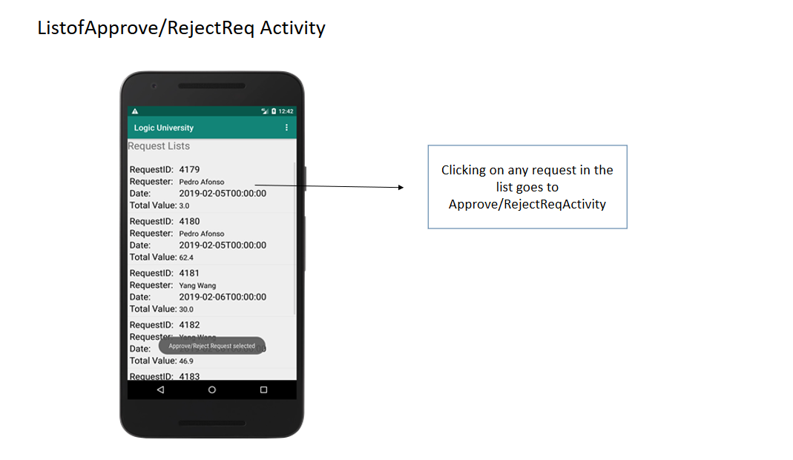

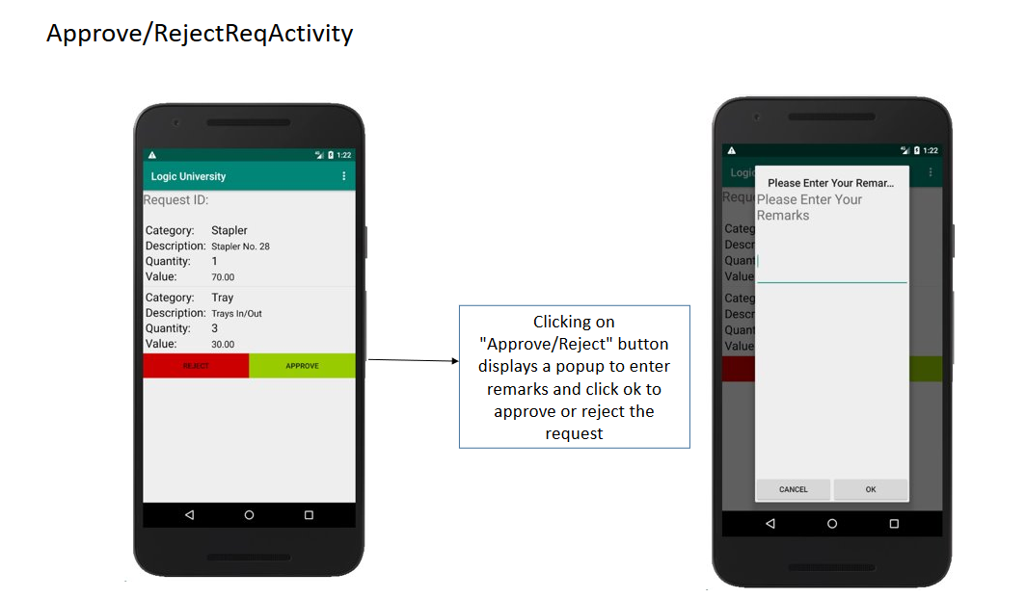

Change of Rep/Collection Point

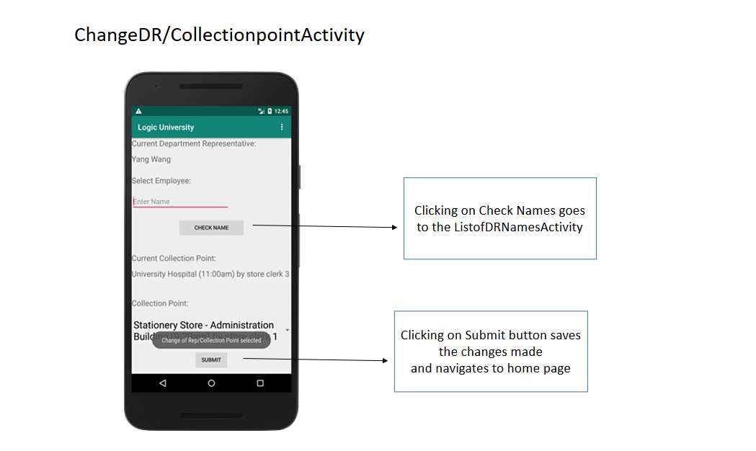

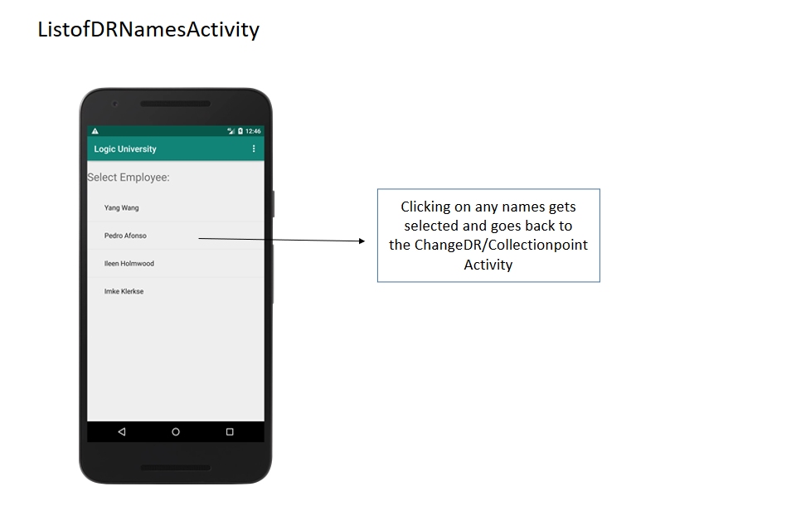

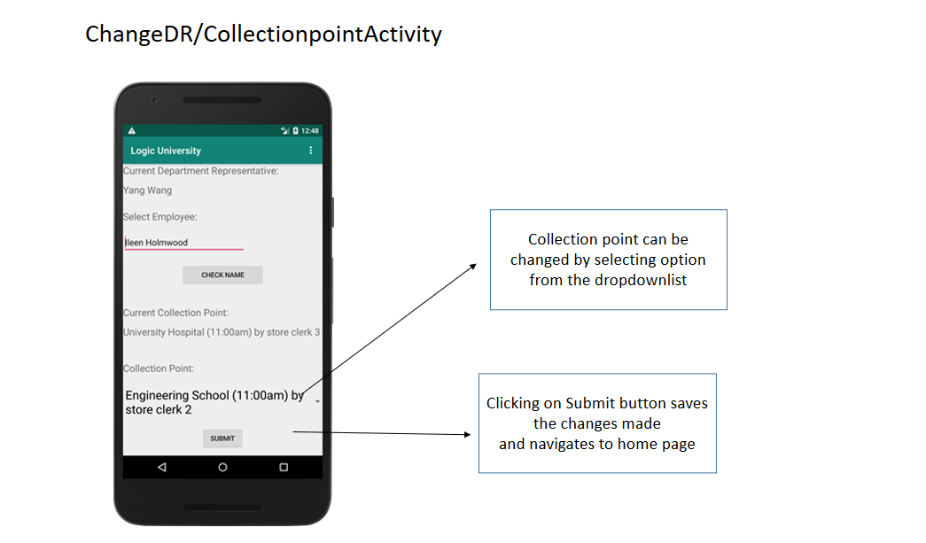

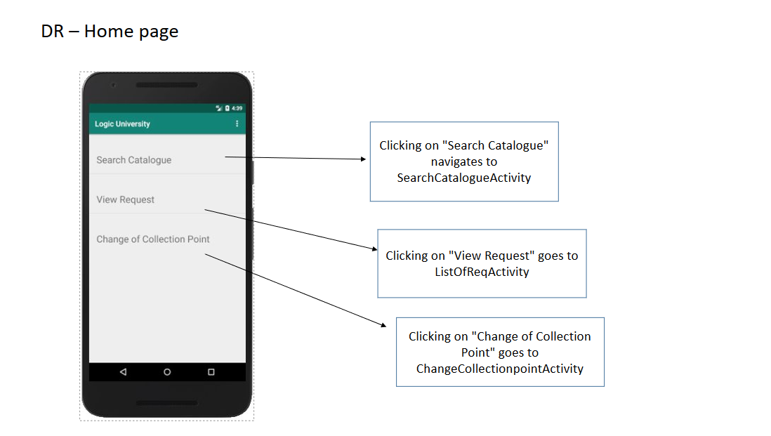

Search Catalogue

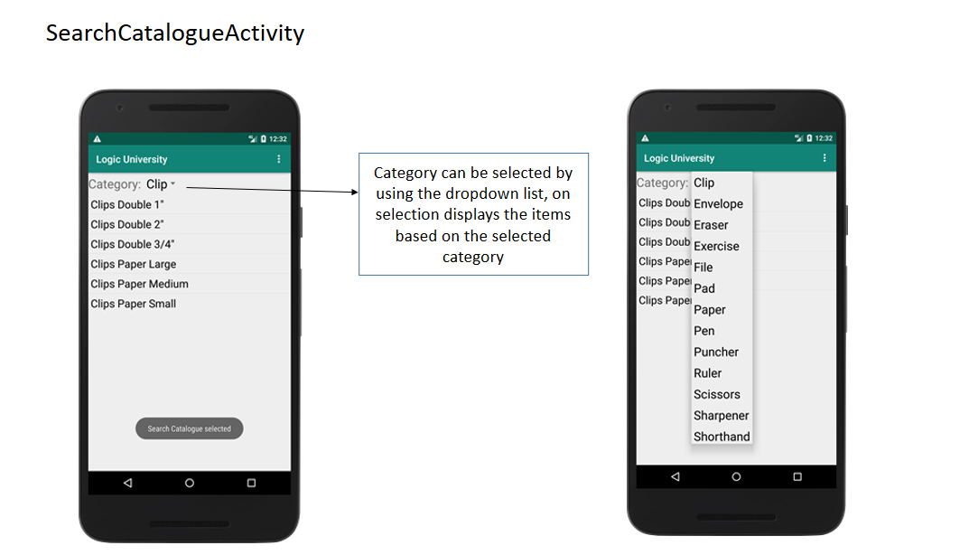

View Request

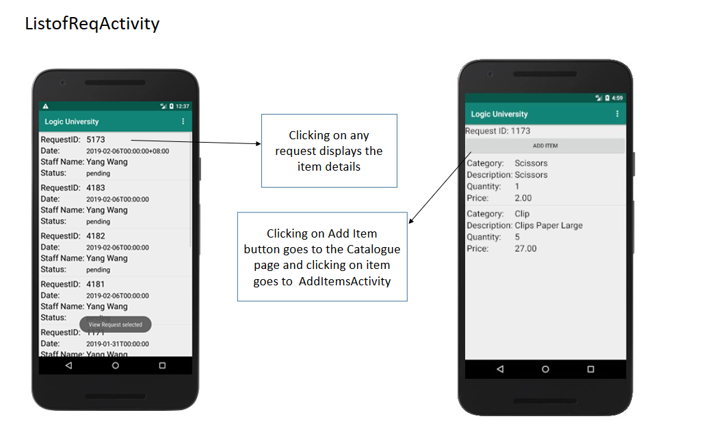

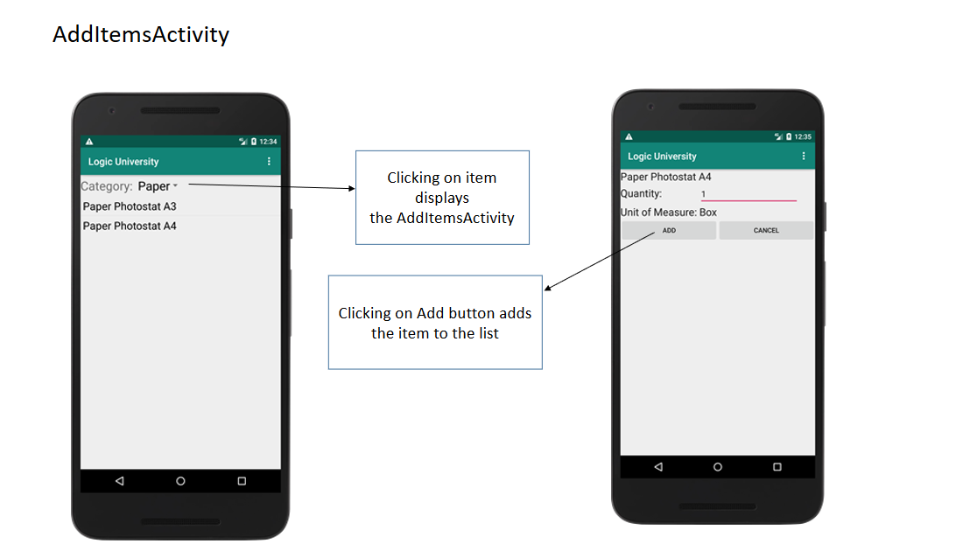

Change Collection Point - DR

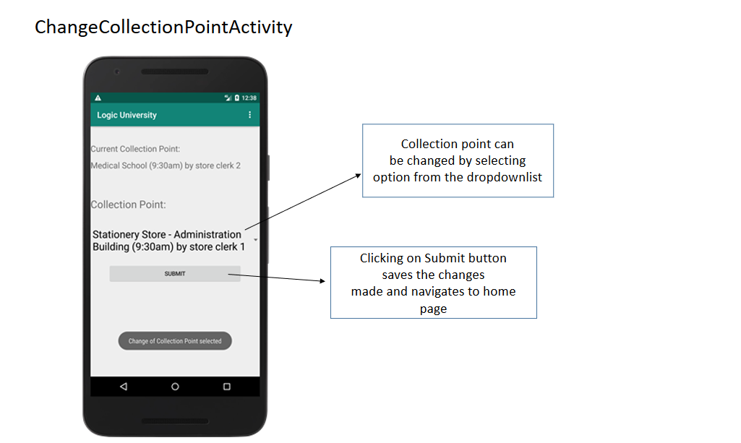

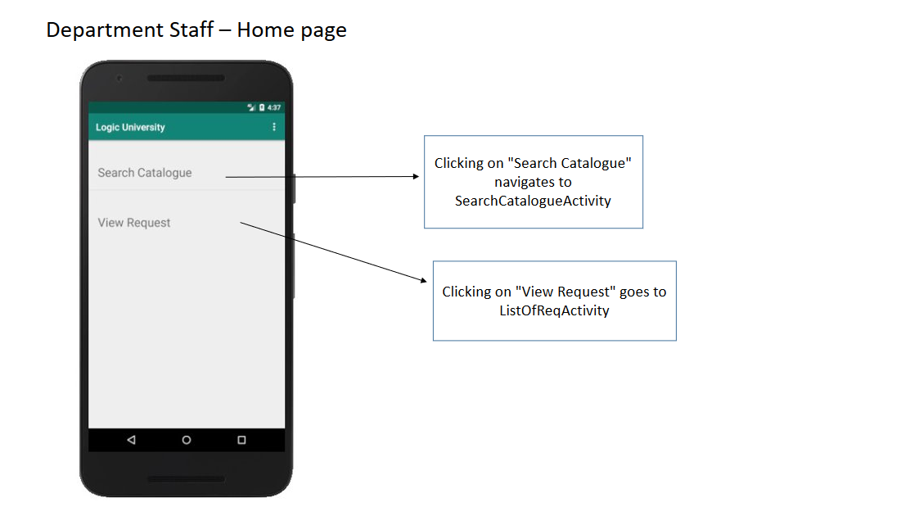

## 10.4 Store Mobile User Interface

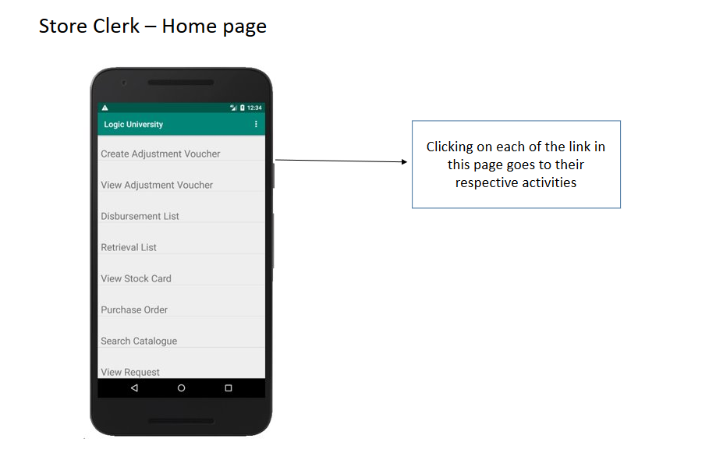

Process Adjustment Voucher

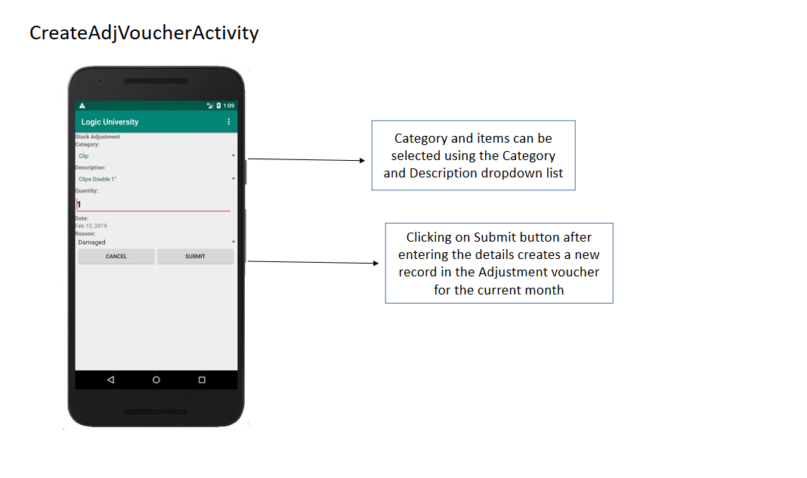

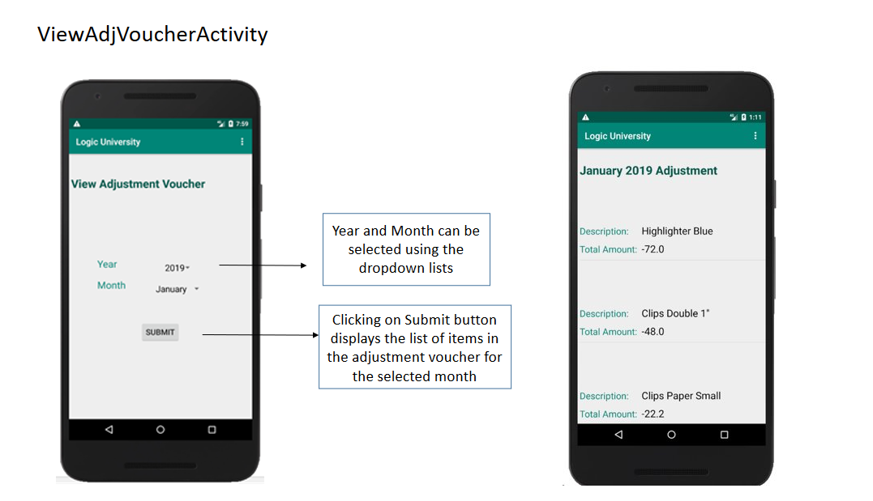

Process Disbursement List

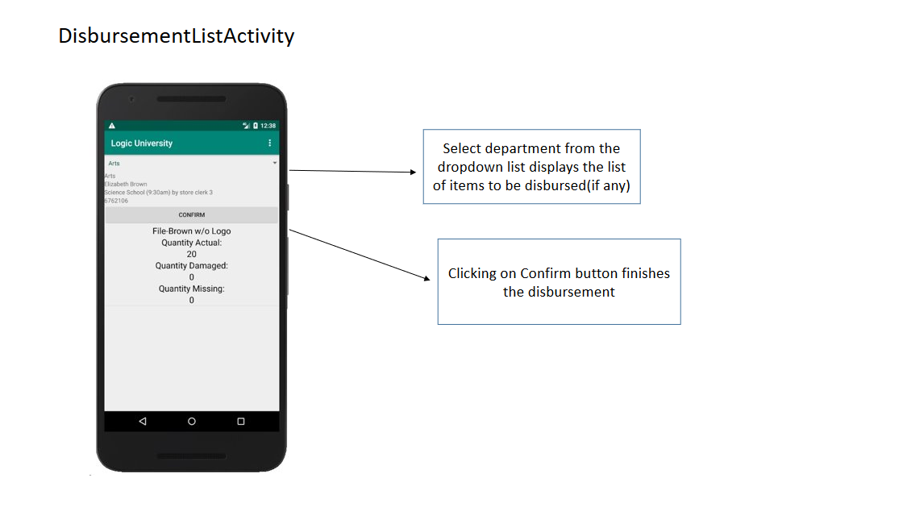

Process Retrieval List

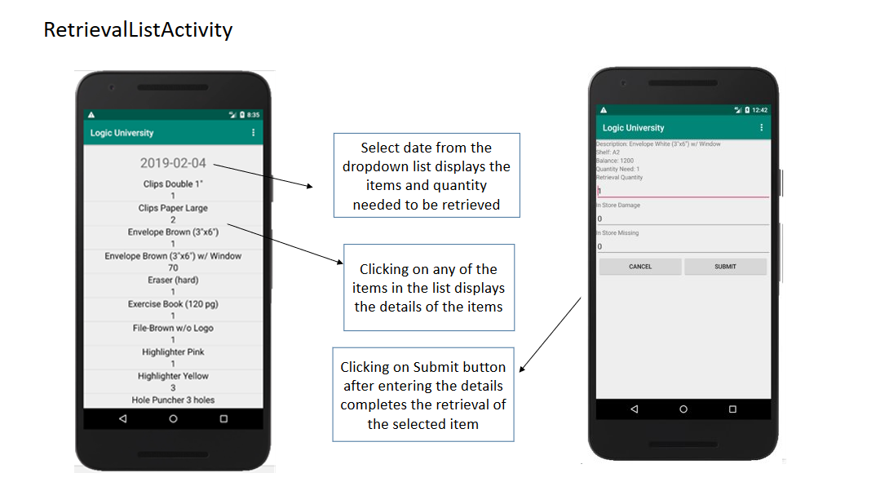

View Stock Card

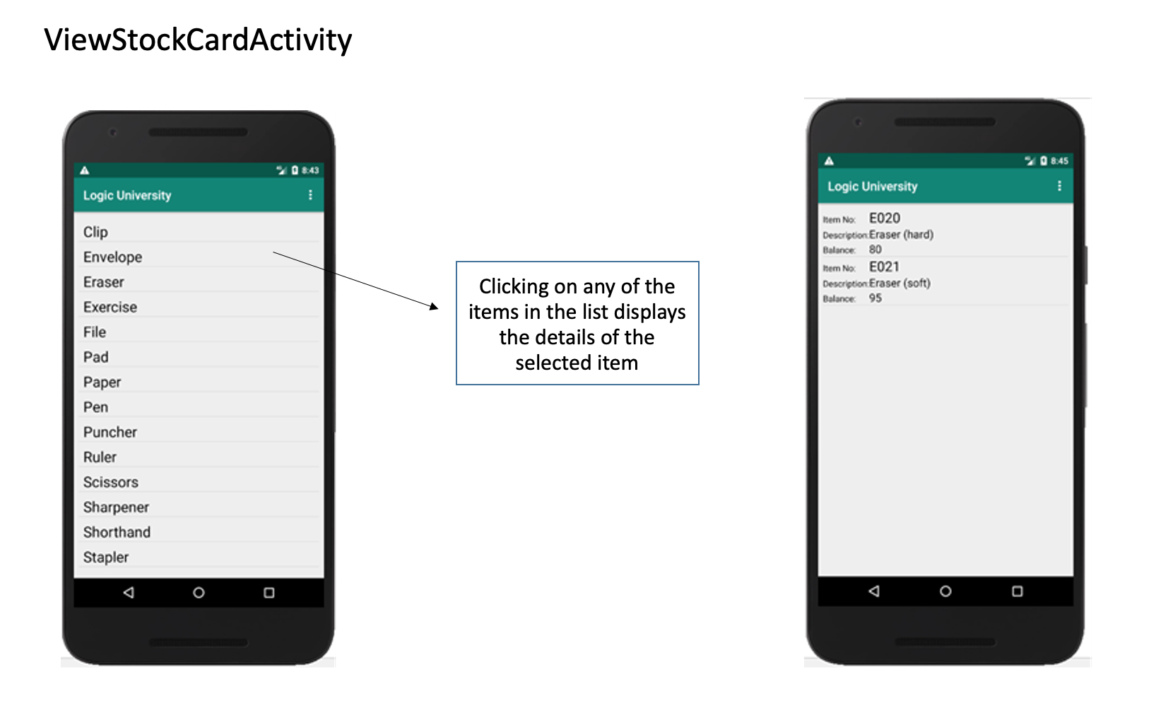

Close PO on delivery

